Indexers

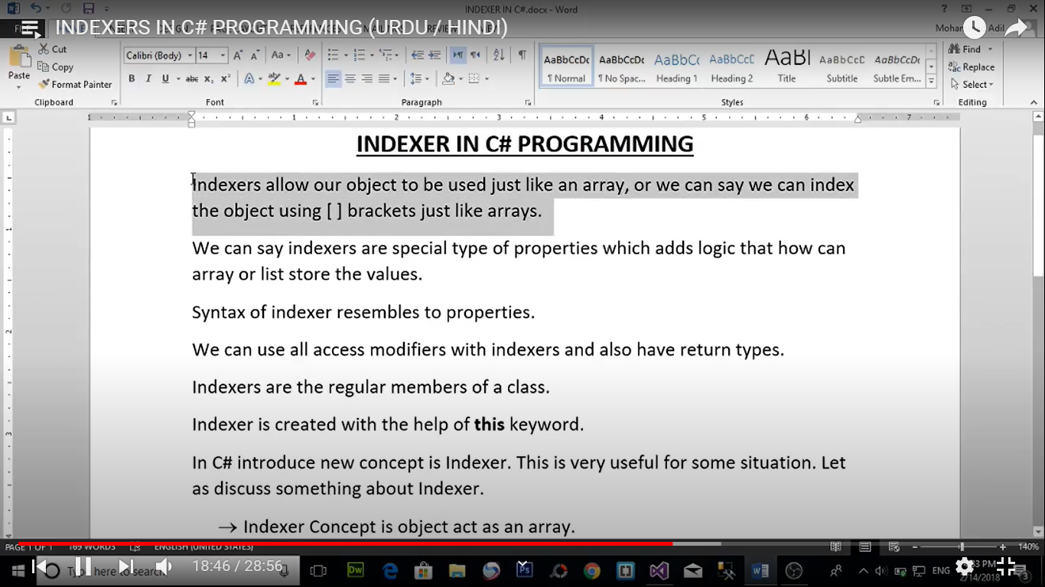

class Employee

{

private int[] Age = new int[3];

public int this[int index]

{

set {

if(index>=0 && index < Age.Length)

{

if (value > 0)

{

Age[index] = value;

}

else

{

Console.WriteLine("Value is Invalid");

}

}

else

{

Console.WriteLine("indexer in invalid");

}

}

get {

return Age[index];

}

}

public int this[int index,int i ]

{

set {

Age[index] = value + i;

}

get {

return Age[index];

}

}

}

class Program

{

static void Main(string[] args)

{

Employee emp=new Employee();

//emp[2] = 3;

//Console.WriteLine( emp[2] );

emp[0, 1] = 5;

Console.WriteLine(emp[0]);

}

}

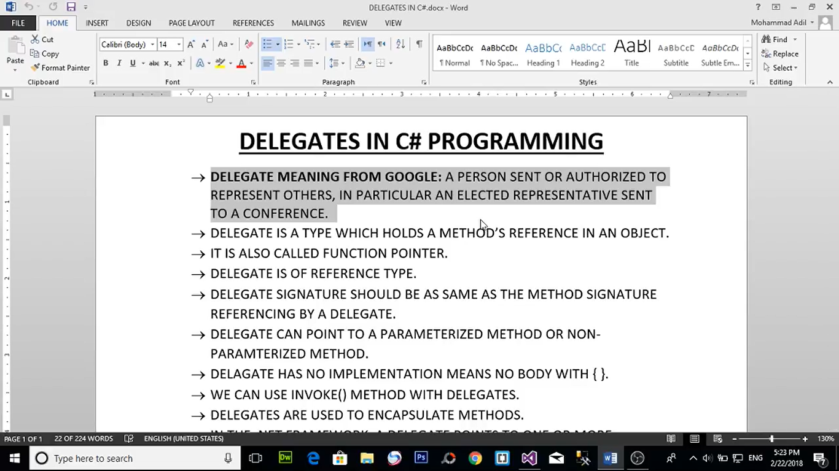

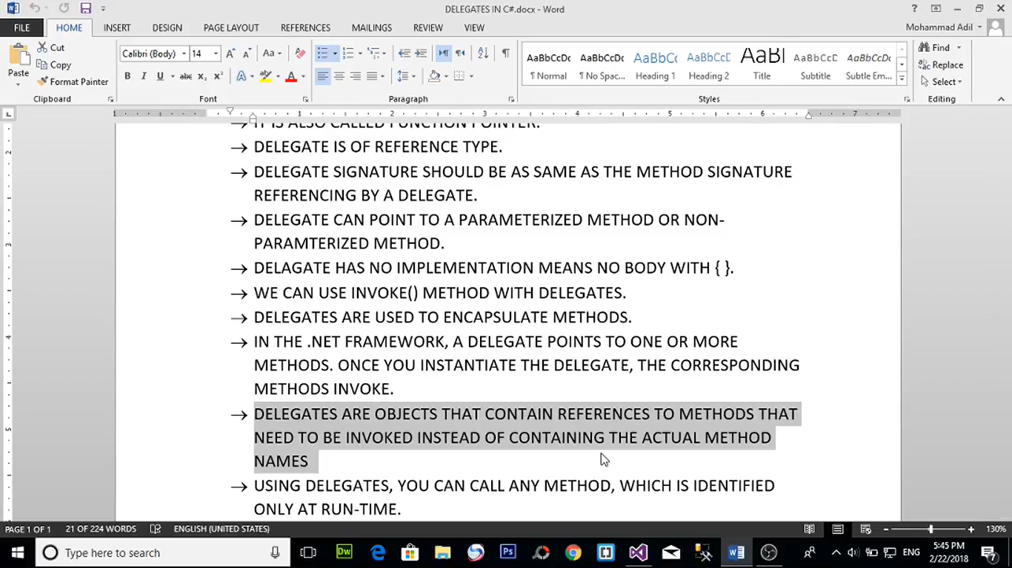

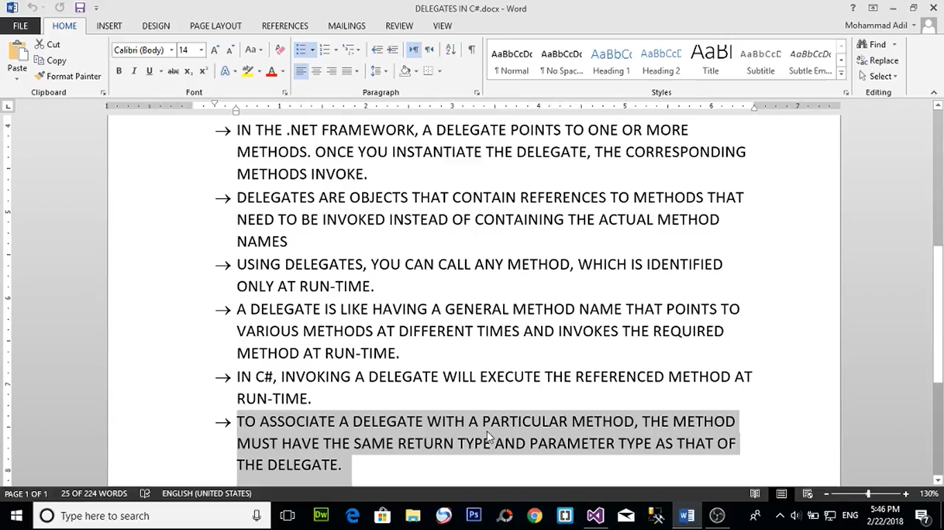

public delegate void Calculation(int a, int b);

class Program

{

public static void Addition(int a , int b)

{

int result = a + b;

Console.WriteLine("Addition Result is :{0}",result);

}

public static void Substraction(int a, int b)

{

int result = a - b;

Console.WriteLine("Substraction Result is :{0}", result);

}

public static void Mutiplication(int a, int b)

{

int result = a * b;

Console.WriteLine("Mutiplication Result is :{0}", result);

}

public static void Division(int a, int b)

{

int result = a / b;

Console.WriteLine("Division Result is :{0}", result);

}

static void Main(string[] args)

{

Calculation obj = new Calculation(Program.Addition);

obj(10, 2);

Calculation obj2 = new Calculation(Program.Substraction);

obj2(30,10);

Calculation obj3 = new Calculation(Program.Mutiplication);

obj3(30, 4);

Calculation obj4 = new Calculation(Program.Division);

obj4(20, 4);

Calculation obj5 = new Calculation(Program.Addition);

obj5.Invoke(10, 2);

}

}

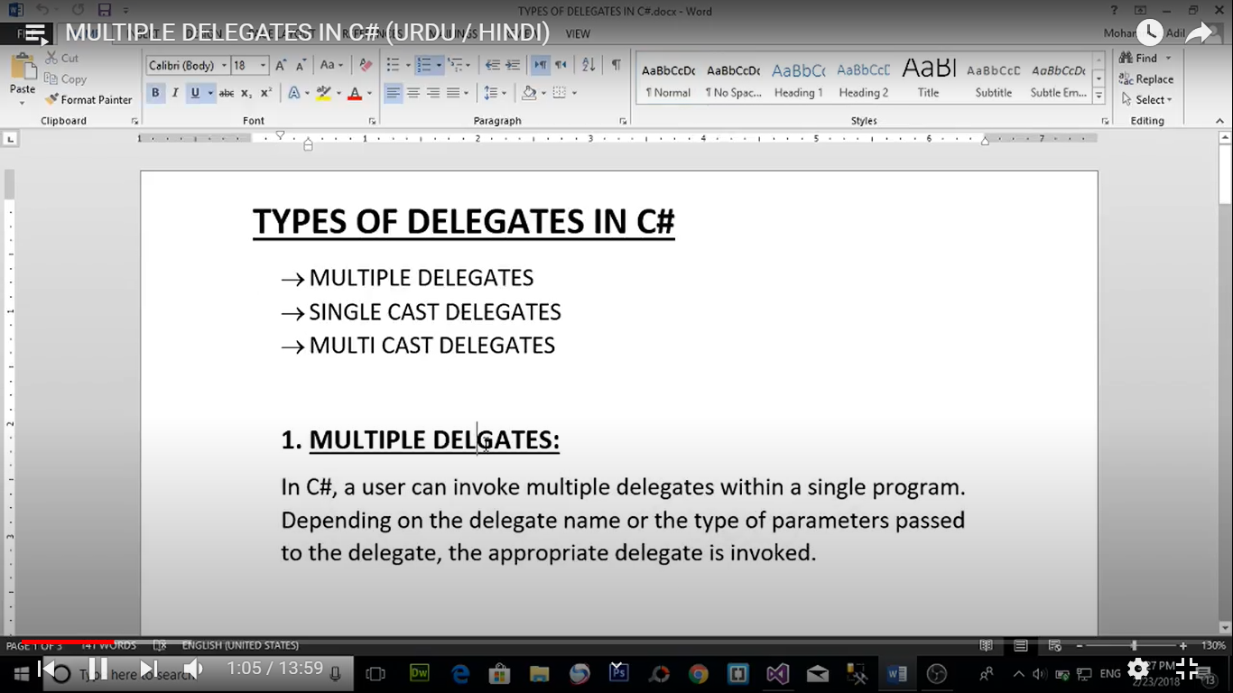

Multiple Delegate

public delegate void Show_Delegate();

public delegate void Calculation2(int a);

public static void show()

{

Console.WriteLine("This is show method");

}

public static void square(int a)

{

int result = a * a;

Console.WriteLine("square of {0} is {1} ",a,result);

}

public static void cube(int a)

{

int result = a * a*a;

Console.WriteLine("cube of {0} is {1} ", a, result);

}

Show_Delegate obj6 = new Show_Delegate(Program.show);

obj6.Invoke();

Calculation2 obj7 = new Calculation2(Program.square);

obj7.Invoke(2);

Calculation2 obj8 = new Calculation2(Program.cube);

obj8.Invoke(3);

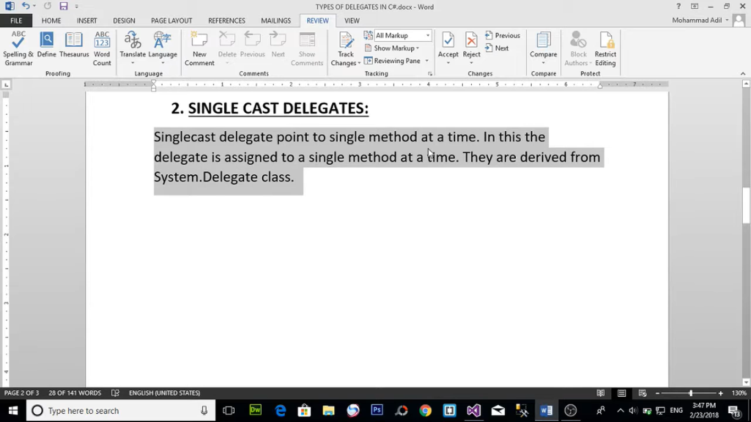

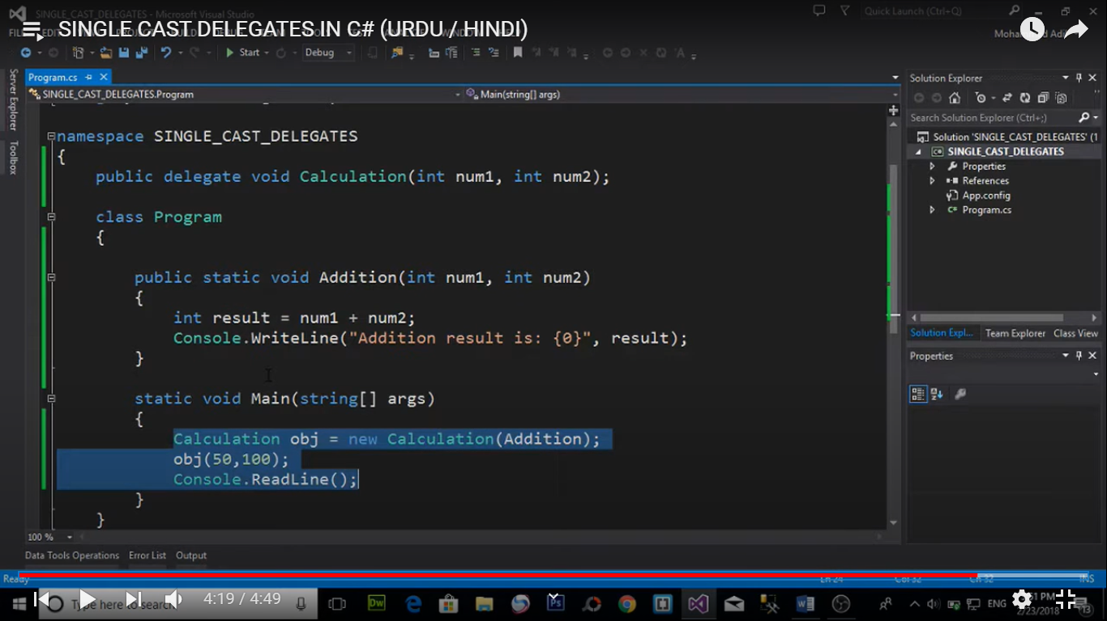

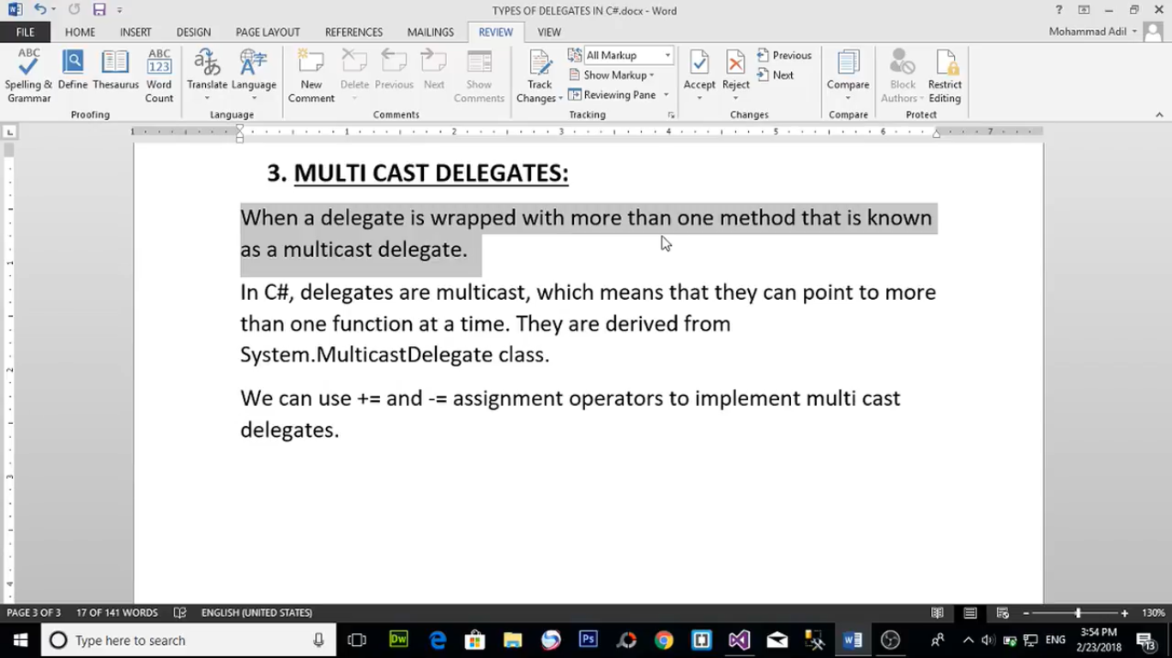

Calculation obj9 = new Calculation(Program.Addition);

obj9 += Substraction;

obj9 += Mutiplication;

obj9 += Division;

obj9.Invoke(150, 100);

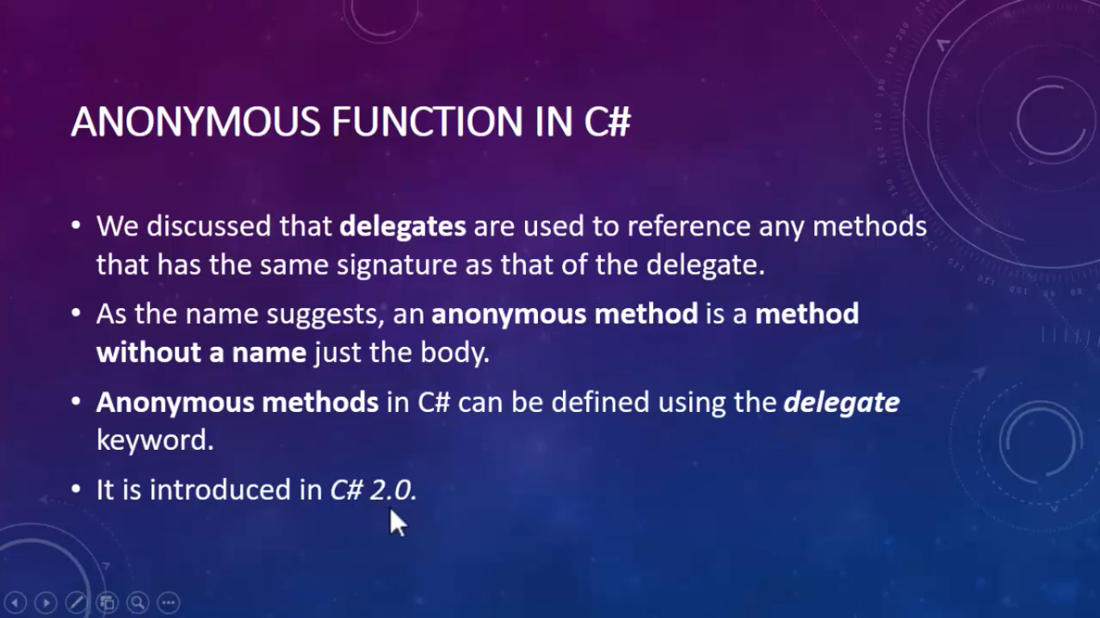

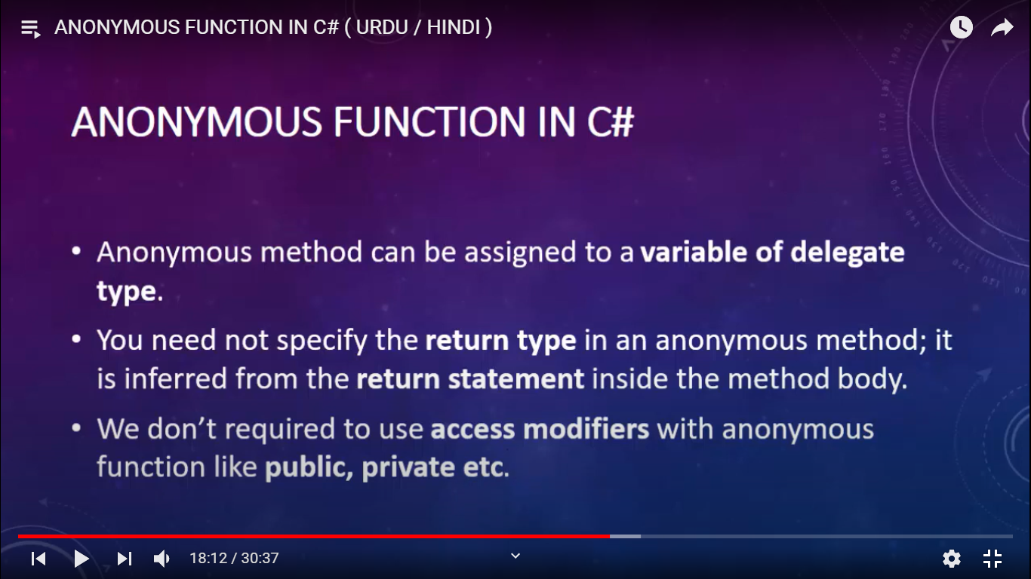

public delegate void myDelegate(int a);

prostatic void Main(string[] args)

{

myDelegate obj = delegate (int a) {

a += 10;

Console.WriteLine(a);

};

obj.Invoke(66);

}

Lambda Expression

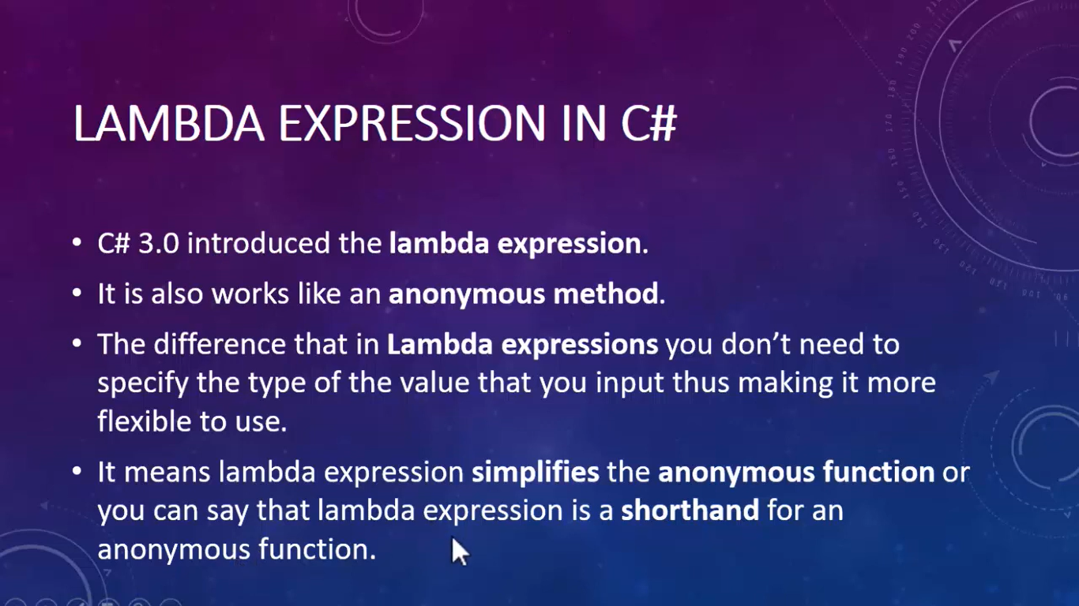

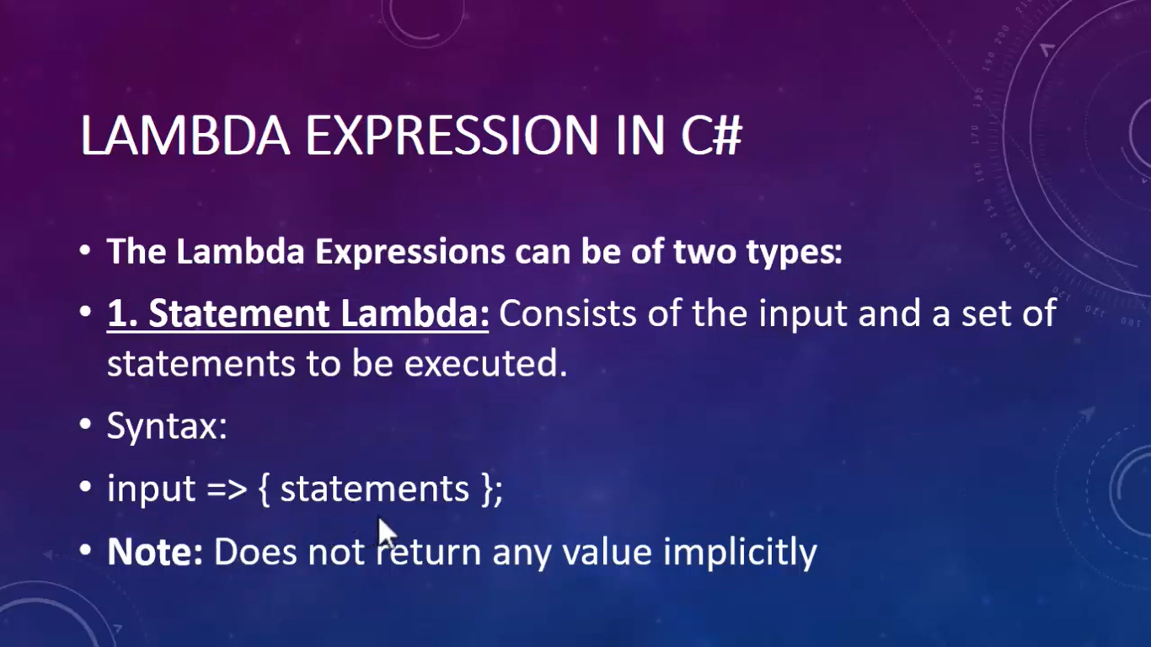

public delegate void MyDelegate(int num);

class Program

{

static void Main(string[] args)

{

MyDelegate obj = ( a)=> {

a += 5;

Console.WriteLine(a);

};

obj.Invoke(5);

}

}

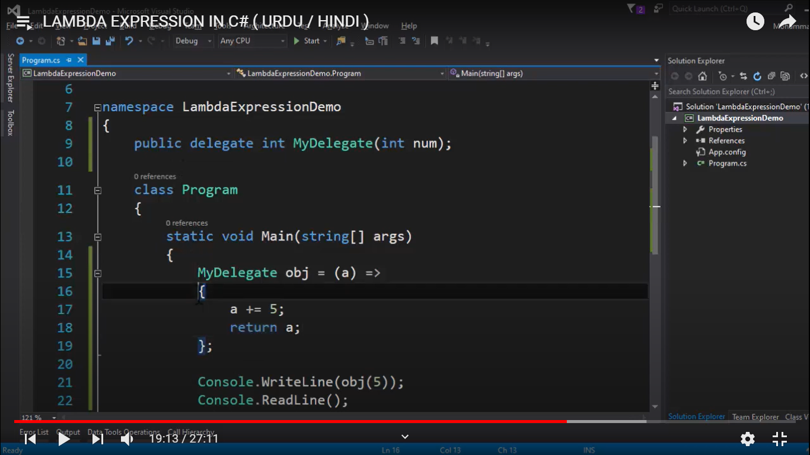

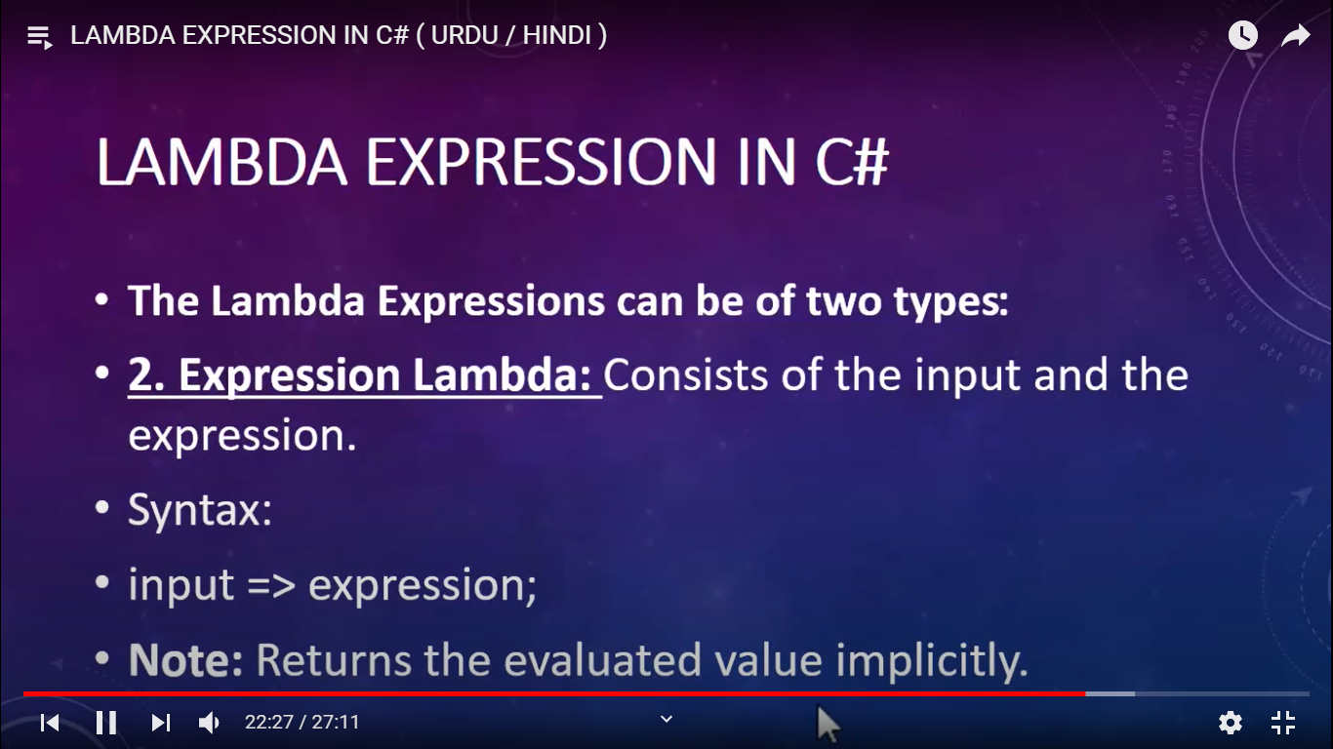

public delegate int MyDelegate2(int a, int b);

MyDelegate2 obj = (a, b) => a + b;

int output = obj.Invoke(11,22);

Console.WriteLine(output);

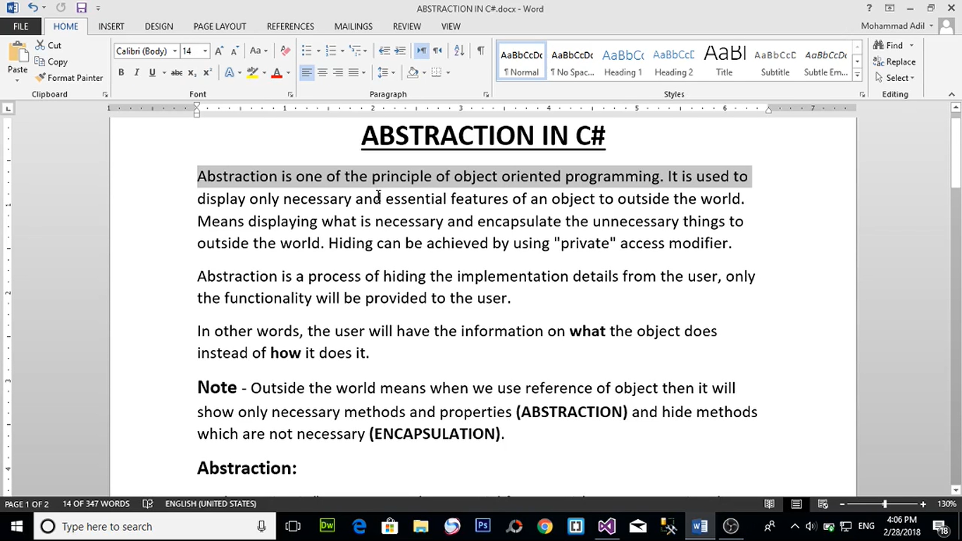

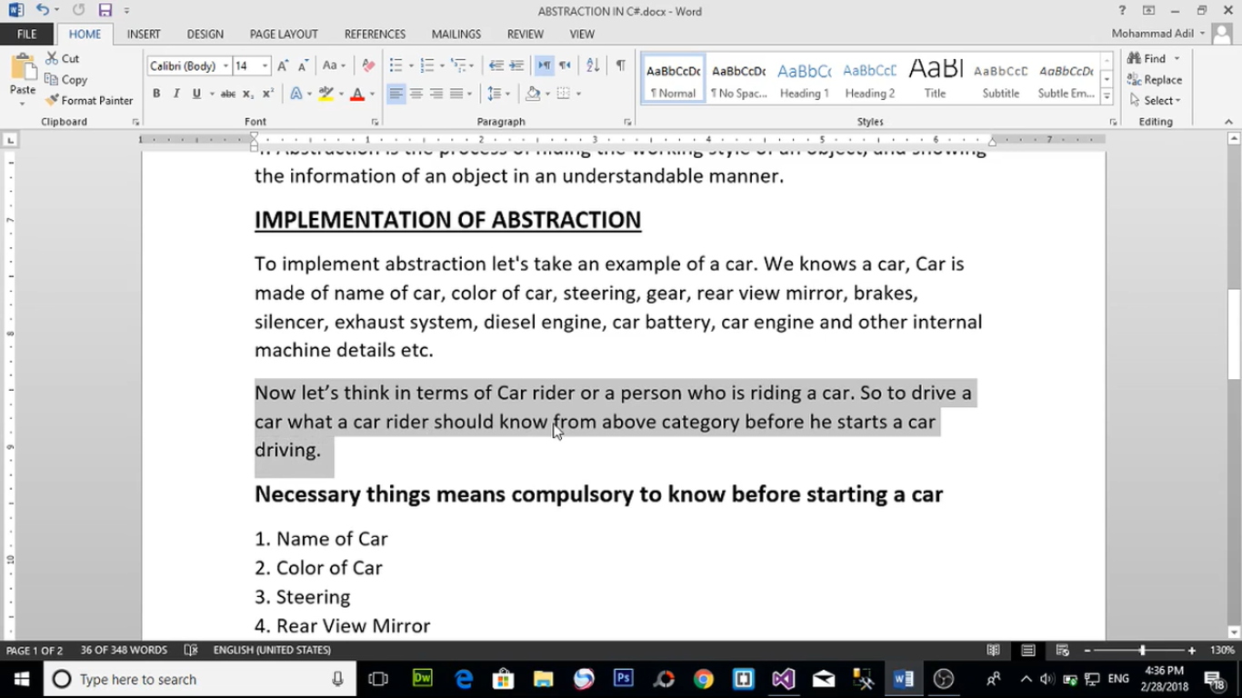

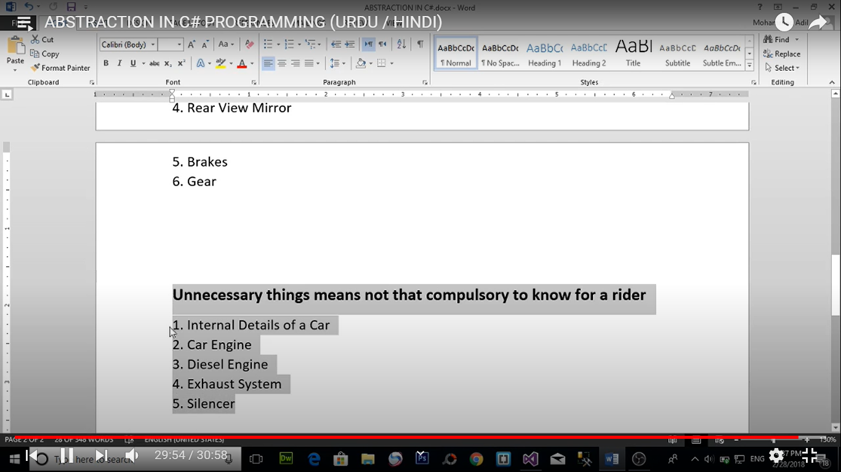

class Employee

{

public int EmpID;

public string EmpName;

public double GrossPay;

double TaxDeduction = 0.1;

double netSalary;

public Employee(int EID,string EName,double EGrossPay) {

this.EmpID = EID;

this.EmpName = EName;

this.GrossPay = EGrossPay;

}

private void CalculateSalary()

{

if (GrossPay >= 40000)

{

netSalary = GrossPay - (TaxDeduction * GrossPay);

Console.WriteLine("Your Salary is: {0}",netSalary);

}

else

{

netSalary = GrossPay;

Console.WriteLine("Your Salary is: {0}", netSalary);

}

}

public void ShowEmployeeDetails()

{

Console.WriteLine("Employee ID is :{0}",this.EmpID);

Console.WriteLine("Employee Name is :{0}", this.EmpName);

this.CalculateSalary();

}

}

class Program

{

static void Main(string[] args)

{

Employee emp = new Employee(100,"Pradeep",35000);

emp.ShowEmployeeDetails();} }

ABSTRACT CLASS

Cannot create object of abstract class

Abstract method are method without body

Body is defined in child class

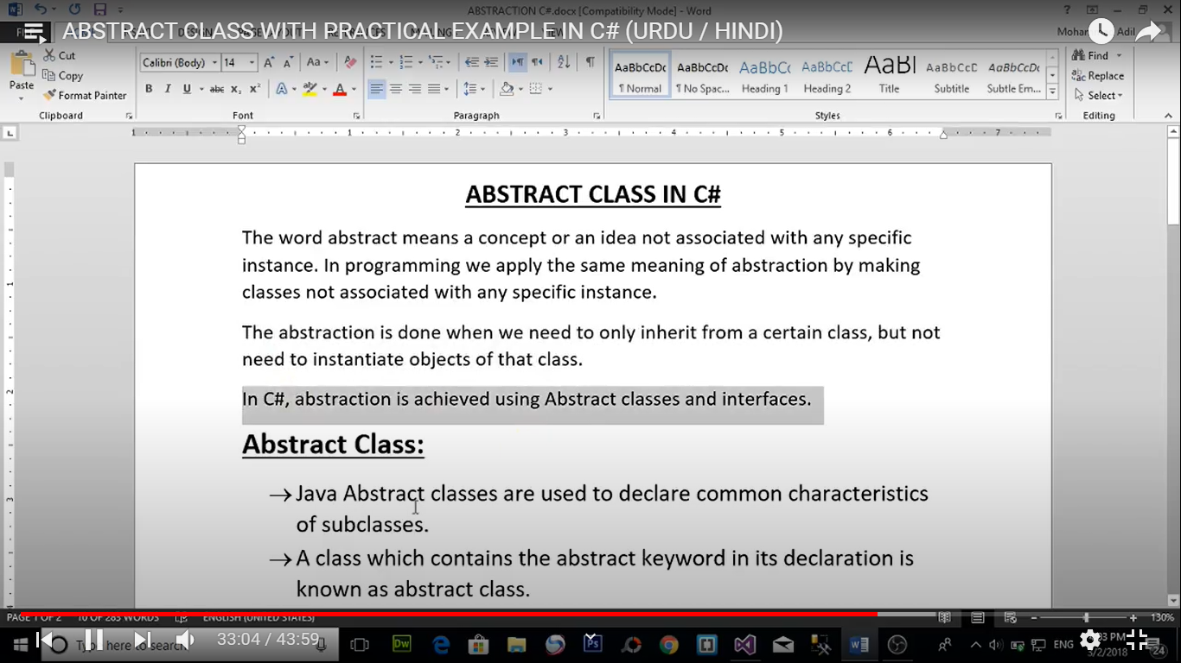

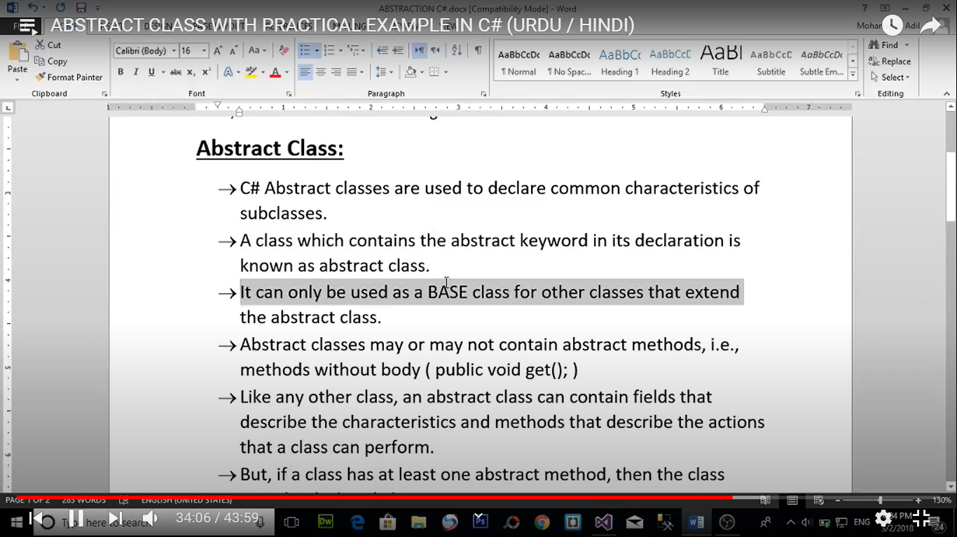

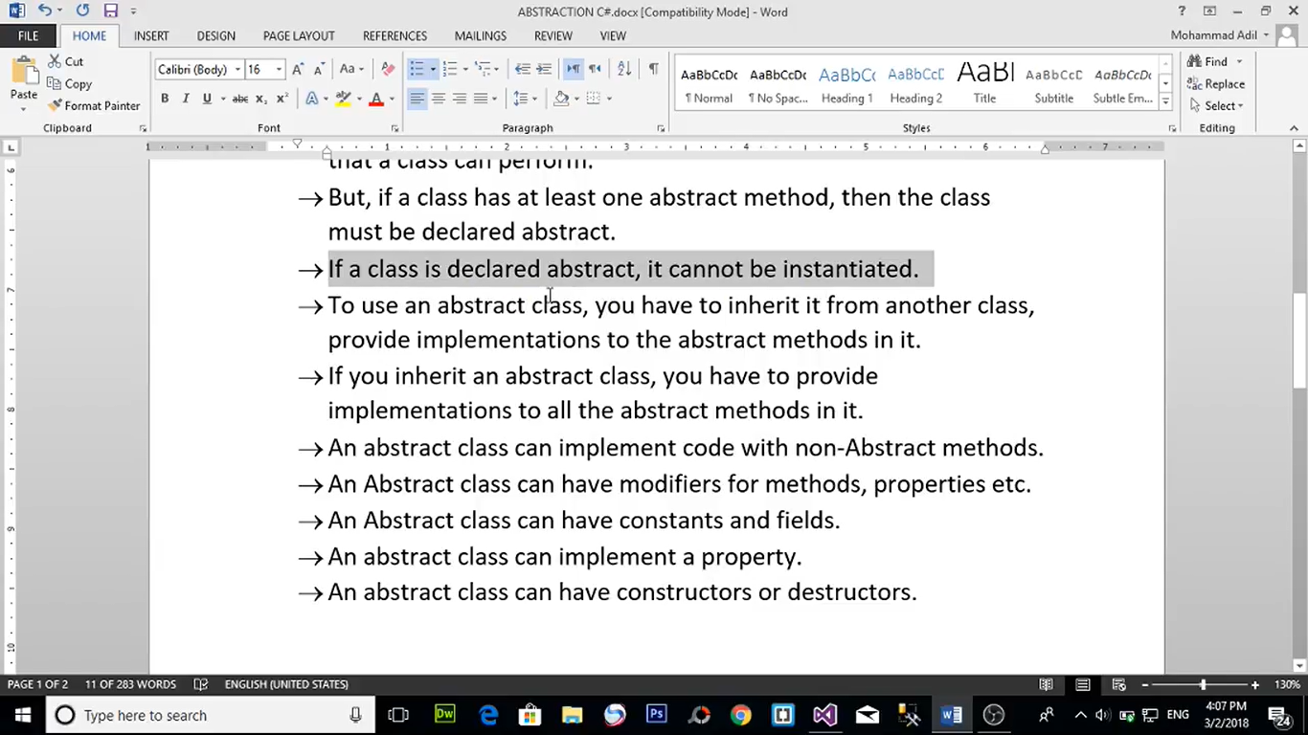

abstract class person

{

public string FirstName;

public string LastName;

public int Age;

public long PhoneNumber;

public abstract void printDetails();

}

class student:person

{

public int RollNo;

public int Fees;

public override void printDetails()

{

string name = this.FirstName + " " + this.LastName;

Console.WriteLine("Student Name is : {0}",name);

Console.WriteLine("Student Age is : {0}", this.Age);

Console.WriteLine("Student PhoneNumber is : {0}", this.PhoneNumber);

Console.WriteLine("Student RollNo is : {0}", this.RollNo);

Console.WriteLine("Student Fees is : {0}", this.Fees);

}

}

class teacher:person

{

public string qualification;

public int salary;

public override void printDetails()

{

string name = this.FirstName + " " + this.LastName;

Console.WriteLine("Teacher Name is : {0}", name);

Console.WriteLine("Teacher Age is : {0}", this.Age);

Console.WriteLine("Teacher PhoneNumber is : {0}", this.PhoneNumber);

Console.WriteLine("Teacher qualification is : {0}", this.qualification);

Console.WriteLine("Teacher salary is : {0}", this.salary);

}

}

class Program

{

static void Main(string[] args)

{

student st = new student();

st.FirstName = "Pradeep";

st.LastName = "Kumar";

st.Age = 24;

st.PhoneNumber = 6968698696;

st.RollNo = 1009;

st.Fees = 090970;

st.printDetails();

Console.WriteLine("---------------------------------");

teacher tc = new teacher();

tc.FirstName = "rajesh";

tc.LastName = "Roshan";

tc.Age = 40;

tc.PhoneNumber = 99979767667;

tc.qualification = "MCA";

tc.salary = 787880;

tc.printDetails();

}

}

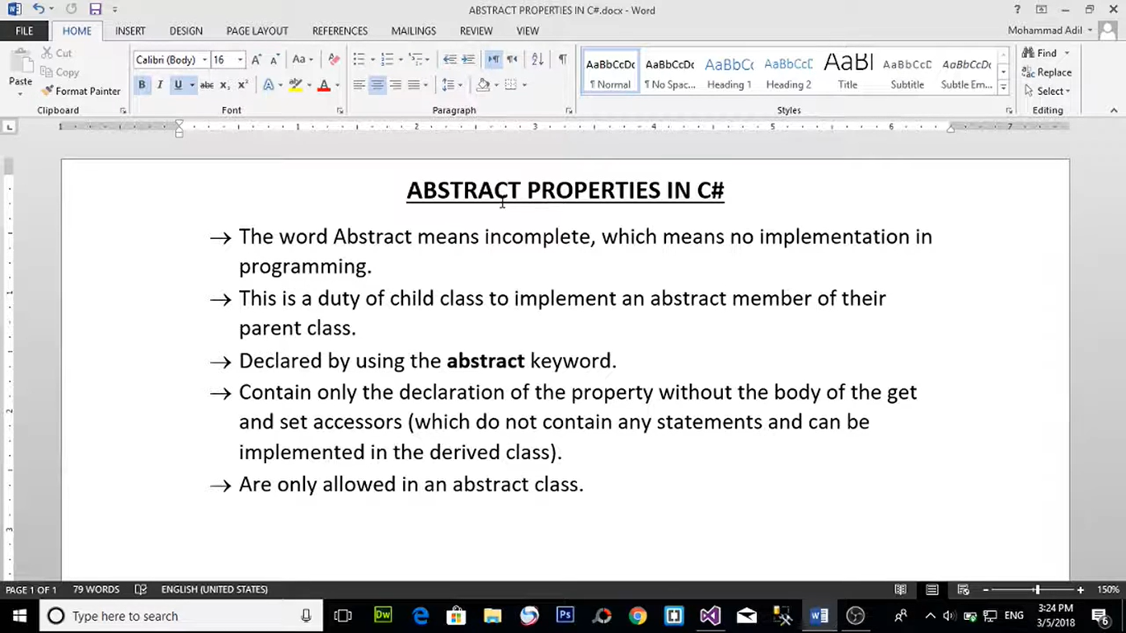

abstract class person

{

public abstract int ID{ get; set; }

public abstract string Name { get; set; }

}

class student : person

{

private int studentID;

private string studentName;

public override int ID

{

set => this.studentID = value;

get { return this.studentID; }

}

public override string Name

{

set => this.studentName = value;

get { return this.studentName; }

}

}

class Program

{

static void Main(string[] args)

{

student st = new student();

st.ID = 1001;

st.Name = "Pradeep Kumar";

Console.WriteLine(st.ID);

Console.WriteLine(st.Name);

}

}

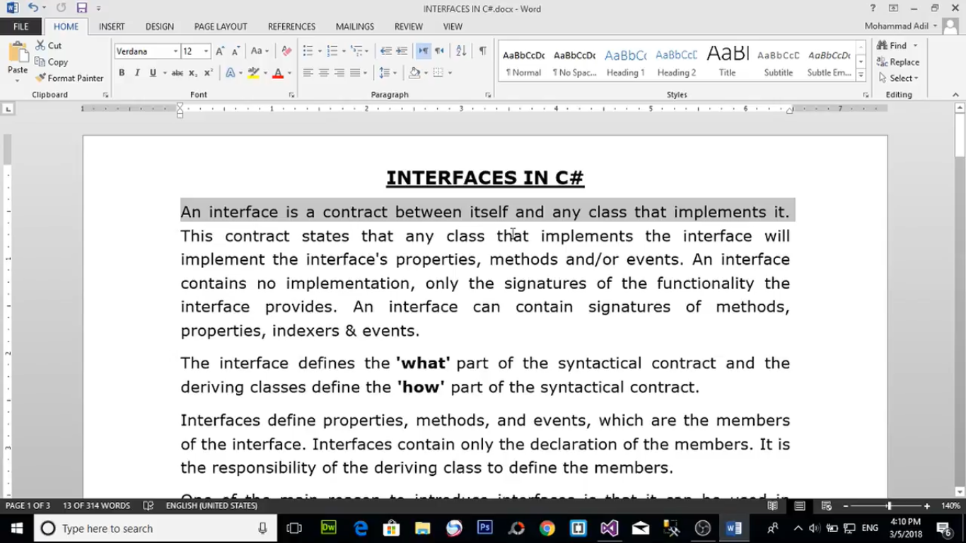

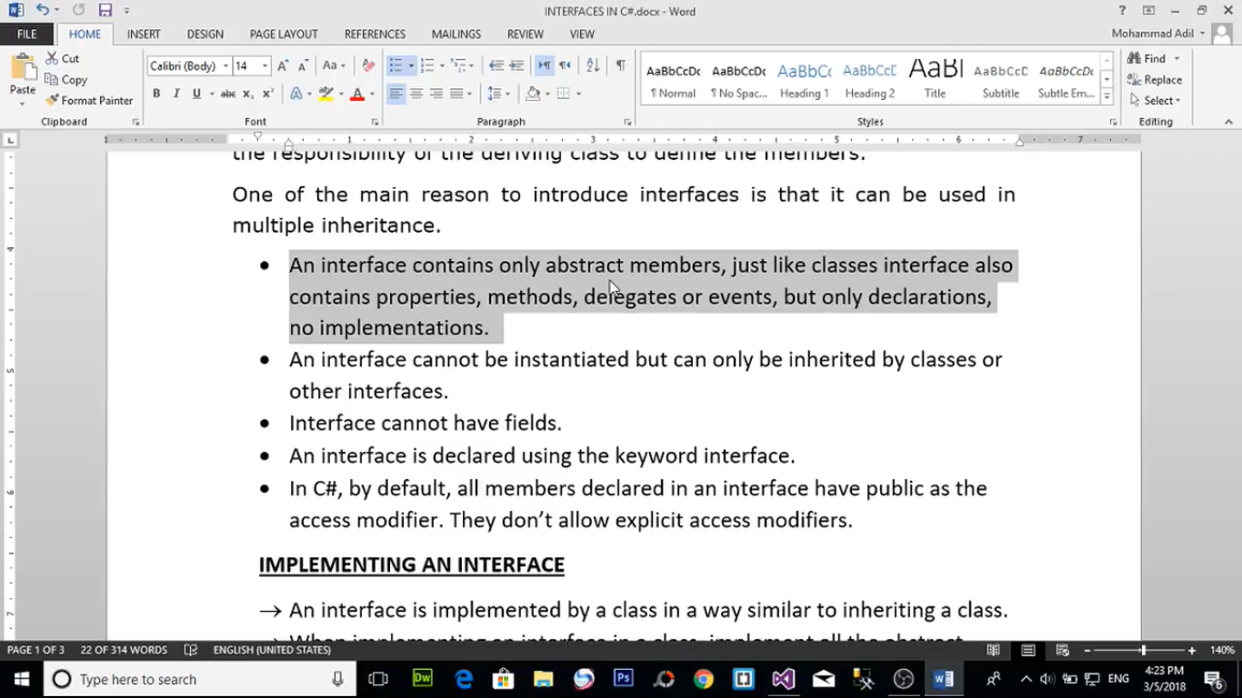

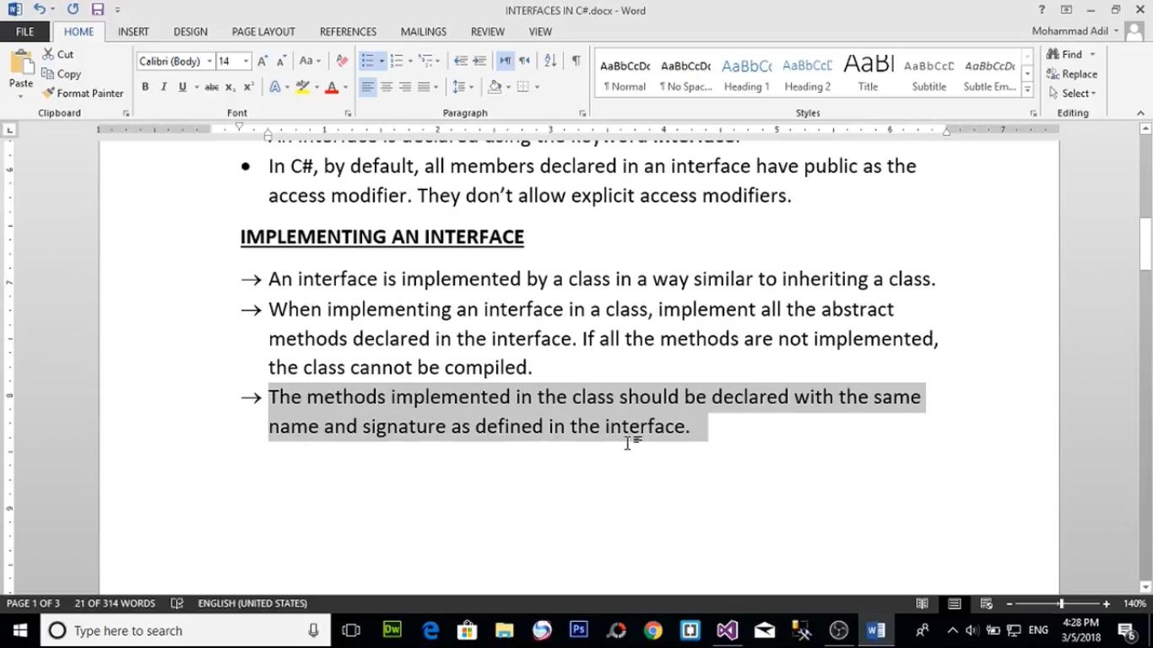

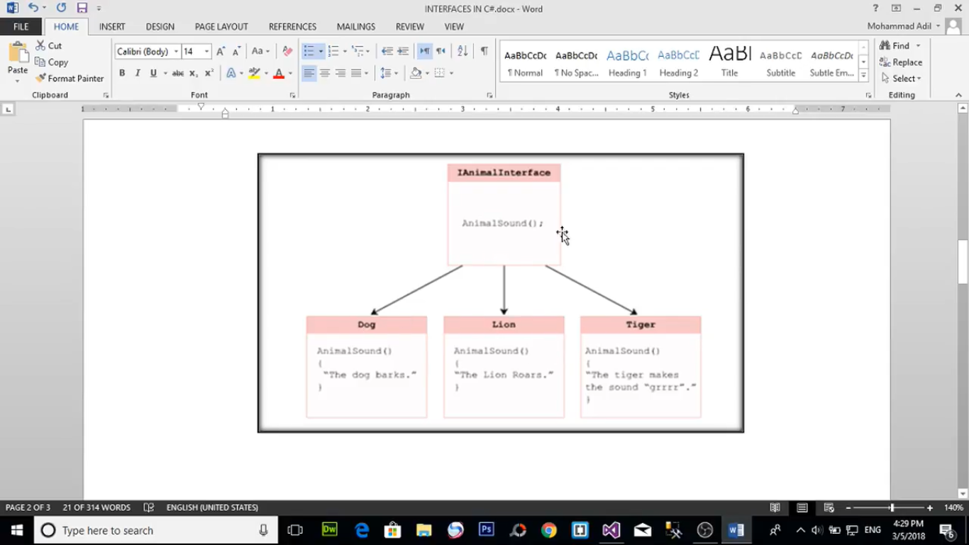

Members in interface are incomplete

Interface contailn no bodies

Class to class inherit= inheritance

Interface to class inherit =inheritance

Member(methods) inside interface is public and abstract

Interface cannot contain fields and static fields

interface i1

{

void print1();

}

interface i2

{

void print2();

}

interface i3:i1,i2

{

void print3();

}

class Program:i3

{

public void print1()

{

Console.WriteLine("This is a method of interface 1");

}

public void print2()

{

Console.WriteLine("This is a method of interface 2");

}

public void print3() {

Console.WriteLine("This is a method of interface 3");

}

static void Main(string[] args)

{

//Program p = new Program();

//p.print1();

//p.print2();

//p.print3();

i1 myinterface1 = new Program();

myinterface1.print1();

i3 myinterface3 = new Program();

myinterface3.print1();

myinterface3.print2();

myinterface3.print3();

}

}

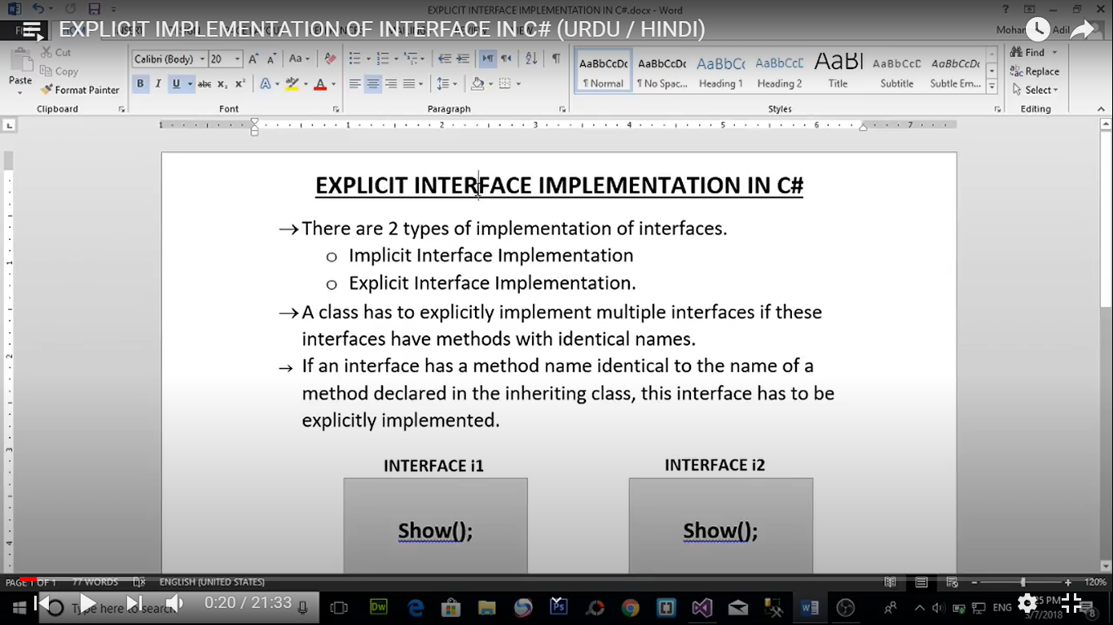

interface i1

{

void show();

}

interface i2

{

void show();

}

class myClass : i1,i2

{

void i1.show()

{

Console.WriteLine("this is implementation method of interface 1");

}

void i2.show()

{

Console.WriteLine("this is implementation method of interface 2");

}

}

class Program

{

static void Main(string[] args)

{

myClass obj = new myClass();

((i1)obj).show();

((i2)obj).show();

Console.WriteLine("---------------------------");

i1 obj1 = new myClass();

obj1.show();

i2 obj2 = new myClass();

obj2.show();}

}

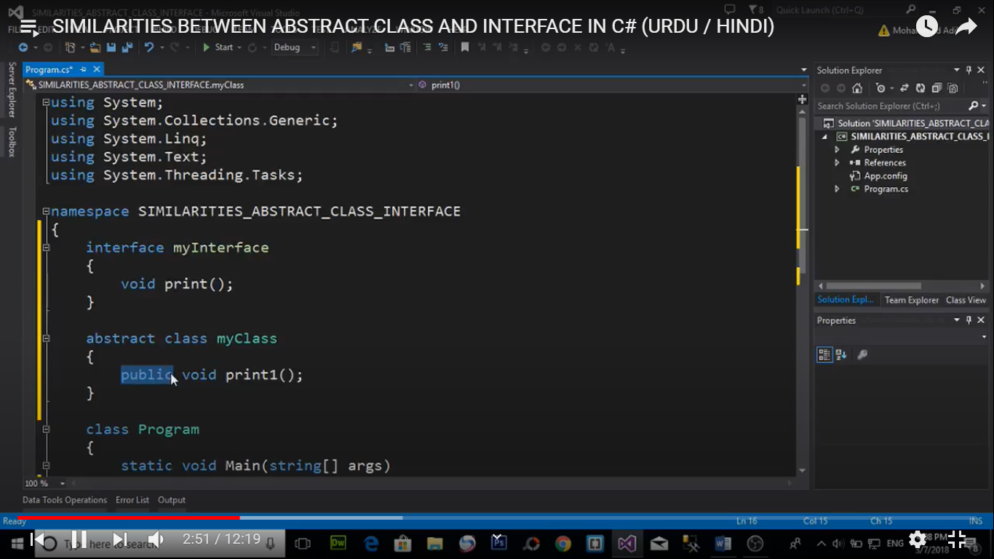

By default method is abstract and public in interface

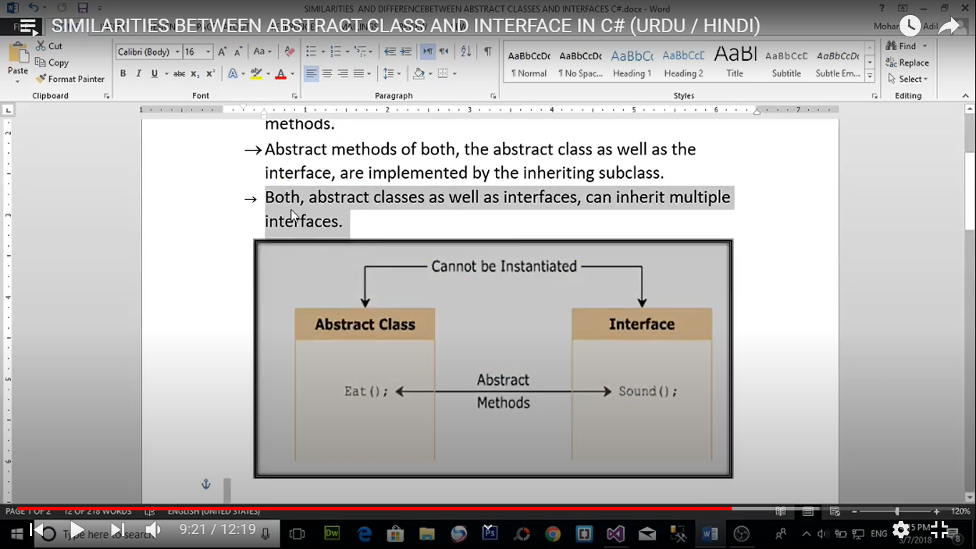

Differences between abstract class and interface

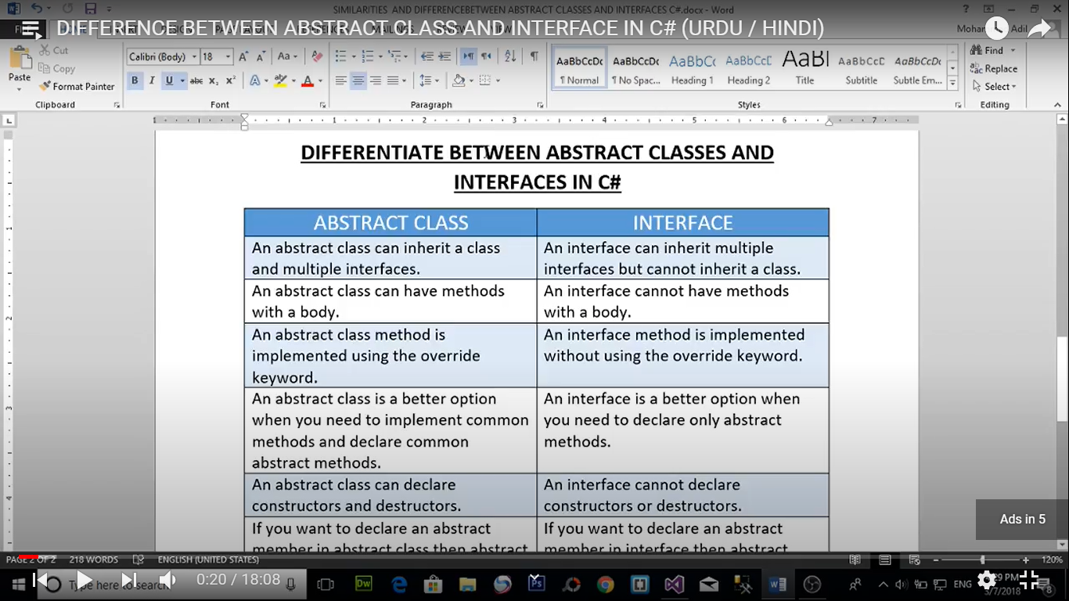

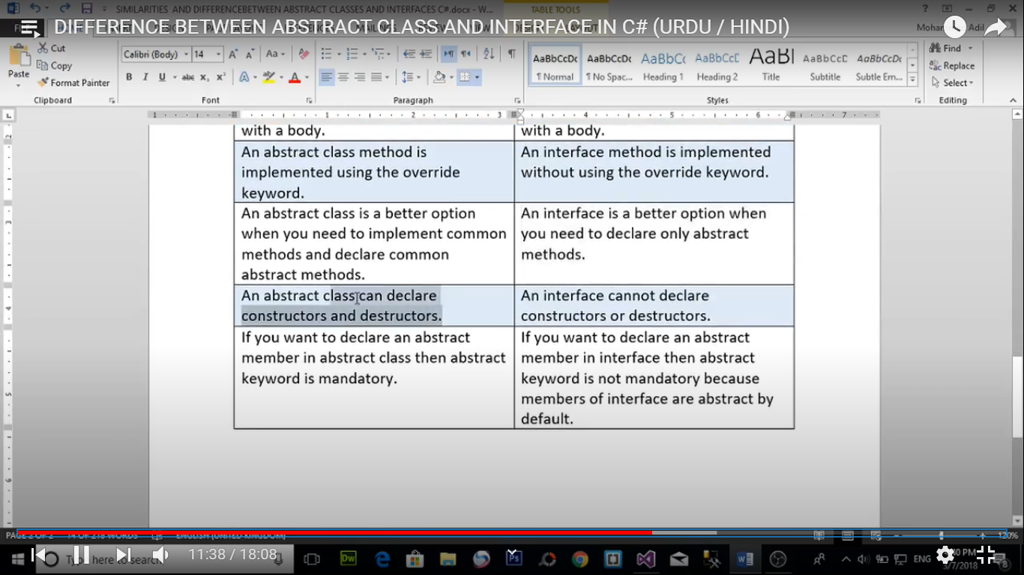

1. Interface inherit interface only
2. Abstract class inherit multiple interface
3. Abstract class may or may not have abstract method
4. Interface class only have abstract method
5. Interface is implement with override keyword
6. Interface cannot have construcror and destructor but abstract class have
7. Abstract keyword is not mendatory in interface but mendatory in abstract class

namespace differences_abstract_interface

{

class example

{

}

interface i1

{

}

interface i2

{

}

interface myinterface : i1, i2

{

void show()

{

}

}

abstract class myabstract :example,i1,i2

{

public abstract void show2();

public myabstract()

{

Console.WriteLine("This is constructor of abstract class");

}

~myabstract()

{

Console.WriteLine("This is destructor of abstract class");

}

}

class myClass1 : myabstract,myinterface

{

public override void show2()

{

Console.WriteLine("This is method of abstract class");

}

public void show()

{

Console.WriteLine("This is method of interface class");

}

}

class Program

{

static void Main(string[] args)

{

myClass1 obj = new myClass1();

}

}

}

MULTIPLE inheritance

One class can have two parent

Multiple inheritance using classes is not possible

Multiple inheritance using interface is possible

namespace multiple_inheritance

{

class person

{

public void show1()

{

Console.WriteLine("this is method of person Class ");

}

}

interface Employee

{

void show2();

}

class Teacher : person, Employee

{

public void show2()

{

Console.WriteLine("this is method of Employee Interface ");

}

}

class Program

{

static void Main(string[] args)

{

Teacher tc = new Teacher();

tc.show1();

tc.show2();

}

}

}

namespace multiple_inheritance

{

class person

{

public void show()

{

Console.WriteLine("this is method of person Class ");

}

}

interface Employee

{

void show();

}

class Teacher : person, Employee

{

void Employee.show()

{

Console.WriteLine("this is method of Employee Interface ");

}

}

class Program

{

static void Main(string[] args)

{

Teacher tc = new Teacher();

tc.show();

Employee e = new Teacher();

e.show();

}

}

}

namespace multiple_inheritance

{

class person

{

public void show()

{

Console.WriteLine("this is method of person Class ");

}

}

interface Employee

{

void show();

}

interface Employee1

{

void show();

}

class Teacher : person, Employee,Employee1

{

void Employee.show()

{

Console.WriteLine("this is method of Employee Interface ");

}

void Employee1.show()

{

Console.WriteLine("this is method of Employee1 Interface ");

}

}

class Program

{

static void Main(string[] args)

{

Teacher tc = new Teacher();

tc.show();

Employee emp = new Teacher();

emp.show();

Employee1 emp1 = new Teacher();

emp1.show();

}

}

}

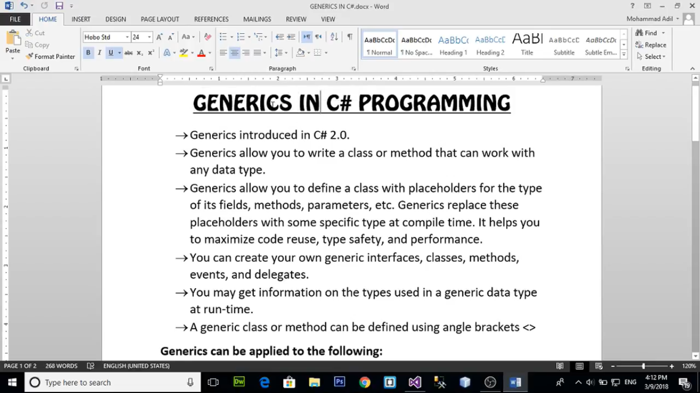

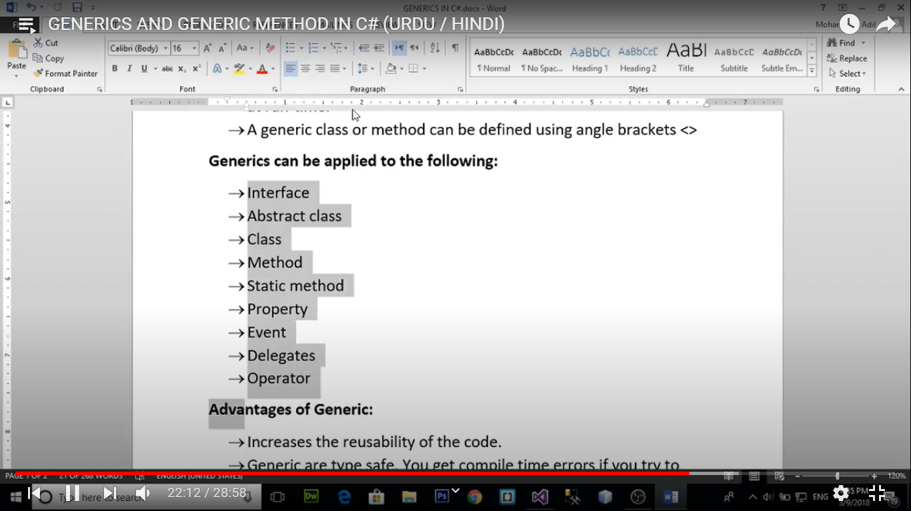

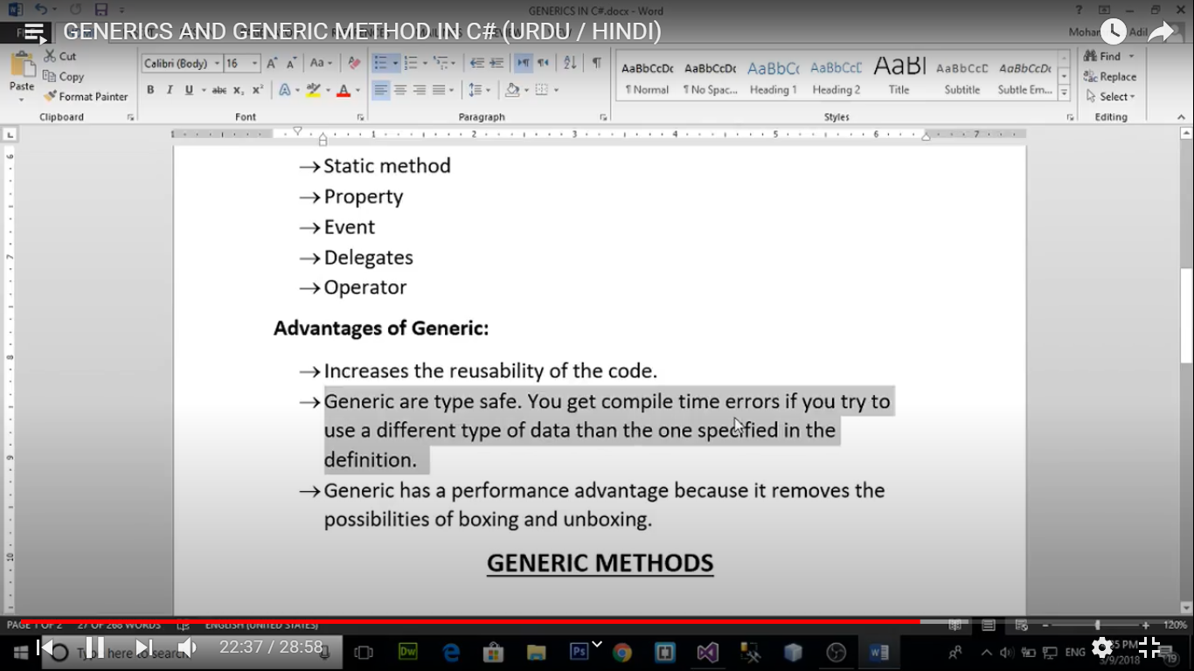

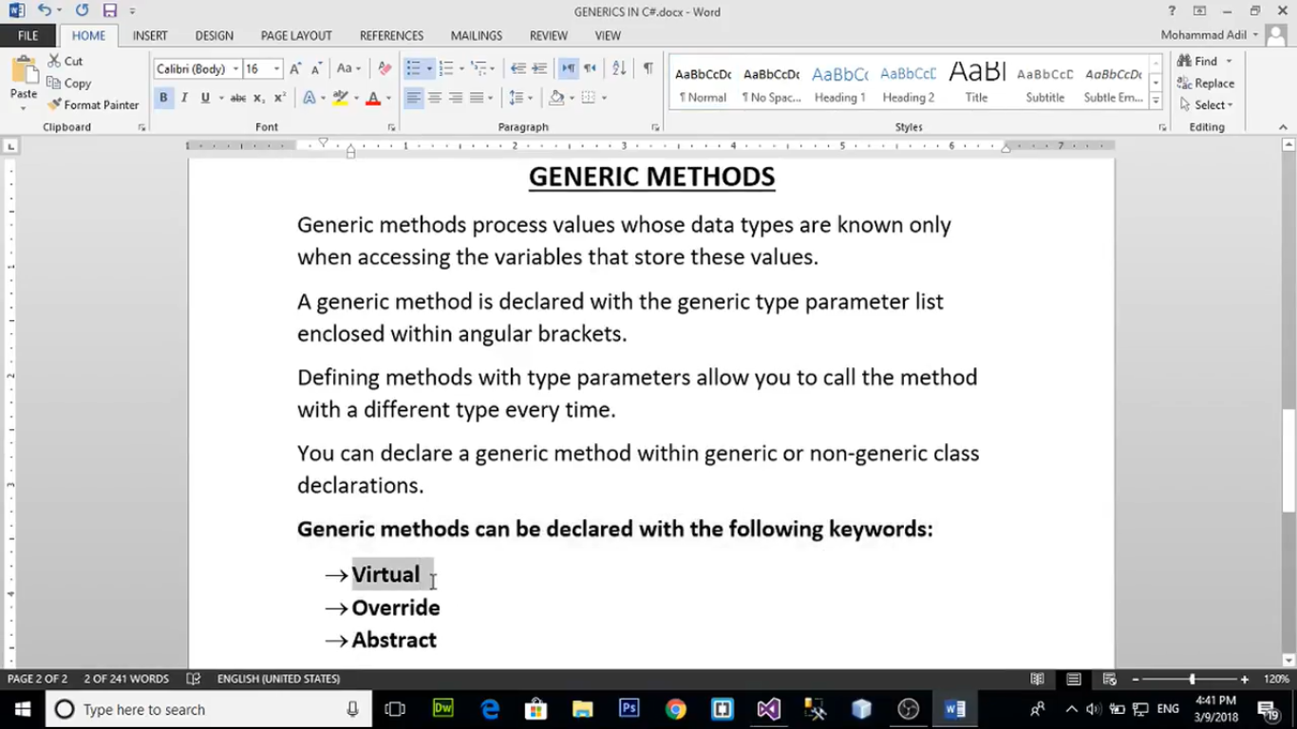

namespace Generics

{

class Example

{

public static void showArray(int[] arr)

{

for (int i = 0; i < arr.Length; i++)

{

Console.WriteLine(arr[i]);

}

}

public static void showArray(string[] arr)

{

for (int i = 0; i < arr.Length; i++)

{

Console.WriteLine(arr[i]);

}

}

}

class Program

{

static void Main(string[] args)

{

int[] numbers = { 11, 22, 33, 44, 55 };

string[] names = { "Pradeep","anuj","raj","tarun"};

Example.showArray(numbers);

Example.showArray(names);

}

}

}

public static void showArray<T>(T[] arr)

{

for (int i = 0; i < arr.Length; i++)

{

Console.WriteLine(arr[i]);

}

}

int[] numbers = { 11, 22, 33, 44, 55 };

string[] names = { "Pradeep", "anuj", "raj", "tarun" };

double[] points = {1.2,7.99,62.77,926,77.772 };

Example.showArray(numbers);

Example.showArray(names);

Example.showArray(points);

class Example2

{

public static bool check<T>(T a,T b)

{

bool c = a.Equals(b);

return c;

}

}

class Program

{

static void Main(string[] args)

{

Console.WriteLine(Example2.check(10, 10));

Console.WriteLine(Example2.check("Pradeep", "Pradeep"));

Console.WriteLine(Example2.check(true, true));

}

}

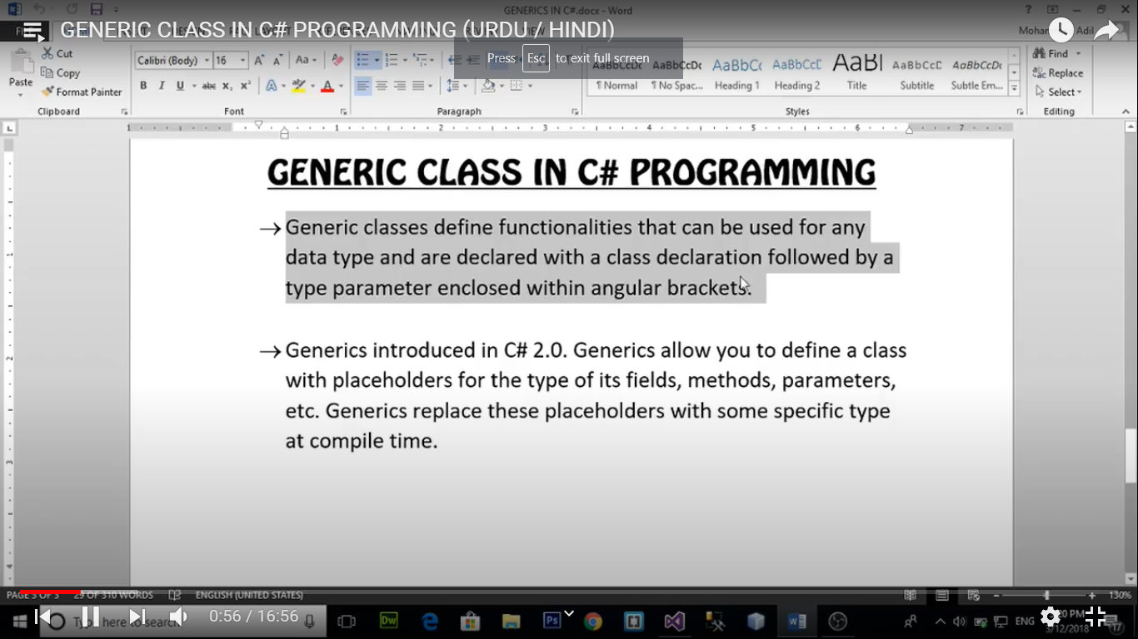

namespace Generic_Class

{

class Example<T>

{

T box;

public T Box {

get { return this.box; }

set { this.box = value; }

}

}

class Program

{

static void Main(string[] args)

{

Example<int> obj = new Example<int>();

obj.Box = 20;

Console.WriteLine( obj.Box );

Example<string> obj2 = new Example<string>();

obj2.Box = "Pradeep";

Console.WriteLine(obj2.Box);

} }}

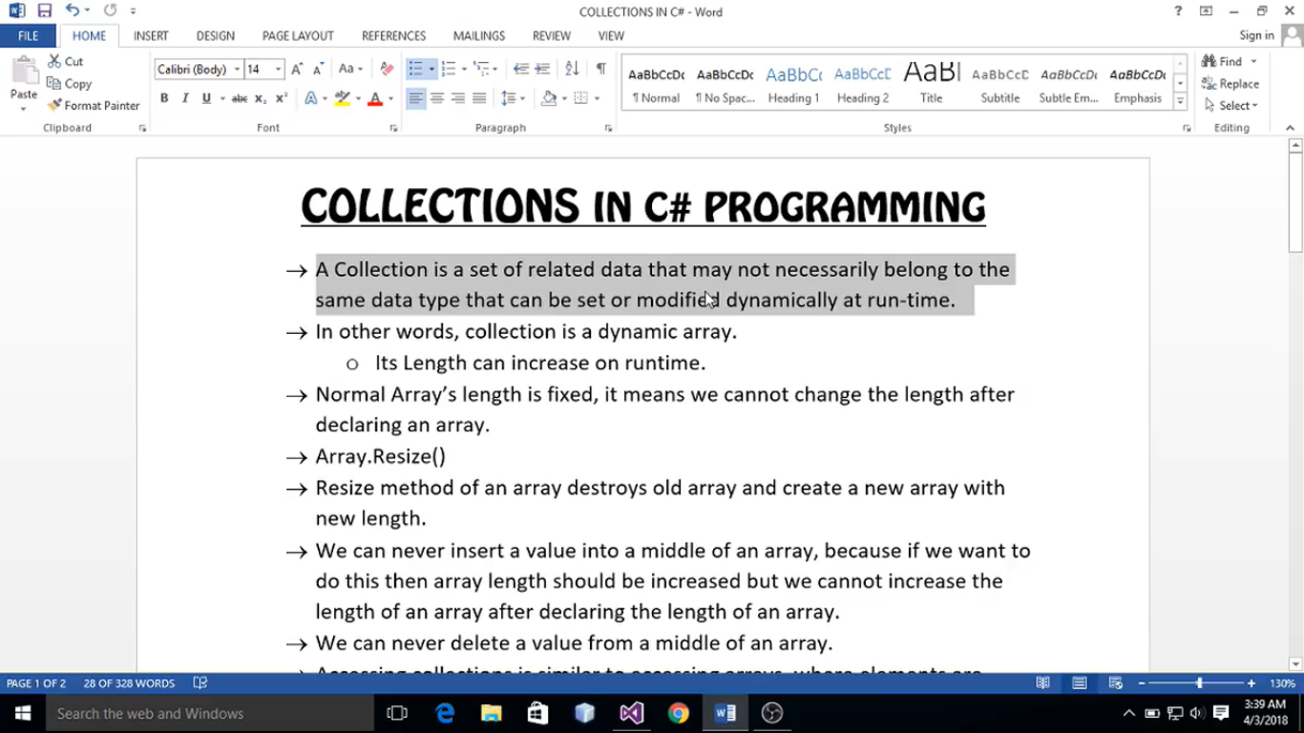

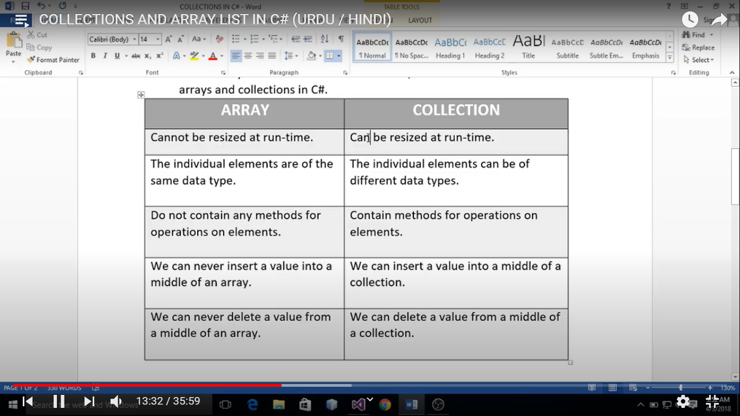

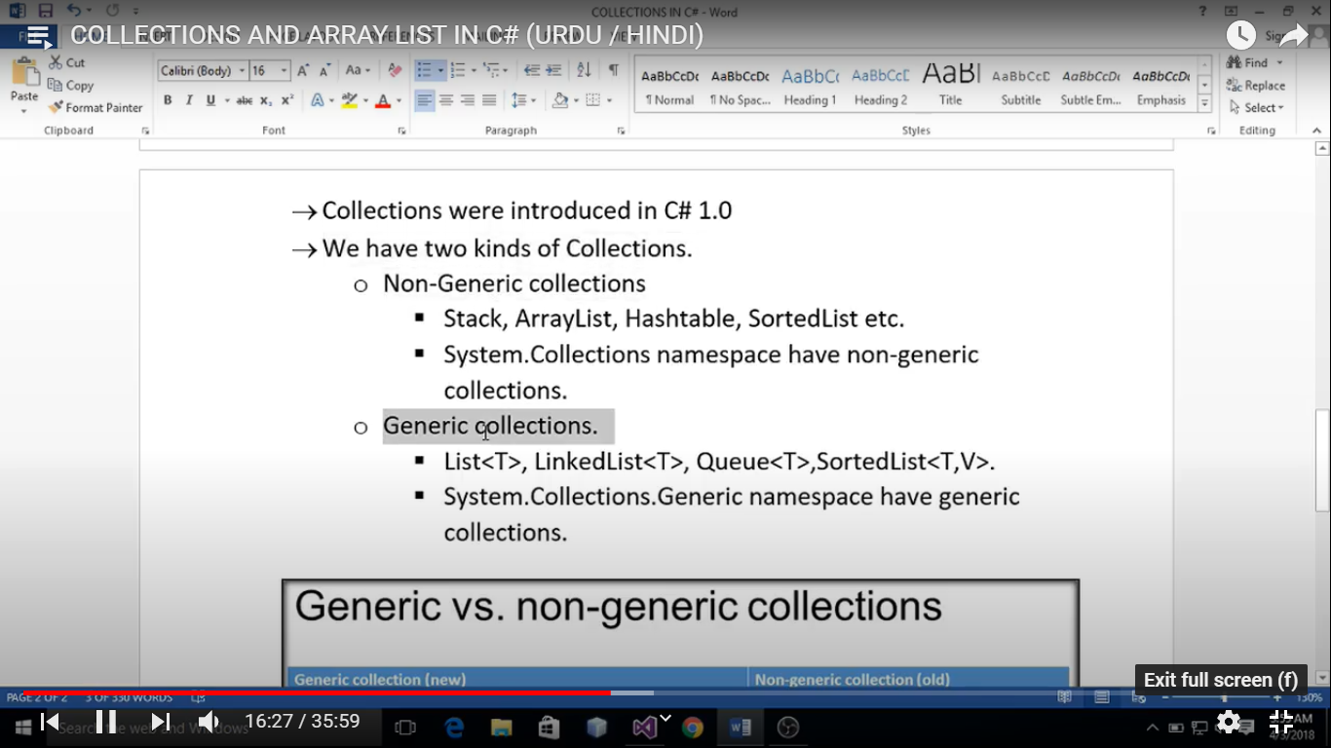

static void Main(string[] args)

{

int[] myArray = new int[3];

Array.Resize(ref myArray, 4);

myArray[0] = 10;

myArray[1] = 20;

myArray[2] = 30;

myArray[3] = 40;

for (int i = 0; i <myArray.Length; i++)

{

Console.WriteLine(myArray[i]);

}

}

}

ArrayList myList = new ArrayList();

myList.Add(10);

myList.Add("Pradeep");

myList.Add(10.88);

myList.Add(true);

myList.Add(88.727f);

Console.WriteLine(myList.Capacity); //8

foreach(object obj in myList)

{

Console.WriteLine(obj);

}

class Program

{

static void Main(string[] args)

{

int[] myArray = new int[3];

Array.Resize(ref myArray, 4);

myArray[0] = 10;

myArray[1] = 20;

myArray[2] = 30;

myArray[3] = 40;

for (int i = 0; i <myArray.Length; i++)

{

Console.WriteLine(myArray[i]);

}

}

}

ArrayList myList = new ArrayList();

myList.Add(10);

myList.Add("Pradeep");

myList.Add(10.88);

myList.Add(true);

myList.Add(88.727f);

Console.WriteLine(myList.Capacity); //8

foreach(object obj in myList)

{

Console.Write(obj +" ");

}

Console.WriteLine();

myList.Insert(2,25);

foreach (object obj in myList)

{

Console.Write(obj + " ");

}

myList.Remove(25);

myList.RemoveAt(2);

}

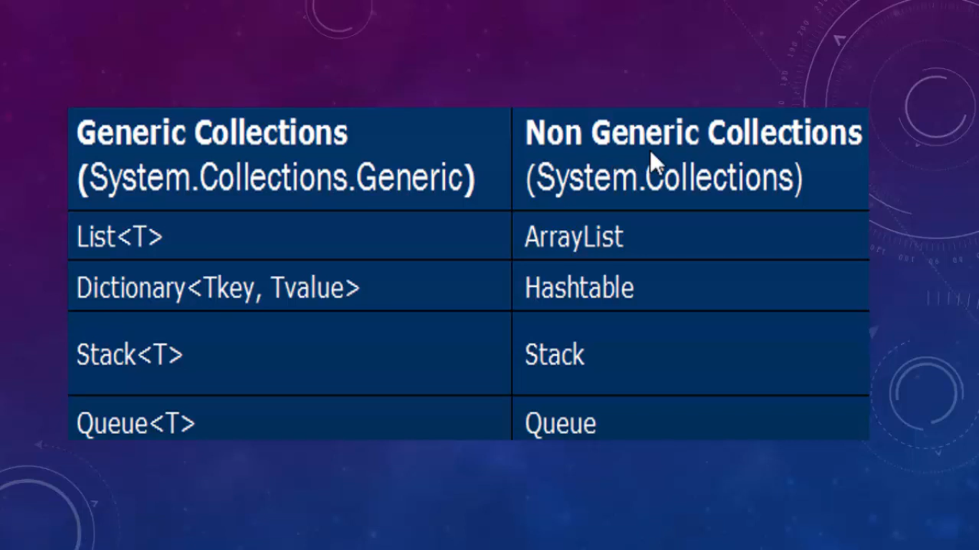

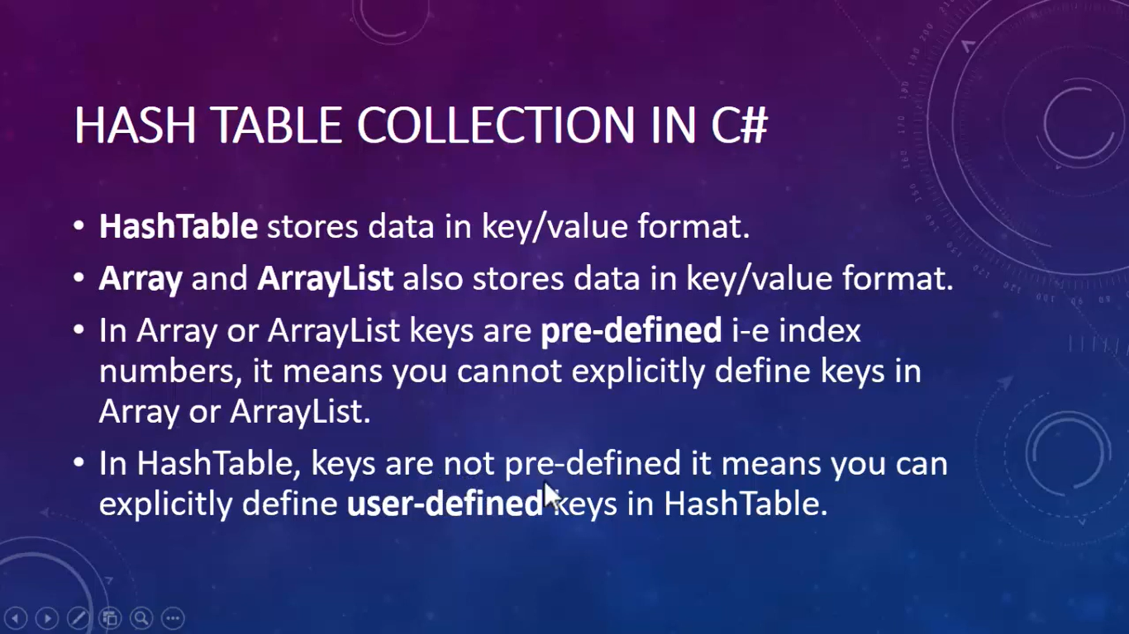

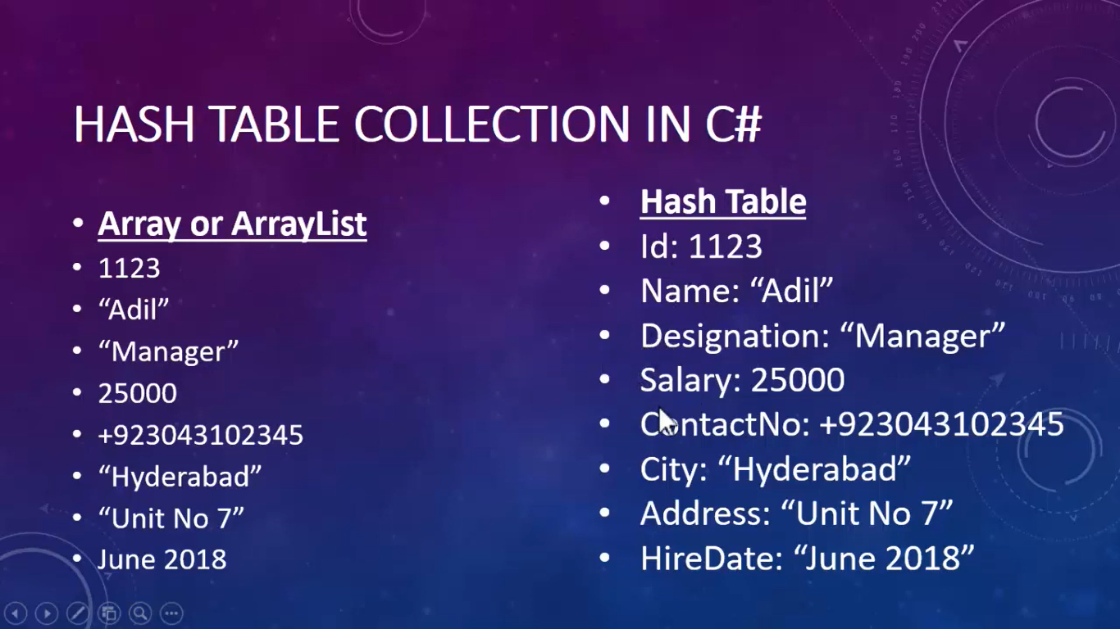

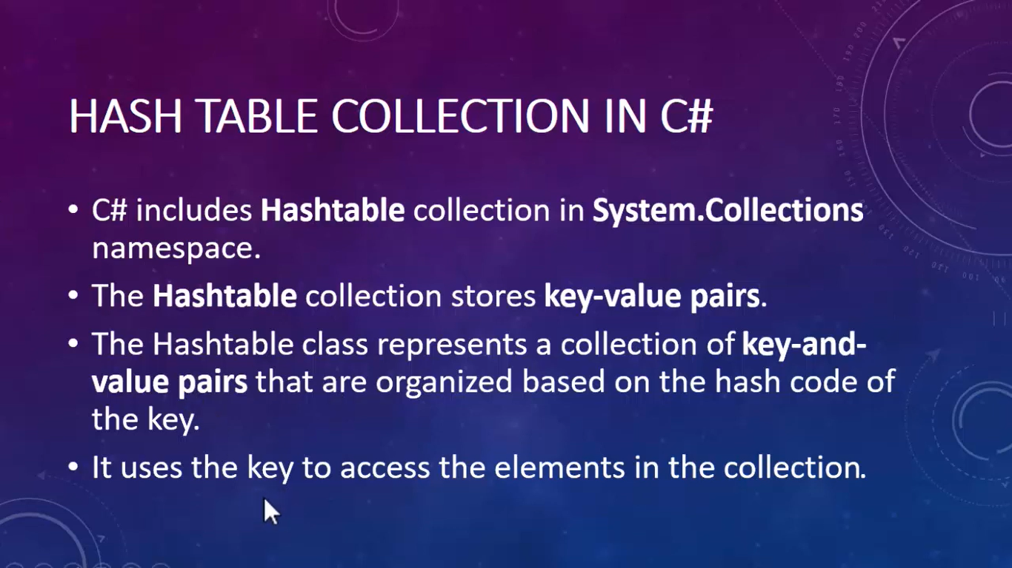



namespace HashTable

{

class Program

{

static void Main(string[] args)

{

Hashtable ht = new Hashtable();

ht.Add("ID", 1453);

ht.Add("Name", "Pradeep");

ht.Add("Salary", 25000);

ht.Add("Designation", "ERP Developer");

ht.Add("IsMarried", false);

Console.WriteLine(ht["ID"]);

Hashtable ht2 = new Hashtable()

{

{ "ID", 1453 },

{ "Name", "Pradeep"},

{ "Salary", 250000 },

{ "Designation", "ERP Developer" },

{ "IsMarried", false }

};

Console.WriteLine(ht2["Salary"]);

}

}

}

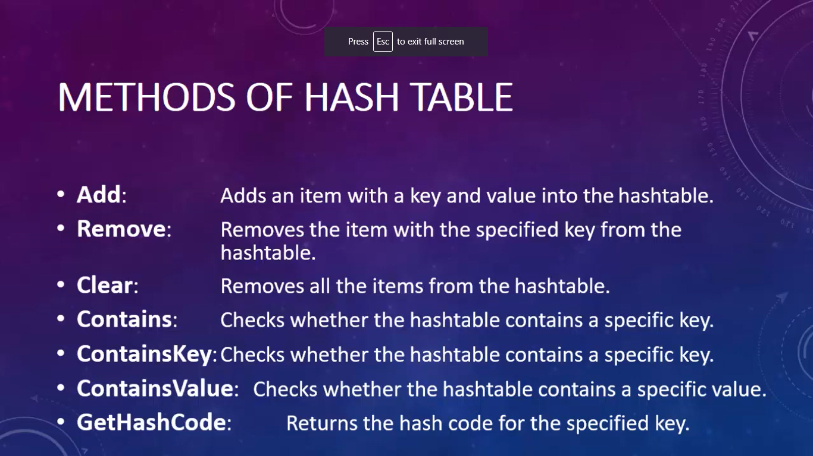

namespace HashTable

{

class Program

{

static void Main(string[] args)

{

Hashtable ht = new Hashtable();

ht.Add("ID", 1453);

ht.Add("Name", "Pradeep");

ht.Add("Salary", 25000);

ht.Add("Designation", "ERP Developer");

ht.Add("IsMarried", false);

// Console.WriteLine(ht["ID"]);

foreach (Object Key in ht.Keys )

{

Console.WriteLine(Key);

}

Console.WriteLine("----------------------");

foreach (Object Value in ht.Values)

{

Console.WriteLine(Value);

}

Console.WriteLine("----------------------");

foreach (Object key in ht.Keys)

{

Console.WriteLine(key +" "+ ht[key]);

}

Console.WriteLine("-------------------");

Console.WriteLine(ht.Contains("Name"));

Console.WriteLine(ht.ContainsKey("Name"));

Console.WriteLine(ht.ContainsValue("Pradeep"));

Console.WriteLine("-------------------");

ht.Remove("Salary");

foreach (Object key in ht.Keys)

{

Console.WriteLine(key + " " + ht[key]);

}

}

}

}

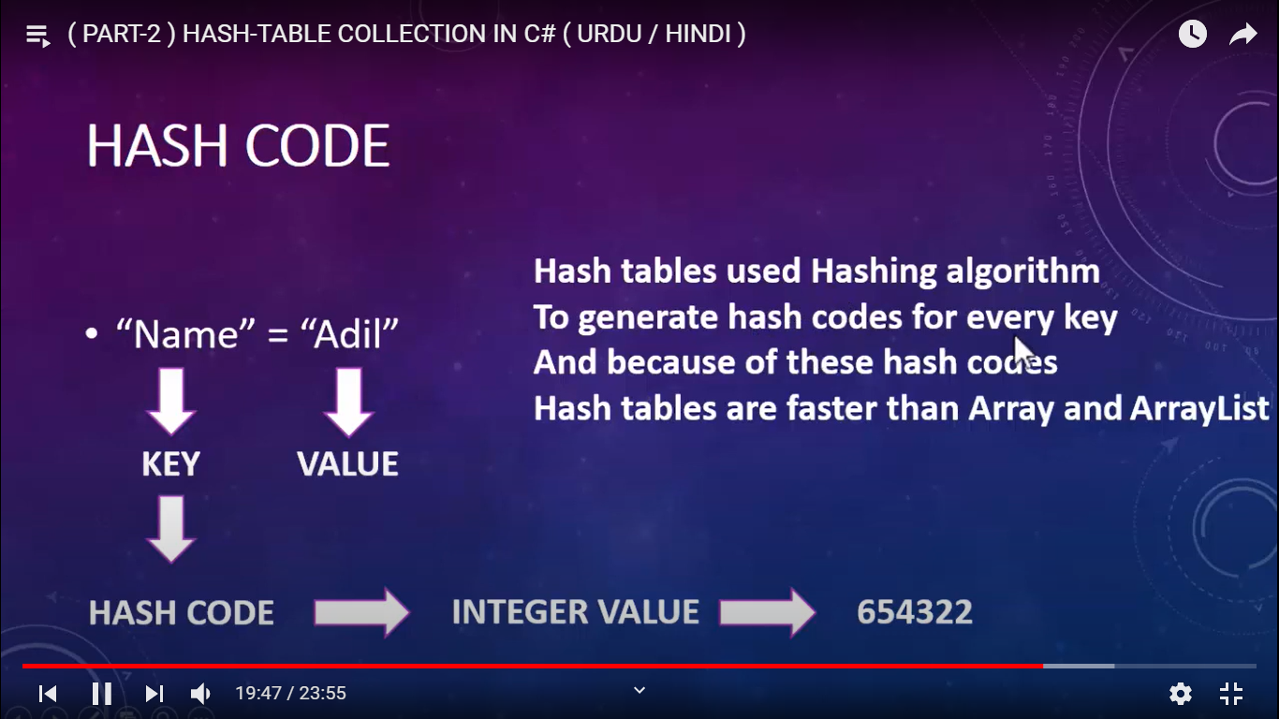

STACK

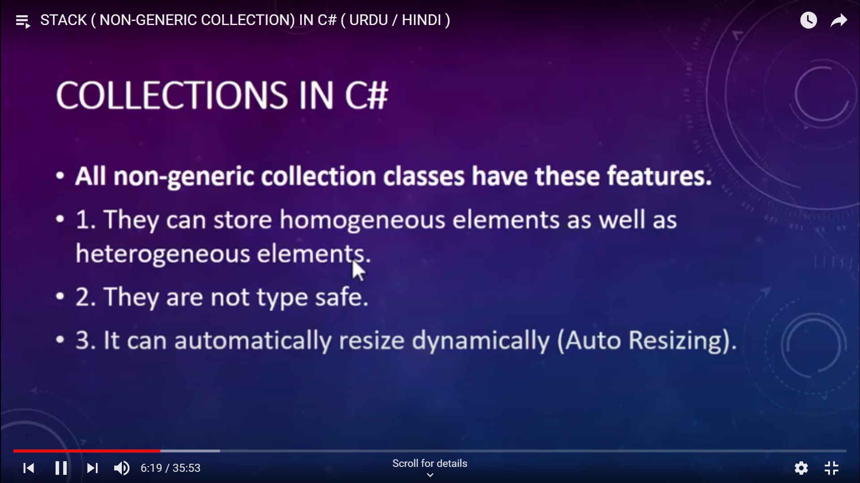

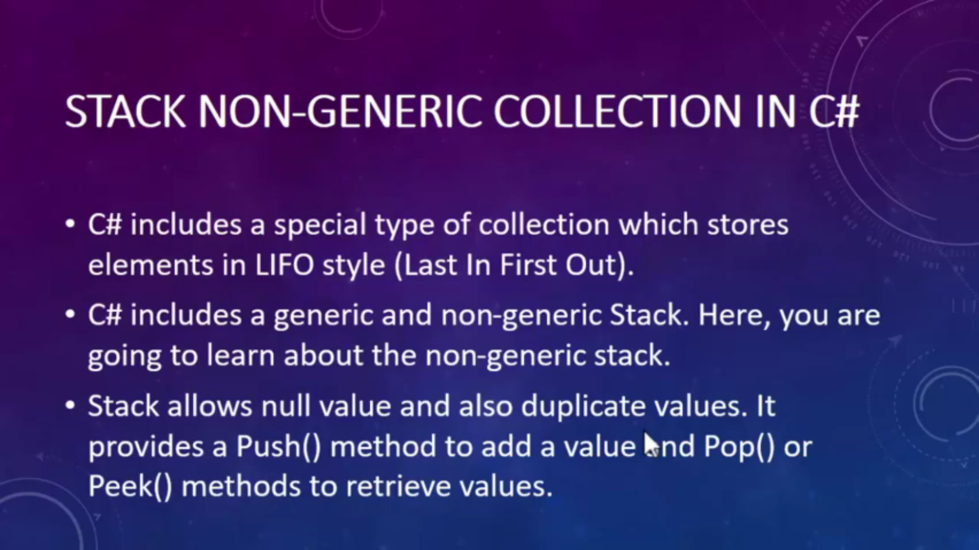

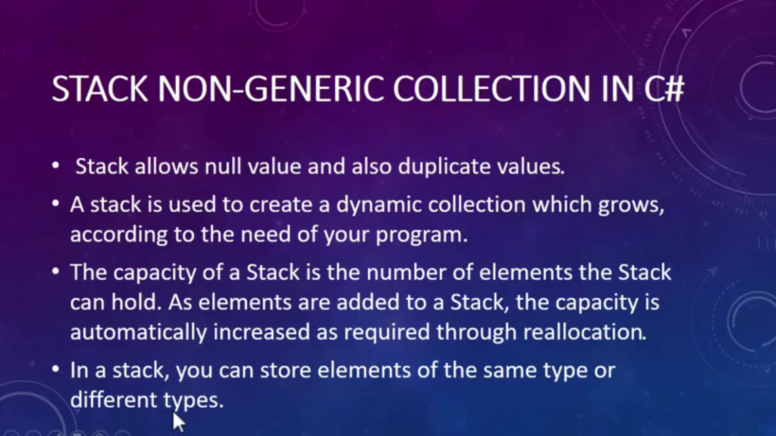

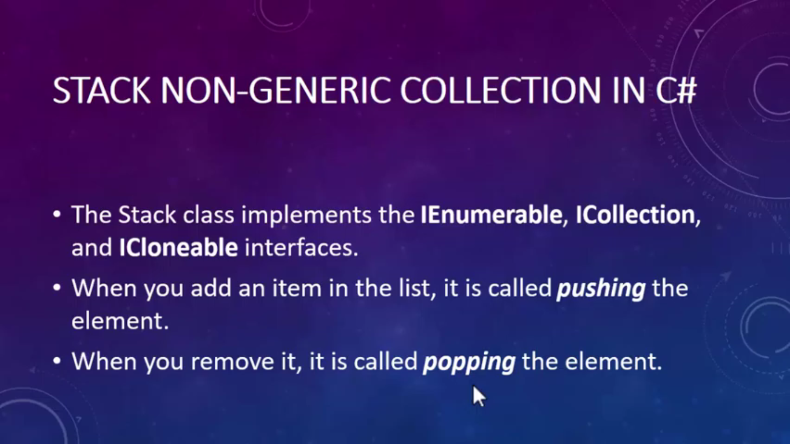

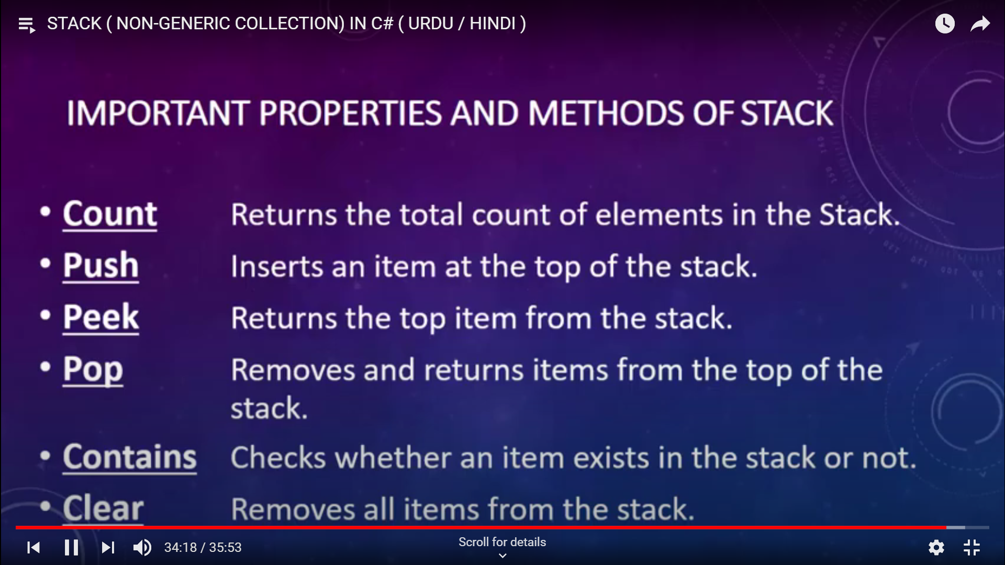

namespace NGStack

{

class Program

{

static void Main(string[] args)

{

Stack mystack = new Stack();

mystack.Push("Pradeep");

mystack.Push(24);

mystack.Push(5.11);

mystack.Push(false);

foreach (Object item in mystack)

{

Console.WriteLine(item);

}

}

}

}

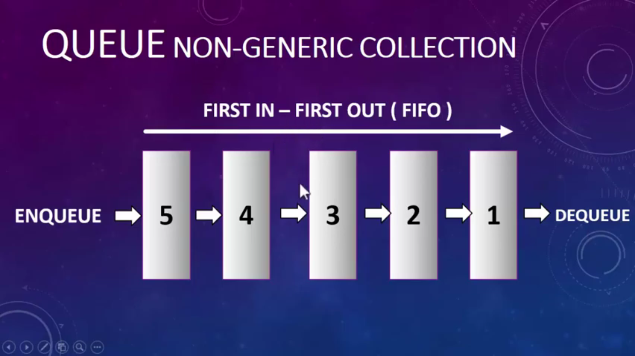

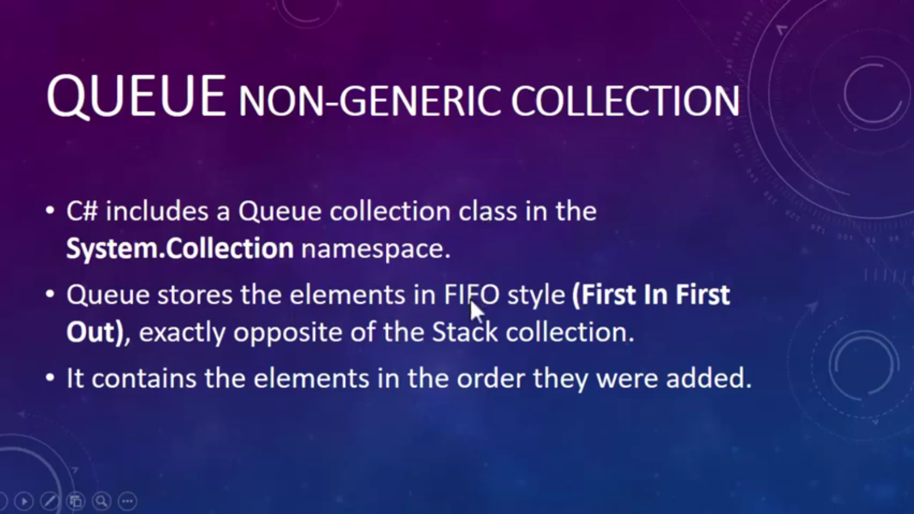

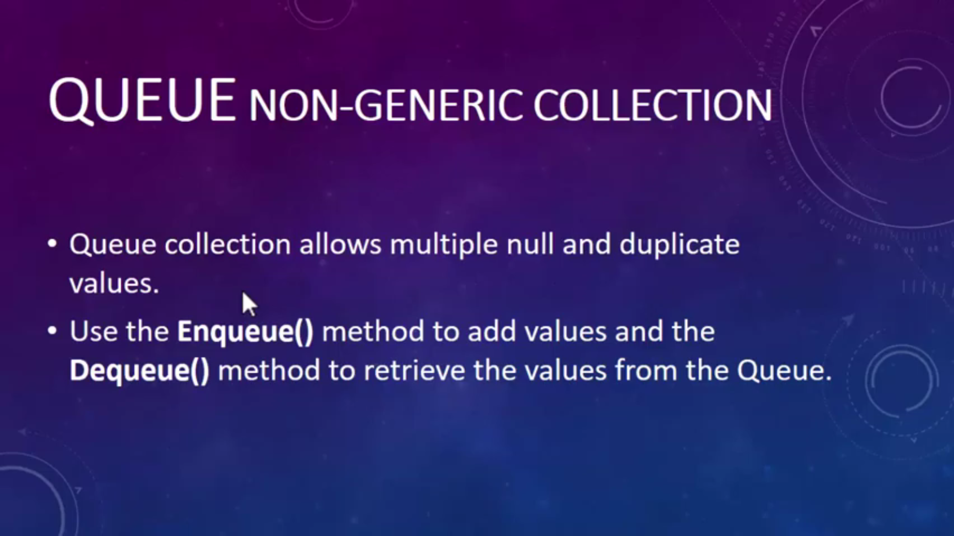

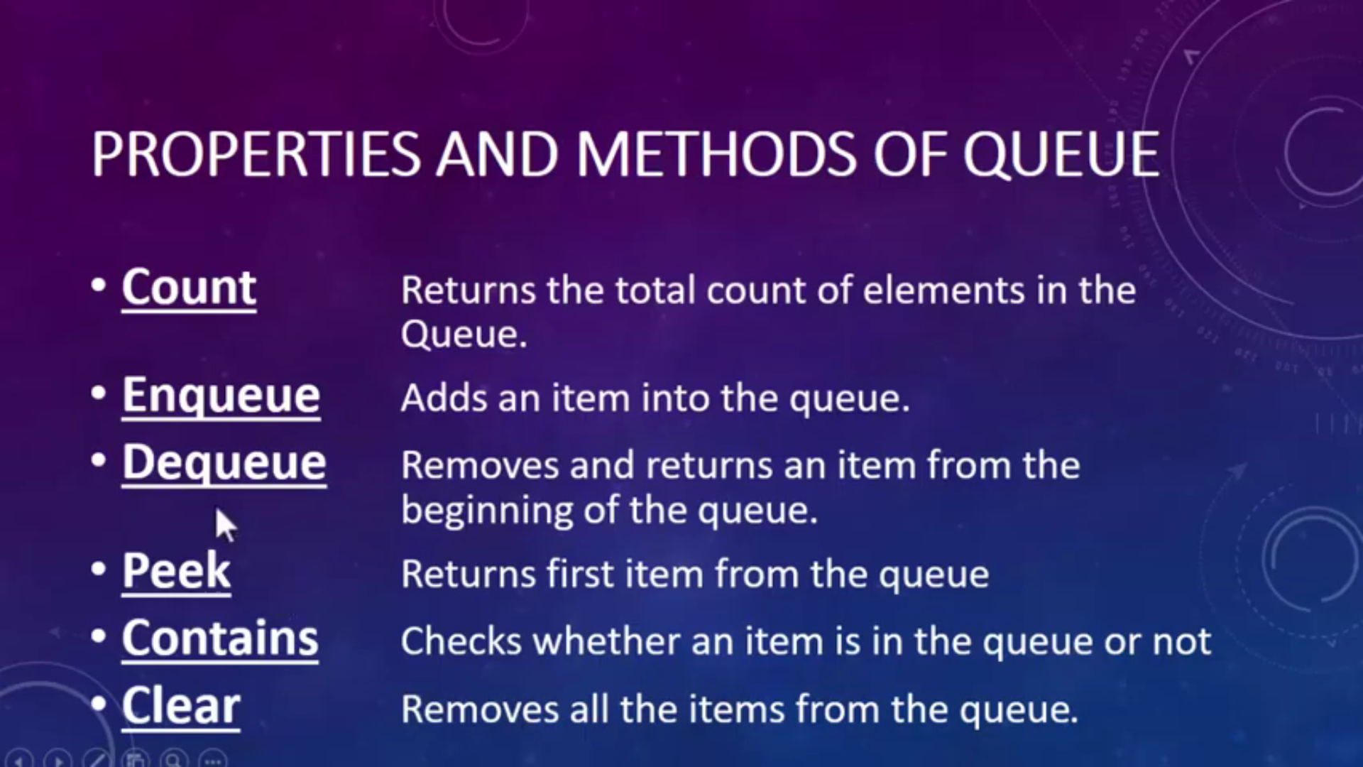

namespace NGQueue

{

class Program

{

static void Main(string[] args)

{

Queue myqueue = new Queue();

myqueue.Enqueue("Pradeep");

myqueue.Enqueue('A');

myqueue.Enqueue(99);

myqueue.Enqueue(98.66);

myqueue.Enqueue(true);

foreach (Object item in myqueue)

{

Console.WriteLine(item);

}

}

}

}

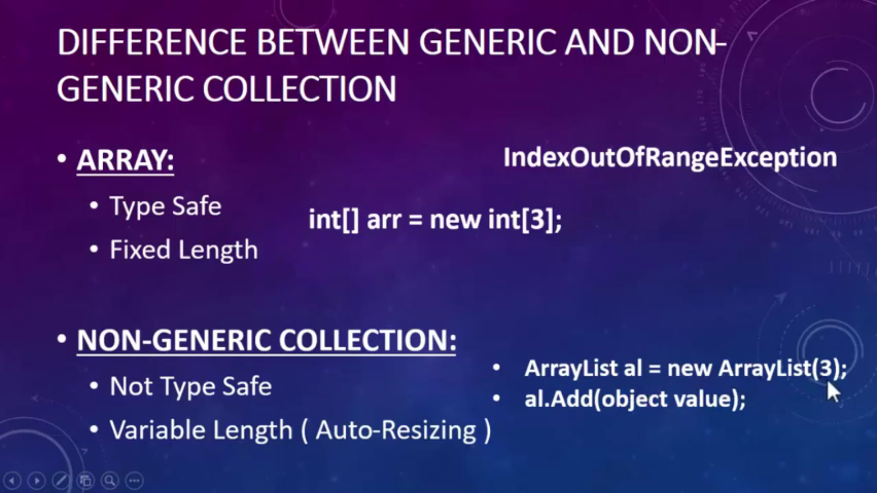

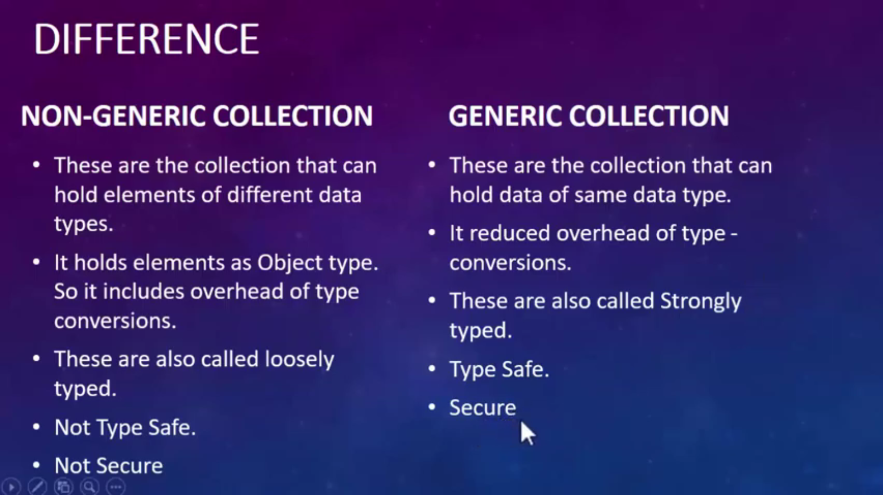

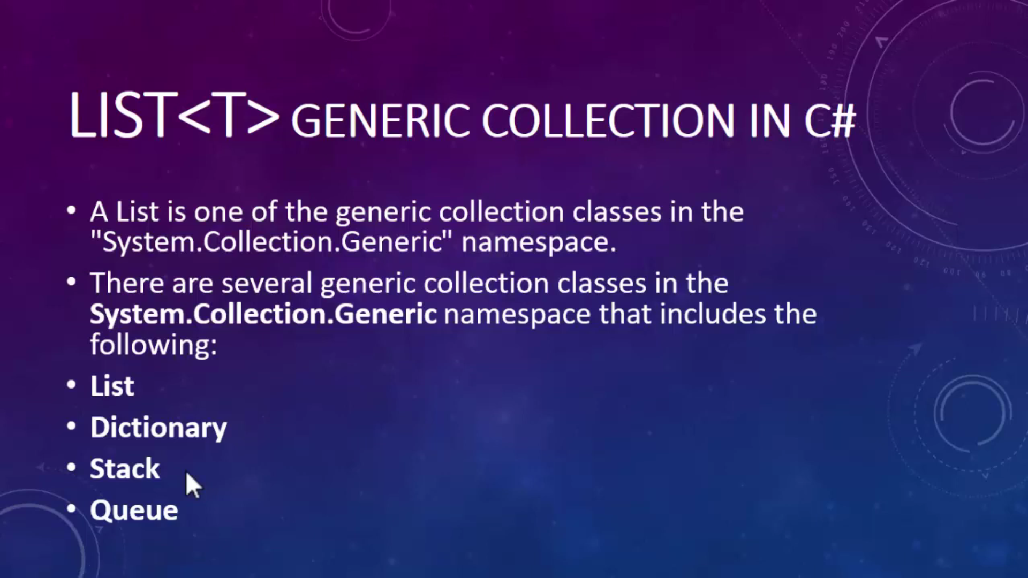

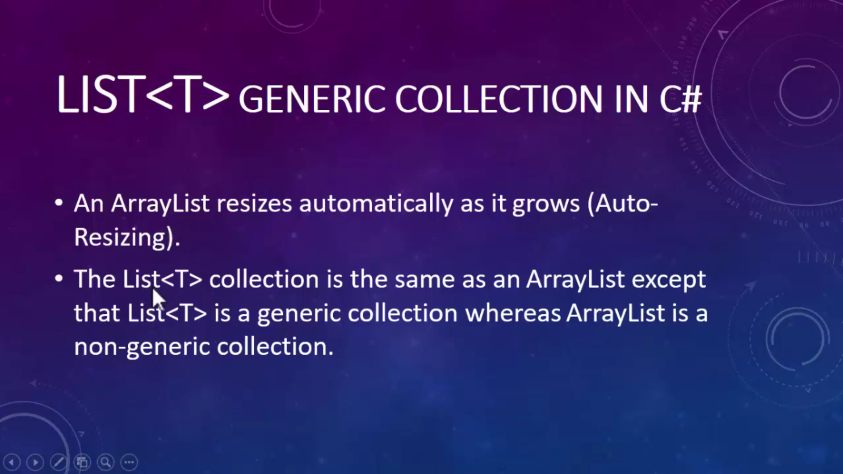

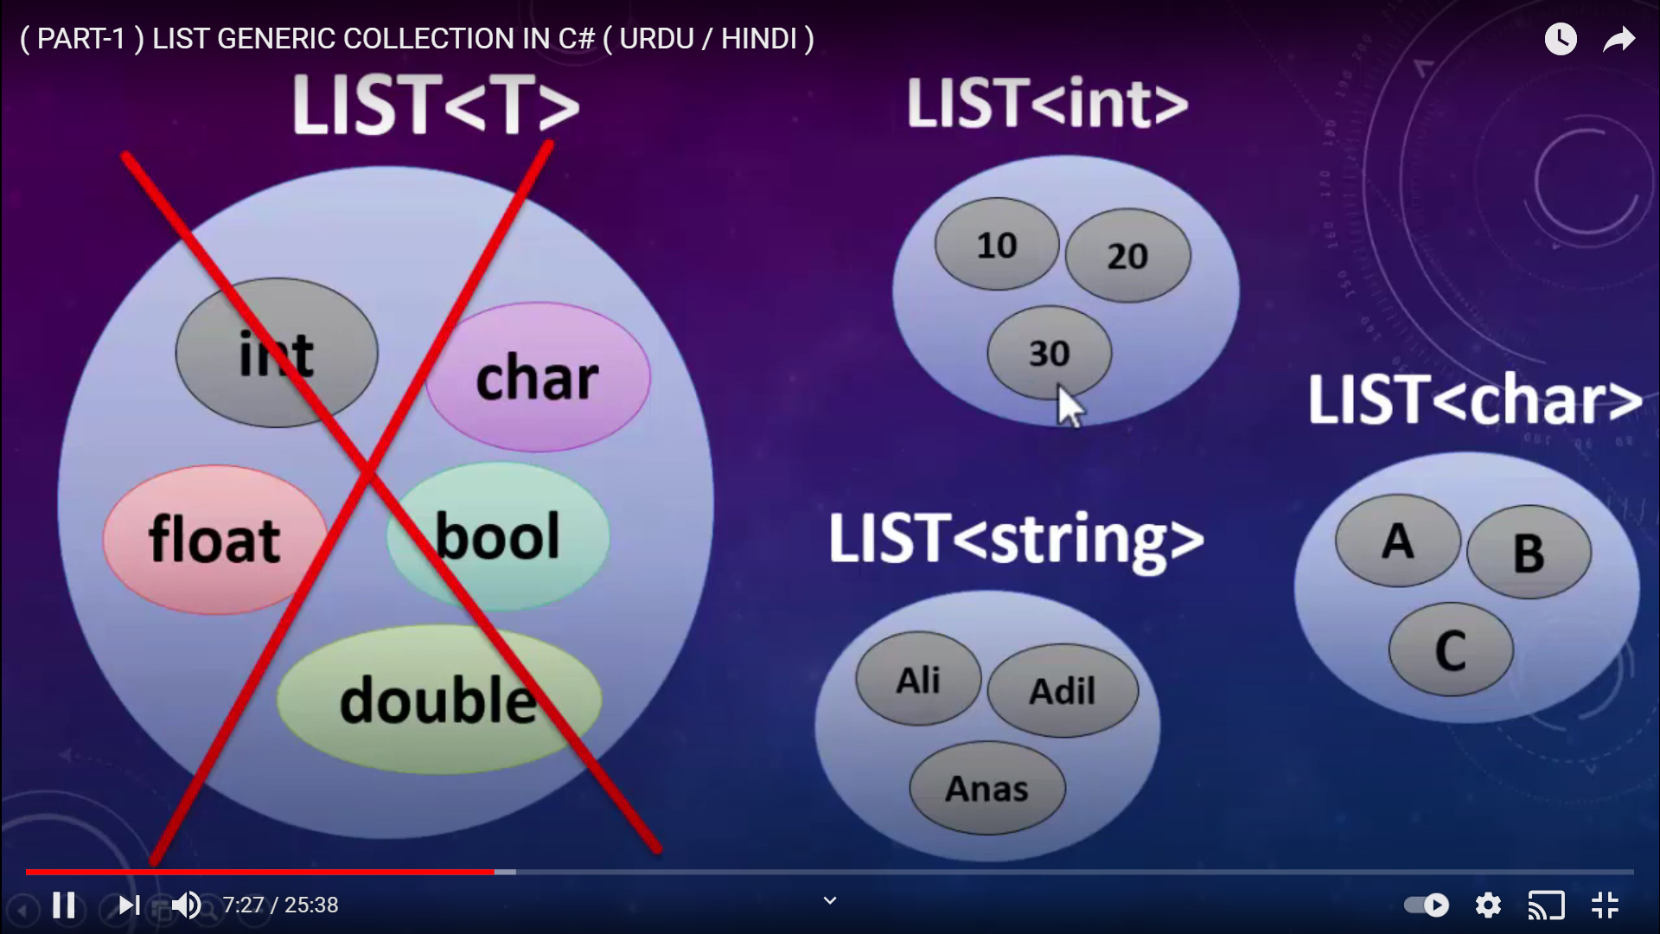

List<int> myNumbers = new List<int>();

myNumbers.Add(11);

myNumbers.Add(12);

myNumbers.Add(13);

myNumbers.Add(14);

myNumbers.Add(15);

Console.WriteLine(myNumbers.Capacity);

Console.WriteLine("----------------");

foreach (int item in myNumbers)

{

Console.WriteLine(item);

}

Console.WriteLine("----------------");

List<string> myString = new List<string>();

myString.Add("Pradeep");

myString.Add("Anuj");

myString.Add("raj");

myString.Add("sharif");

myString.Add("anmol");

foreach (string item in myString)

{

Console.WriteLine(item);

}

Employee emp1 = new Employee()

{ name="Pradeep",

age=24,

designation="developer"

};

Employee emp2 = new Employee()

{

name = "Anuj",

age = 28,

designation = " senior developer"

};

Employee emp3 = new Employee()

{

name = "Raj",

age = 30,

designation = "CEO"

};

List<Employee> empList = new List<Employee>();

empList.Add(emp1);

empList.Add(emp2);

empList.Add(emp3);

foreach ( Employee emp in empList)

{

Console.WriteLine("Emplee Name is {0} , Employee Age is {1} , Employee Designation is {2}",emp.name,emp.age,emp.designation);

}

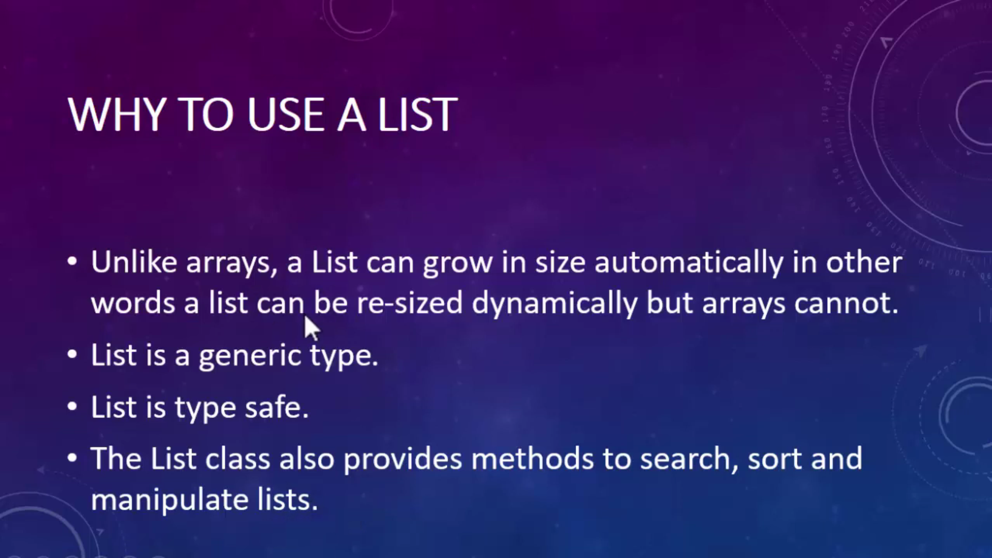

List<string> myName = new List<string>();

myName.Add("Pradeep");

myName.Add("Arjun");

myName.Add("Ram");

myName.Add("Alok");

myName.Add("");

myName.Add("Pradeep");

myName.Add(null);

foreach (string item in myName)

{

Console.WriteLine(item);

}

Console.WriteLine("--------------Add,AddRange,Insert , InsertRange,-----");

List<int> myNumbers = new List<int>();

myNumbers.Add(21);

myNumbers.Add(11);

myNumbers.Add(88);

myNumbers.Add(9);

myNumbers.Add(78);

myNumbers.Add(99);

foreach (int item in myNumbers)

{

Console.WriteLine(item);

}

myNumbers.Sort();

Console.WriteLine("List After Sort---------");

foreach (int item in myNumbers)

{

Console.WriteLine(item);

}

Console.WriteLine("List AddRange---------");

myNumbers.AddRange(myNumbers);

foreach (int item in myNumbers)

{

Console.WriteLine(item);

}

Console.WriteLine("Insert--------------");

myNumbers.Insert(2, 8);

foreach (int item in myNumbers)

{

Console.WriteLine(item);

}

Console.WriteLine("Insert Range---------------");

myNumbers.InsertRange(1, myNumbers);

foreach (int item in myNumbers)

{

Console.WriteLine(item);

}

List<Employee> empList = new List<Employee>();

Employee emp1 = new Employee()

{

Name = "Pradeep",

Age = 26,

Designation = "CTO"

};

Employee emp2 = new Employee()

{

Name = "Raj",

Age = 29,

Designation = "Product Manager"

};

Employee emp3 = new Employee()

{

Name = "Anuj",

Age = 28,

Designation = "Senior developer"

};

empList.Add(emp1);

empList.Add(emp2);

empList.Add(emp3);

foreach (Employee emp in empList)

{

Console.WriteLine("Employee Name :{0} , age:{1},Designation:{2}", emp.Name, emp.Age, emp.Designation);

}

Console.WriteLine(empList.Exists(emp=>emp.Name.StartsWith('A')));

Console.WriteLine("-----------------ToArray");

Employee[] emparr = empList.ToArray();

foreach(Employee emp in emparr)

{

Console.WriteLine("Employee Name :{0} , age:{1},Designation:{2}", emp.Name, emp.Age, emp.Designation);

}

Console.WriteLine("------------------------ToList");

List<Employee> emplist1 = emparr.ToList();

foreach (Employee emp in emplist1)

{

Console.WriteLine("Employee Name :{0} , age:{1},Designation:{2}", emp.Name, emp.Age, emp.Designation);

}

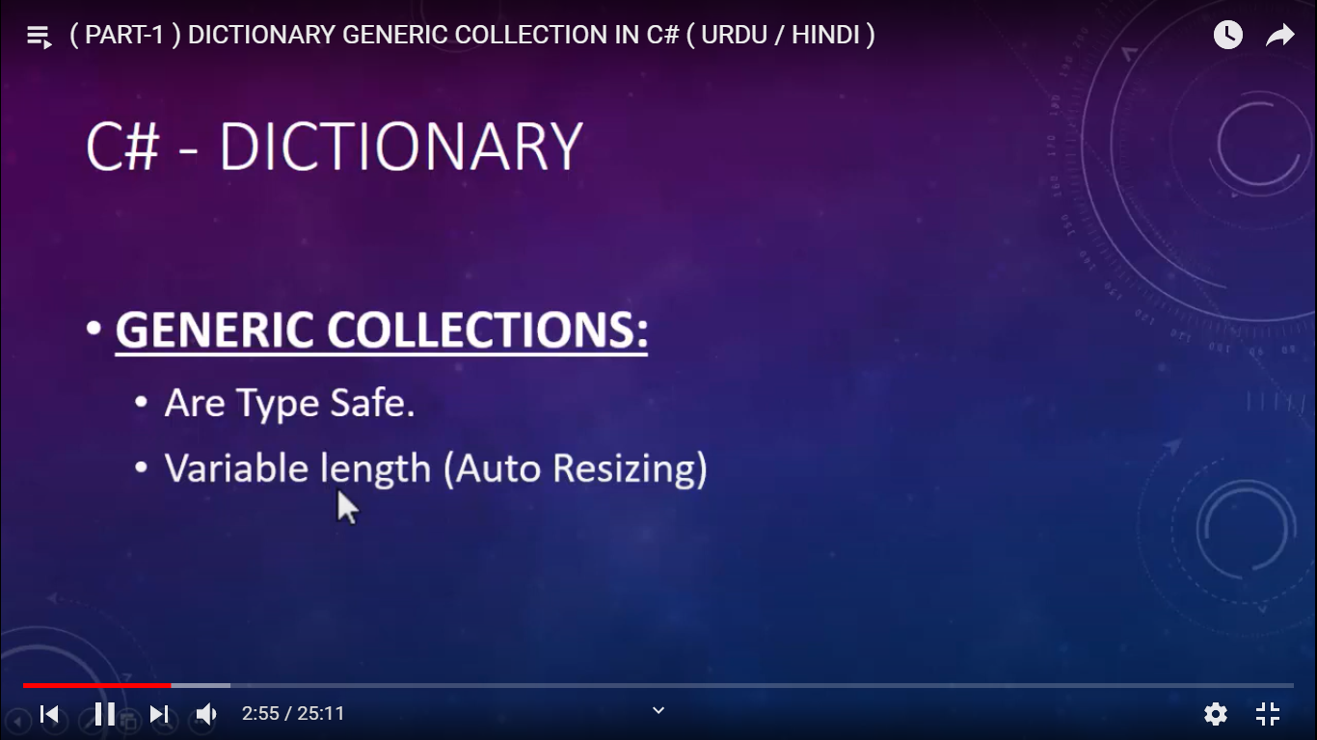

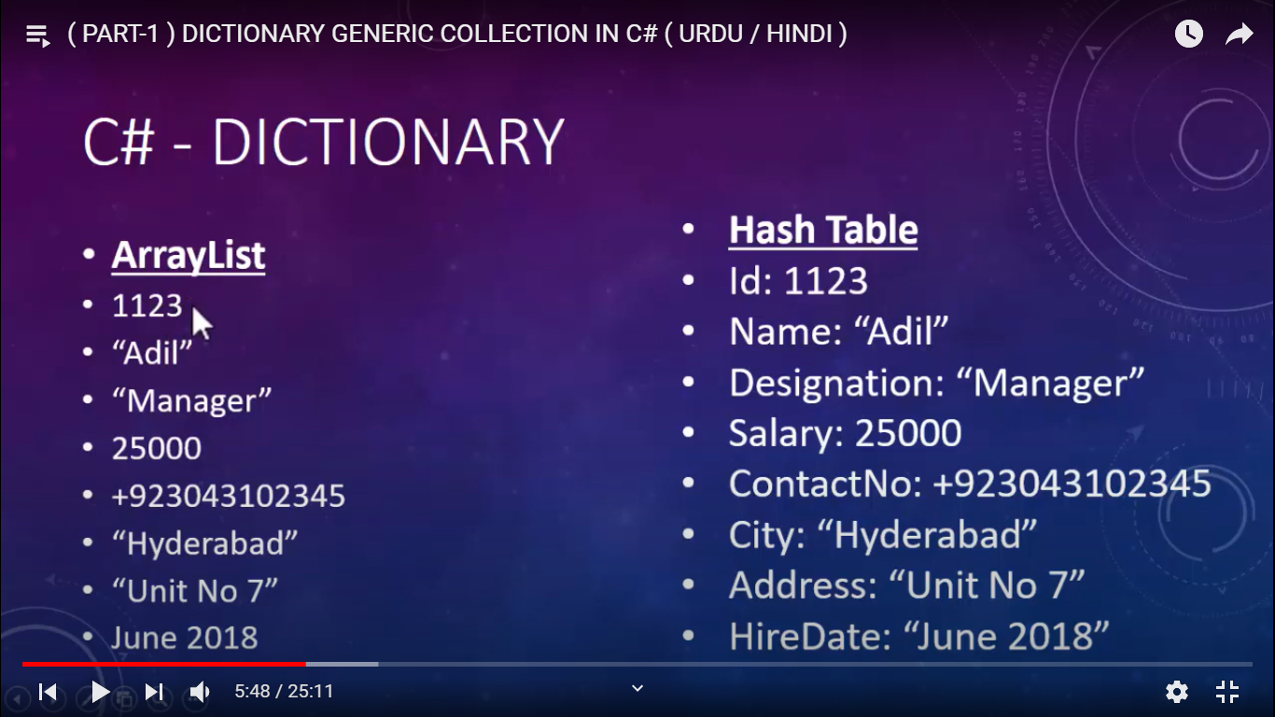

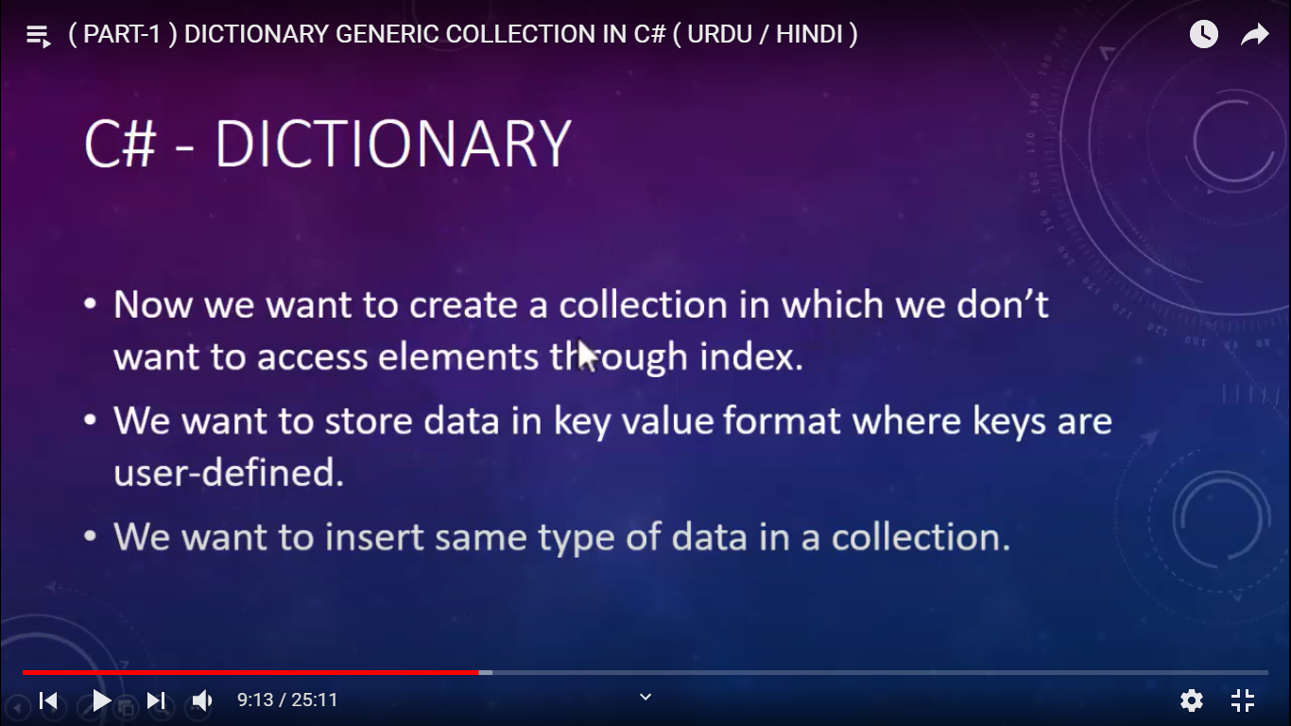

static void Main(string[] args)

{

Dictionary<string, string> myDict = new Dictionary<string, string>();

myDict.Add("active", "ready to engage in physically activity");

myDict.Add("amazing", "causing great surprise");

myDict.Add("honest", "free of deceit, truthful");

myDict.Add("patriotic", "expressing devotion");

myDict.Add("quarintine", "place of isolation");

Console.WriteLine(myDict["active"]);

foreach (KeyValuePair<string,string> item in myDict)

{

Console.WriteLine( "Key is :"+item.Key+ " Value is :"+item.Value );

}

foreach (string key in myDict.Keys)

{

Console.WriteLine( key);

}

foreach (string value in myDict.Values)

{

Console.WriteLine(value);

}

}

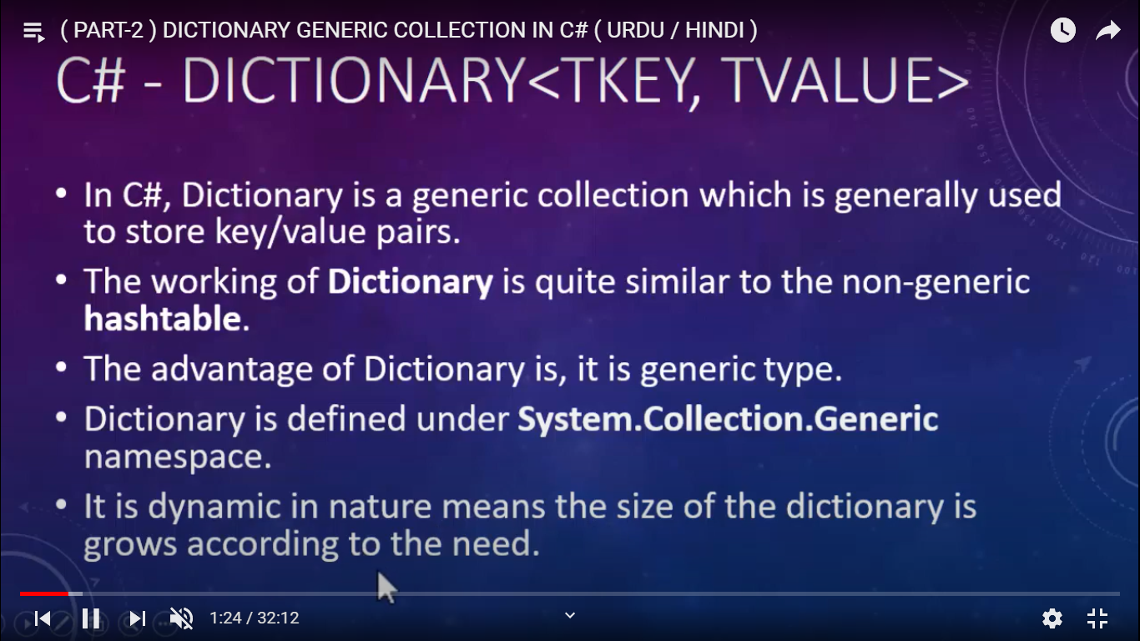

Employee emp1 = new Employee()

{ id=101,

name = "Pradeep",

designation = "CTO",

salary = 8928822

};

Employee emp2= new Employee()

{ id=102,

name = "sanjay",

designation = "dev",

salary = 982662

};

Employee emp3 = new Employee()

{ id=103,

name = "raj",

designation = "senior dev",

salary = 425522

};

Employee emp4 = new Employee()

{ id=104,

name = "Akriti",

designation = "Manager",

salary = 62772772

};

Dictionary<int, Employee> myEmployees = new Dictionary<int, Employee>();

myEmployees.Add(emp1.id, emp1);

myEmployees.Add(emp2.id, emp2);

myEmployees.Add(emp3.id, emp3);

myEmployees.Add(emp4.id, emp4);

Console.WriteLine("Count--------");

// Console.WriteLine( myEmployees.Count(emp=>emp.Value.name.StartsWith("P")) );

foreach (var item in myEmployees)

{

Console.WriteLine("employeeID:{0},name:{1},designation:{2},salary{3}",item.Key,item.Value.name, item.Value.designation, item.Value.salary);

}

Dictionary<string, string> myDict = new Dictionary<string, string>();

myDict.Add("active", "ready to engage in physically activity");

myDict.Add("amazing", "causing great surprise");

myDict.Add("honest", "free of deceit, truthful");

myDict.Add("patriotic", "expressing devotion");

myDict.Add("quarintine", "place of isolation");

Console.WriteLine(myDict["active"]);

foreach (KeyValuePair<string, string> item in myDict)

{

Console.WriteLine("Key is :" + item.Key + " Value is :" + item.Value);

}

foreach (string key in myDict.Keys)

{

Console.WriteLine(key);

}

foreach (string value in myDict.Values)

{

Console.WriteLine(value);

}

string value1;

Console.WriteLine("Tryget Value---");

myDict.TryGetValue("honest", out value1);

Console.WriteLine(value1);

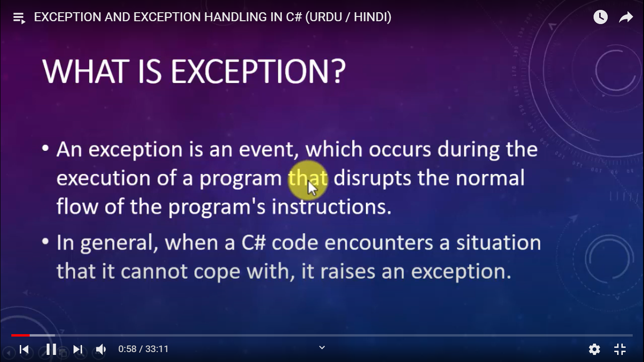

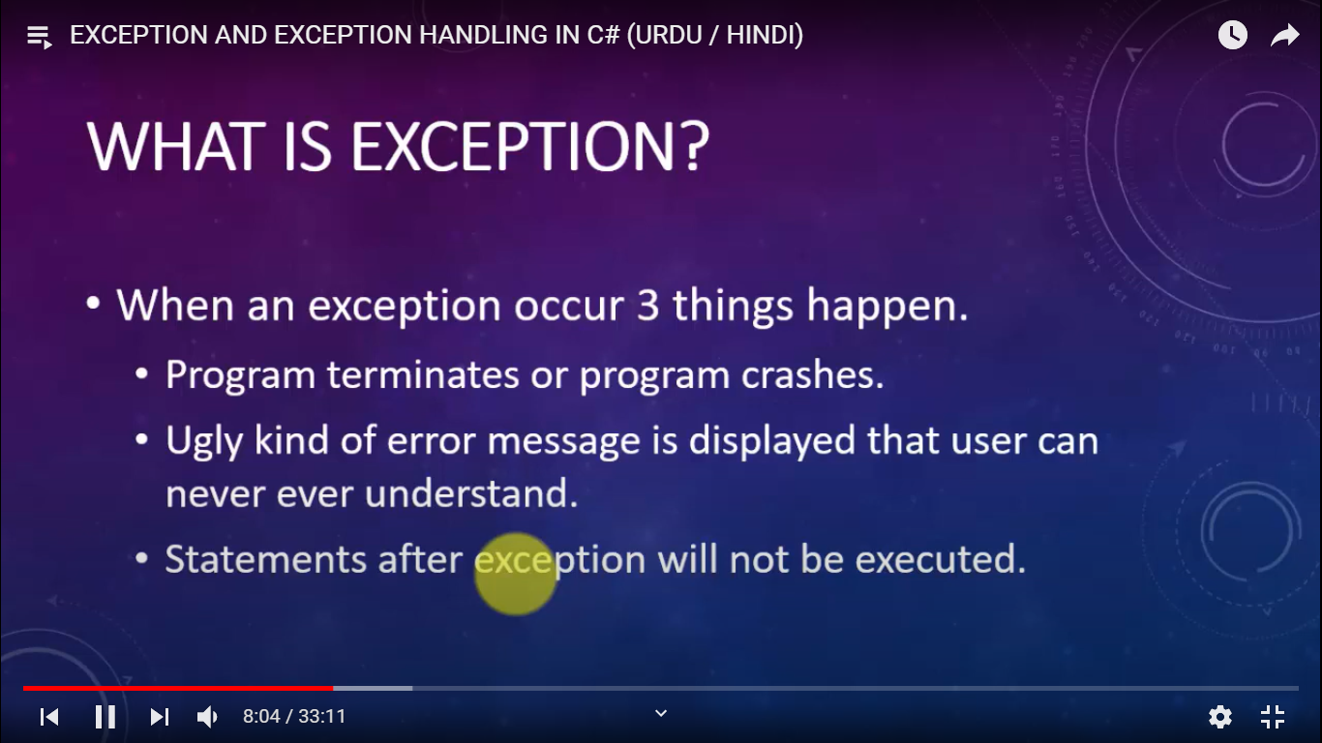

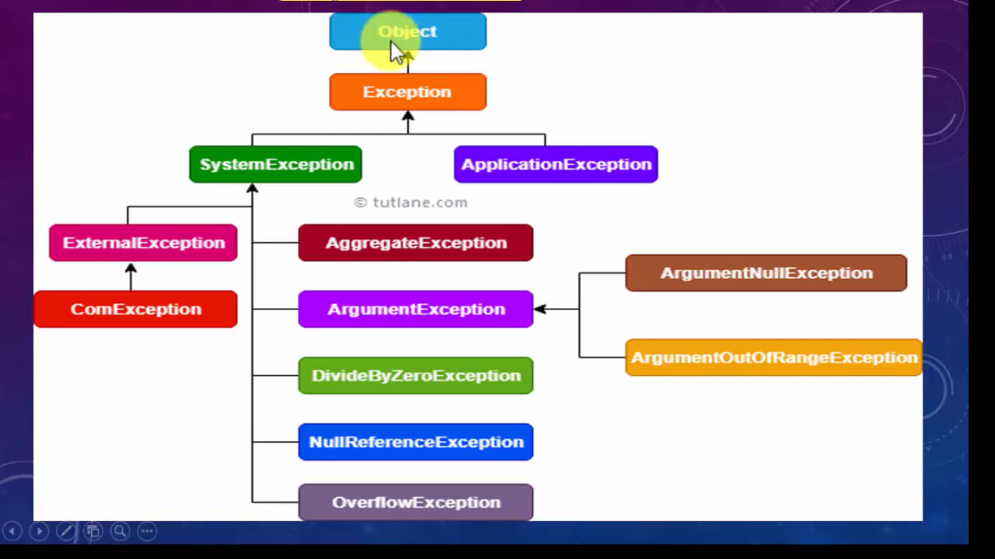 static void Main(string[] args)

{

Console.WriteLine("Enter First Number");

int num1 = int.Parse(Console.ReadLine());

Console.WriteLine("Enter Second Number");

int num2 = int.Parse(Console.ReadLine());

try

{

int result = num1 / num2;

Console.WriteLine("Division Result is :" + result);

}

catch (DivideByZeroException ex)

{

Console.WriteLine("You cannot divide a numbetr by zero");

Console.WriteLine(ex.Message);

}

Console.WriteLine("Remaining Statement 1");

Console.WriteLine("Remaining Statement 2");

Console.WriteLine("Remaining Statement 3");

}

static void Main(string[] args)

{

try {

string name = null;

Console.WriteLine(name.Length);

}

catch (Exception ex) {

Console.WriteLine( ex.Message );

}

}

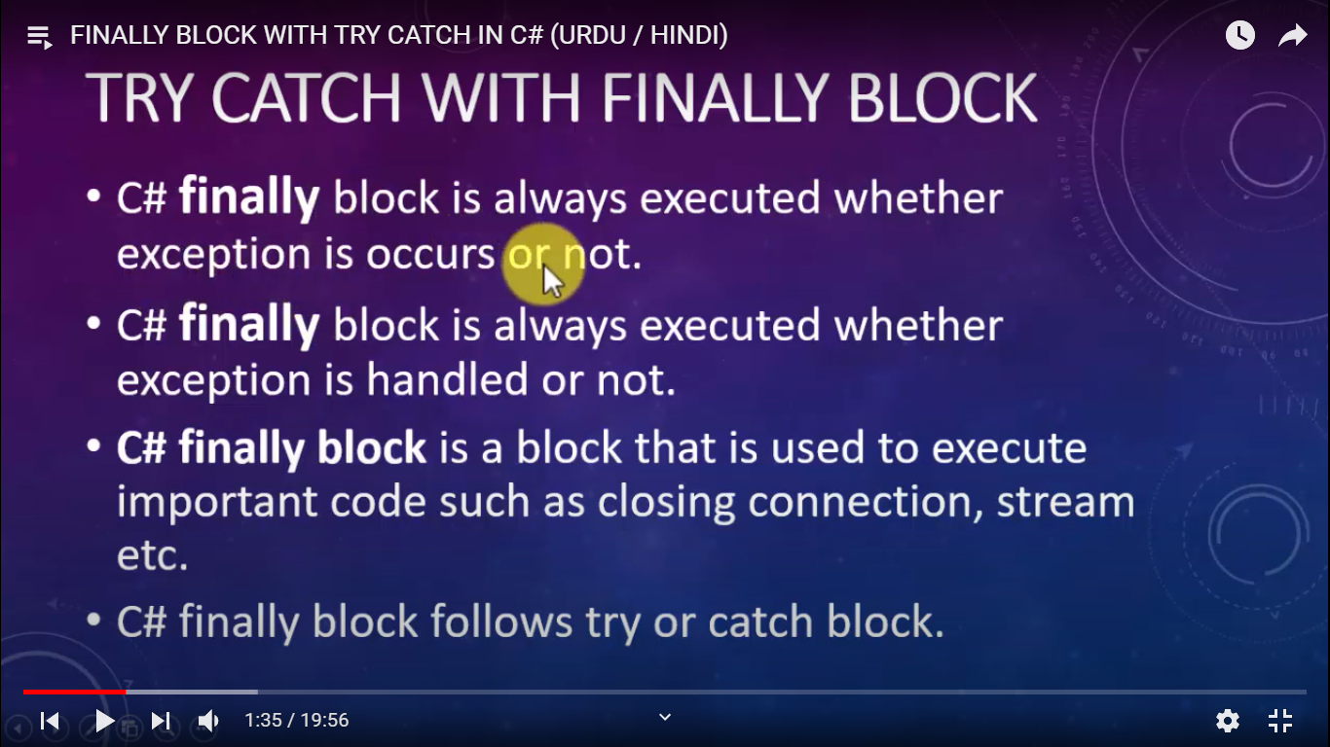

try {

int a = 10;

int b = 0;

int c = a / b;

}

catch(DivideByZeroException ex)

{

Console.WriteLine(ex.Message);

}

finally

{

Console.WriteLine("Finally Block is executed");

}

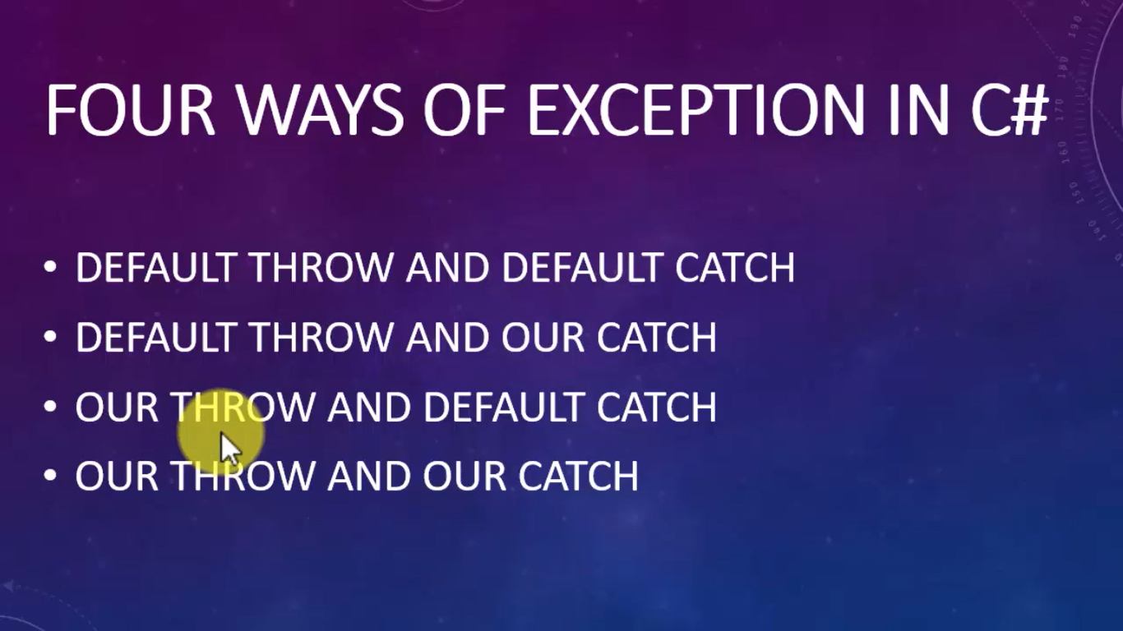

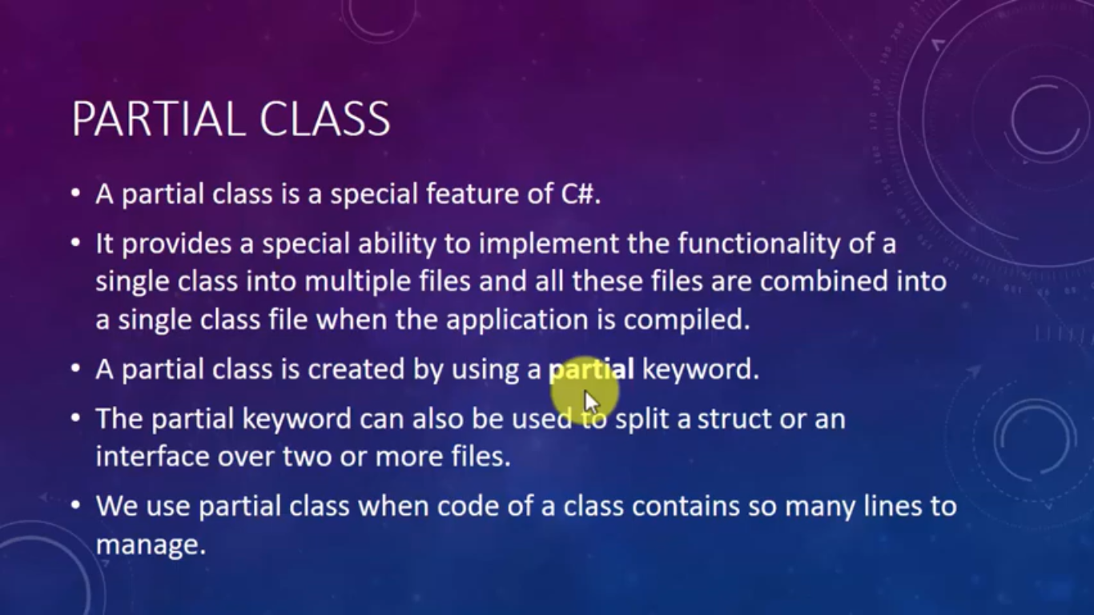

public partial class StudentPartial

{

private string _firstName;

private string _lastName;

public string FirstName

{

set

{

_firstName = value;

}

get

{

return _firstName;

}

}

public string LastName

{

get => _lastName;

set => _lastName = value;

}

}

public partial class StudentPartial

{

public string getFullName()

{

return _firstName + " " + _lastName;

}

}

}

class Program

{

static void Main(string[] args)

{

StudentPartial obj = new StudentPartial();

obj.FirstName = "Pradeep";

obj.LastName = "Kumar";

Console.WriteLine("Your Complete name is {0}",obj.getFullName());

}

}

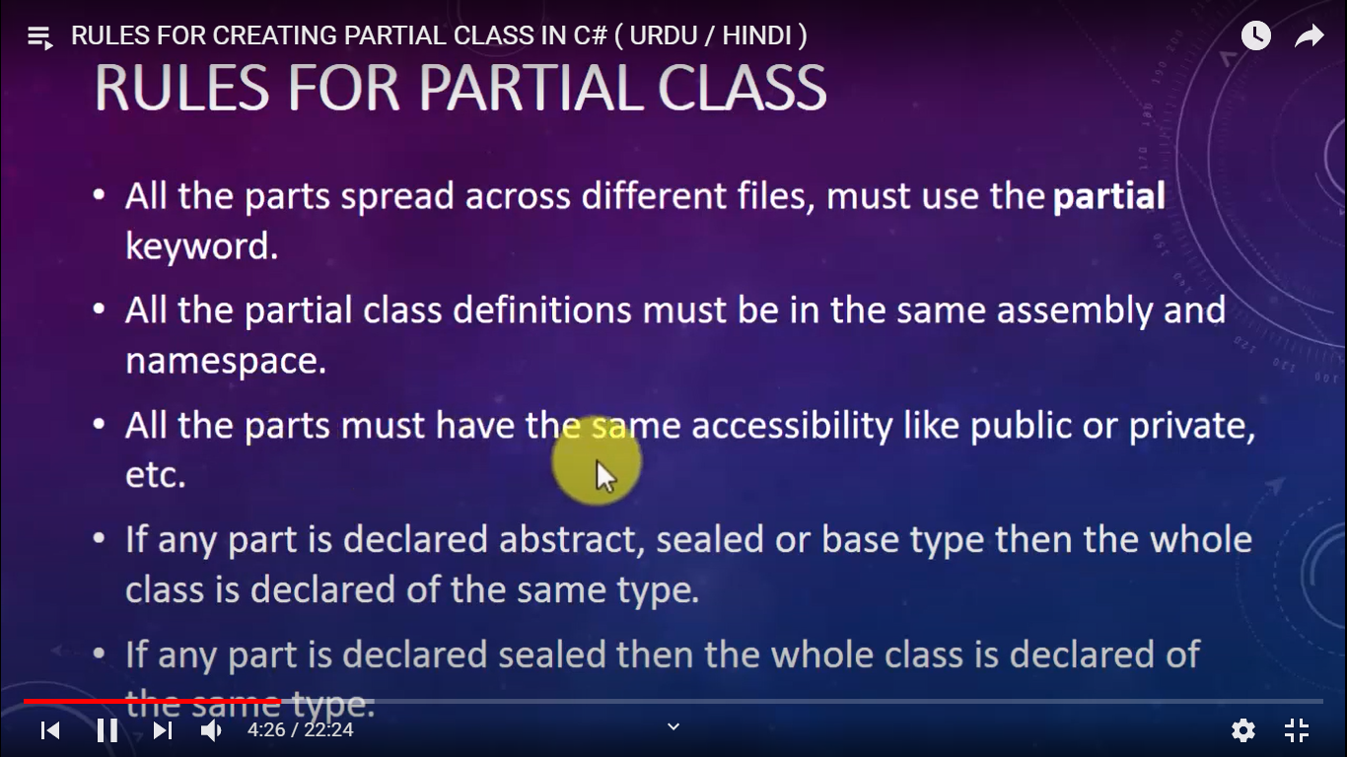

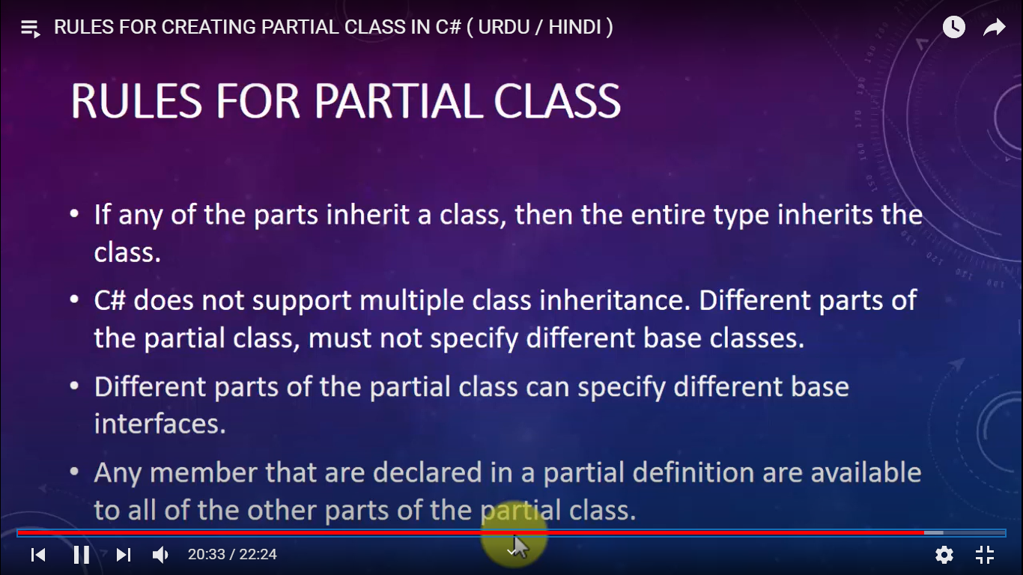

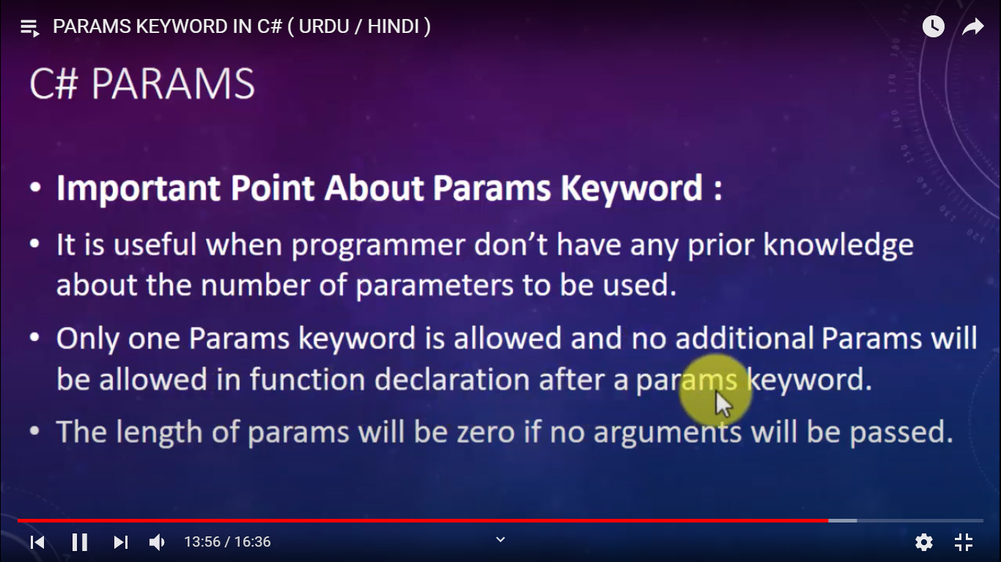

class Program

{

public static int add(int a, int b)

{

int sum = a + b;

return sum;

}

public static int addUsingParam(params int[] num)

{

int sum = 0;

foreach (int item in num)

{

sum += item;

}

return sum;

}

static void Main(string[] args)

{

// Console.WriteLine(Program.add(10, 20)) ;

Console.WriteLine( Program.addUsingParam(10,20,30,40,50));

}

}

**String VS StringBuilder**

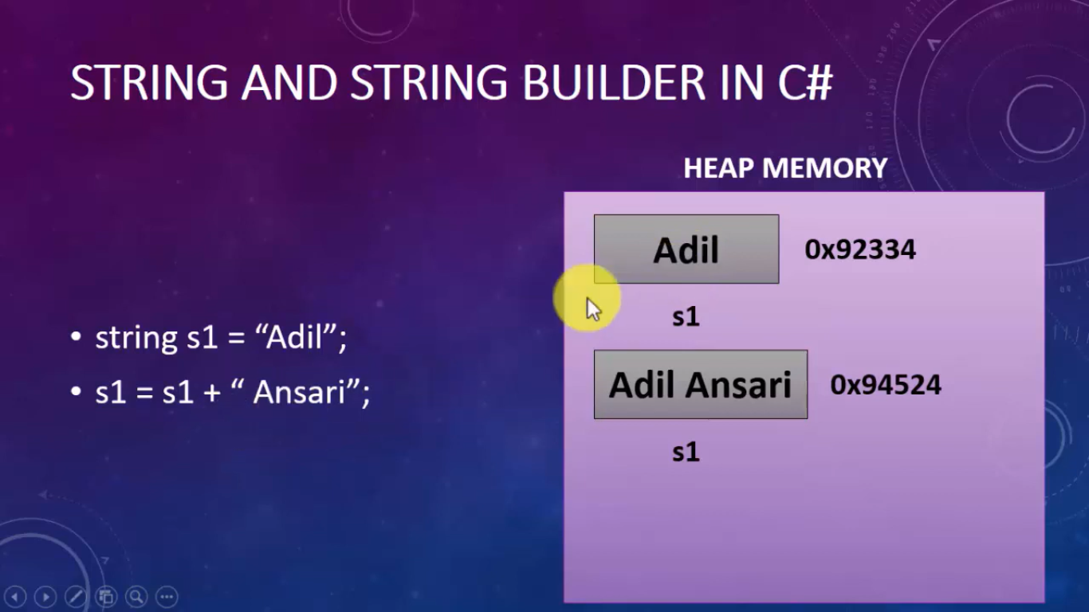

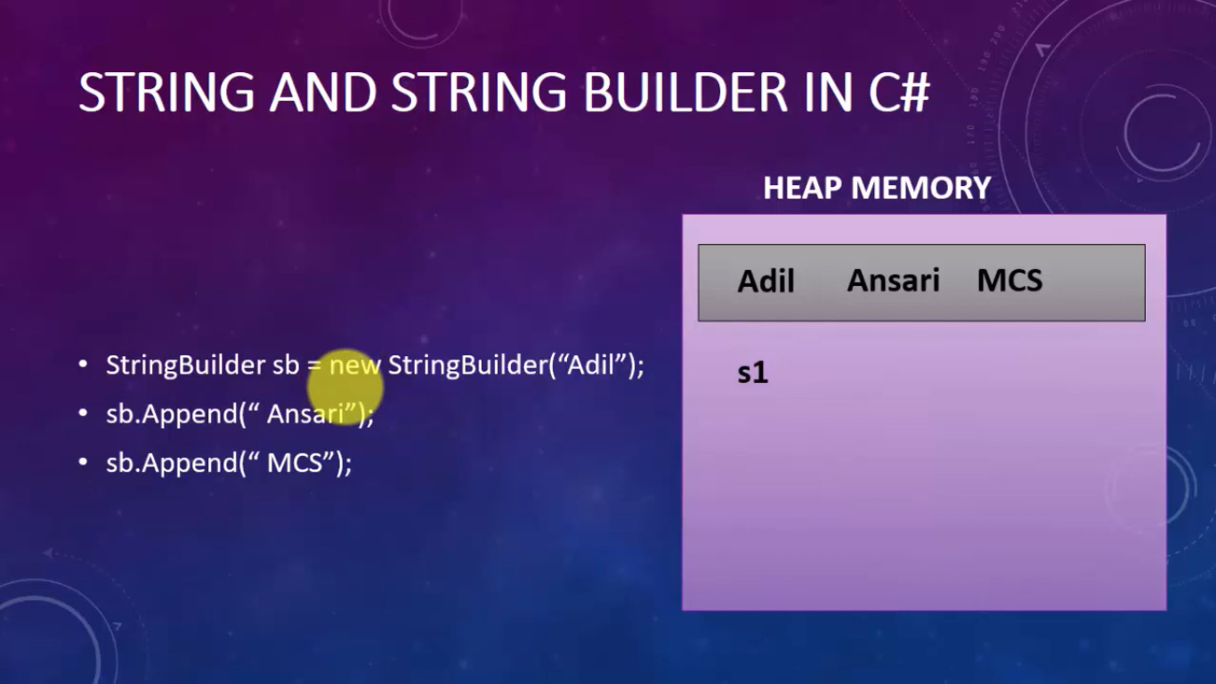

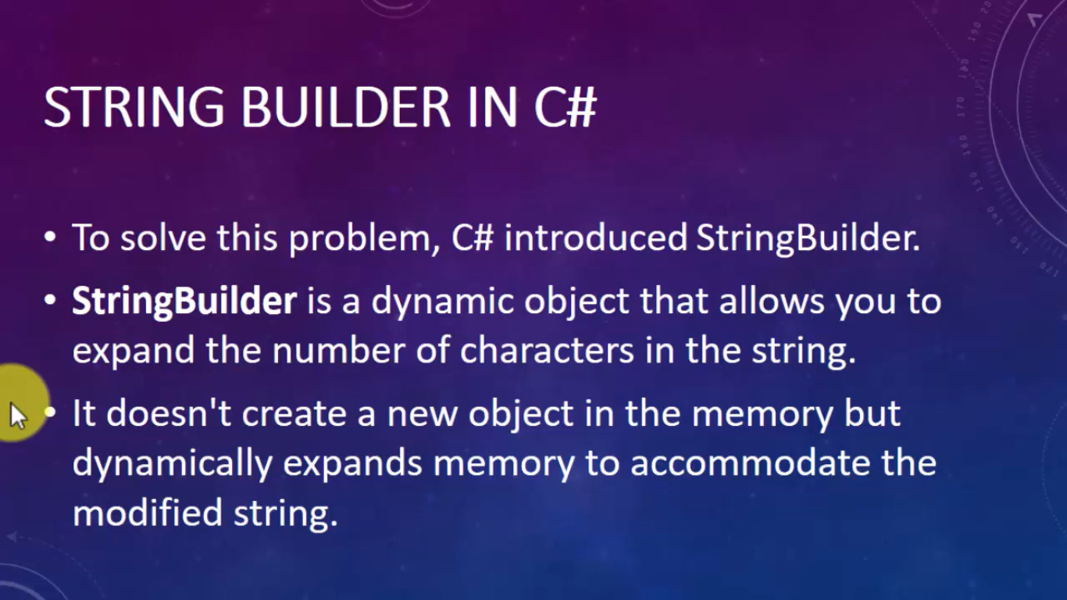

class Program

{

static void Main(string[] args)

{

Stopwatch sw1 = new Stopwatch();

string s1 = "Pradeep";

sw1.Start();

for (int i = 0; i < 100000; i++)

{

s1 = s1 + 1;

}

sw1.Stop();

StringBuilder sb = new StringBuilder("Pradeep2");

Stopwatch sw2 = new Stopwatch();

sw2.Start();

for (int i = 0; i < 100000; i++)

{

sb.Append(i);

}

sw2.Stop();

Console.WriteLine("Time Taken by String :{0}",sw1.ElapsedMilliseconds);

Console.WriteLine("Time Taken by StringBuilder :{0}", sw2.ElapsedMilliseconds);

}

}

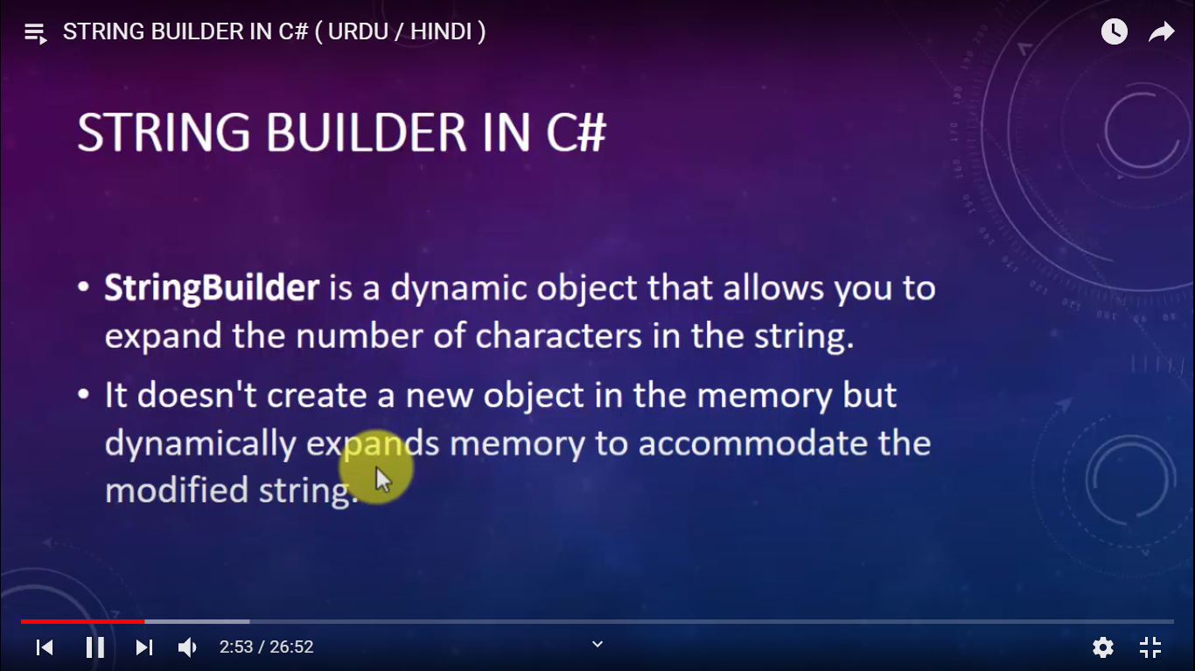

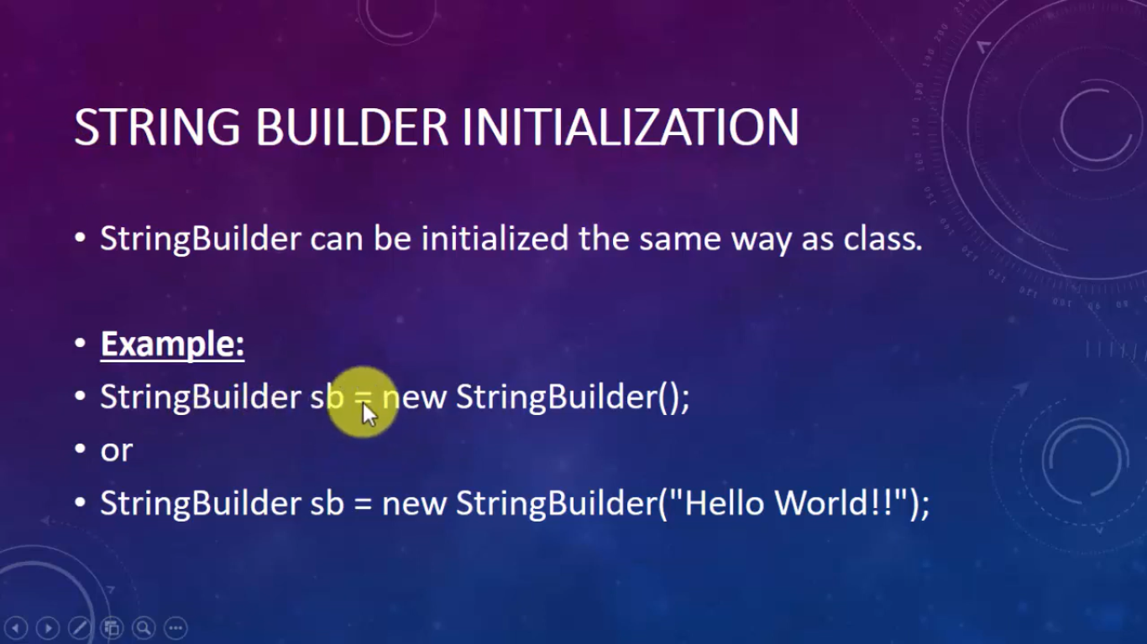

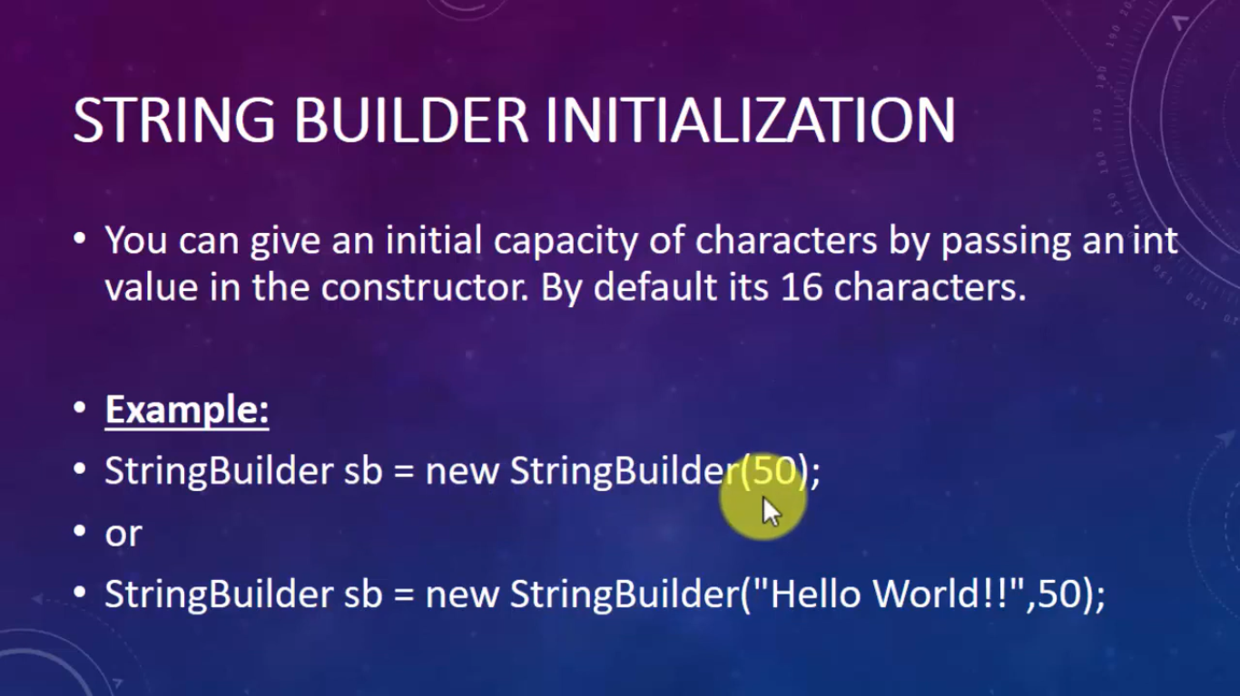

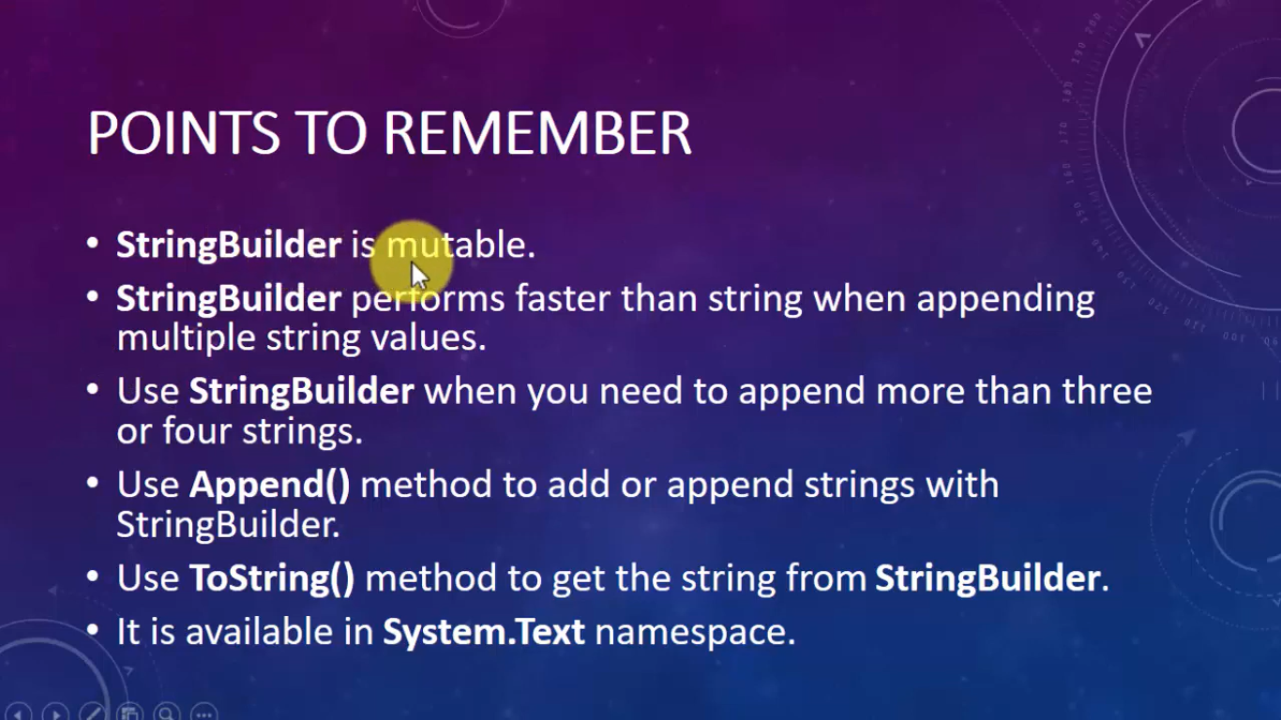

static void Main(string[] args)

{

StringBuilder sb1 = new StringBuilder();

sb1.Append("Pradeep");

sb1.AppendLine("Kumar");

sb1.AppendLine("Sftware Developer");

sb1.AppendFormat("{0:C}", 25);

//sb1.AppendFormat("{0:N}", 25);

//sb1.AppendFormat("{0:X}", 25);

Console.WriteLine(sb1);

/

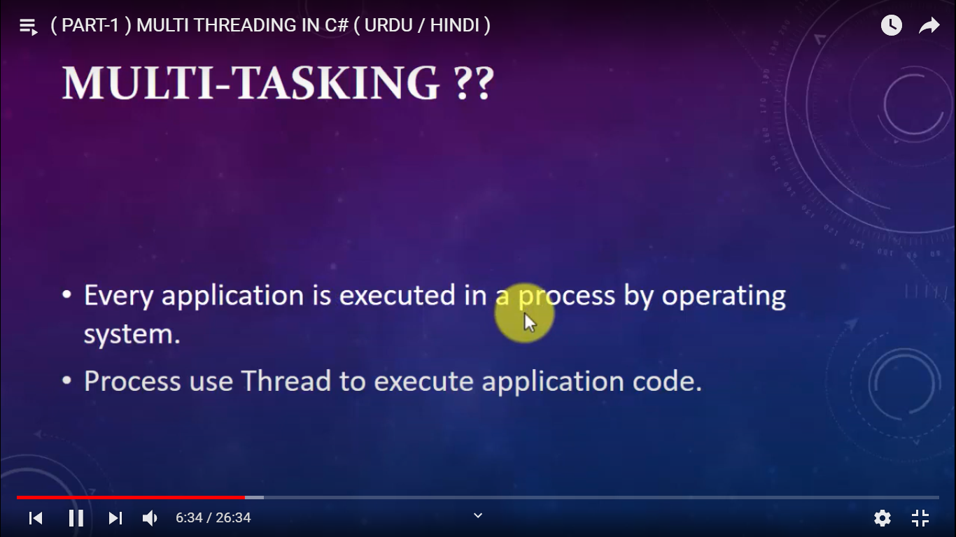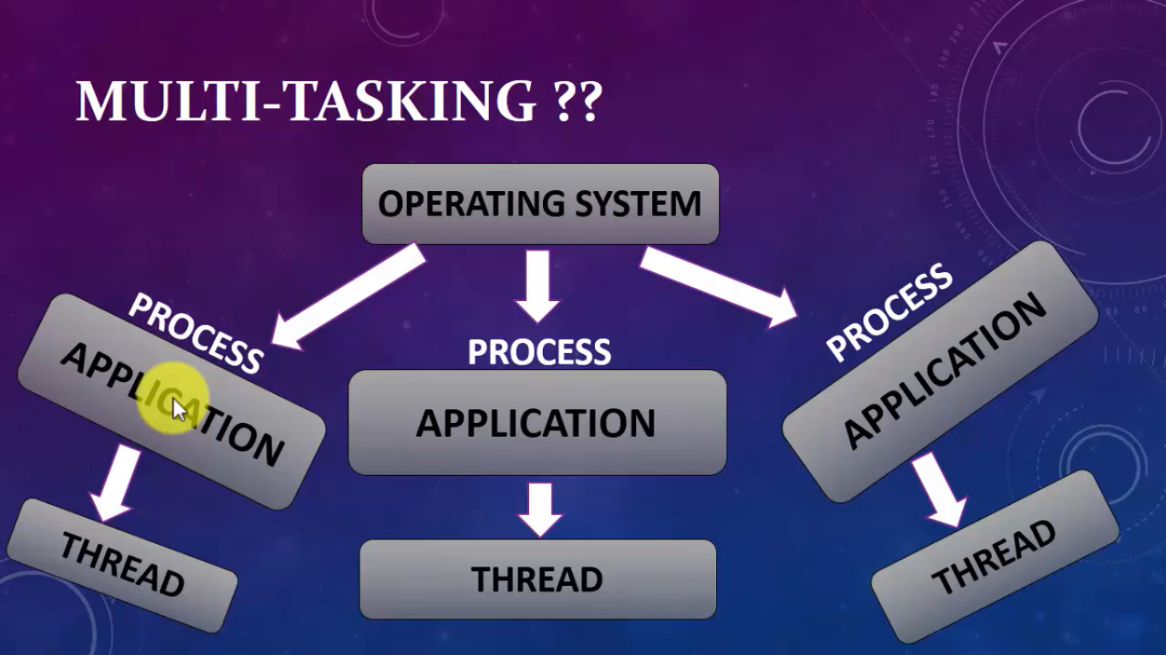

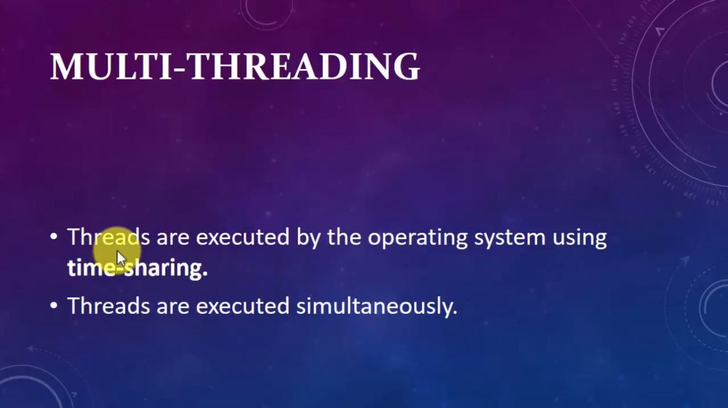

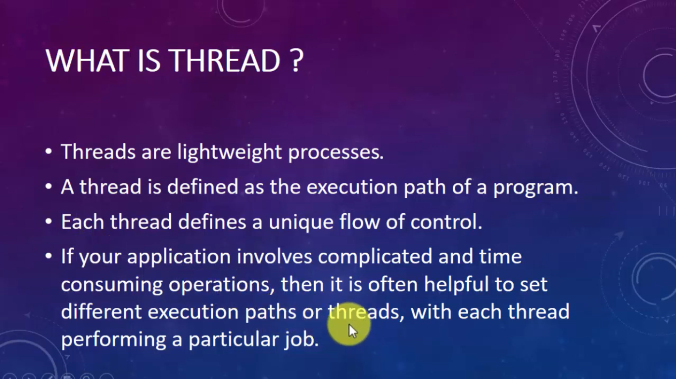

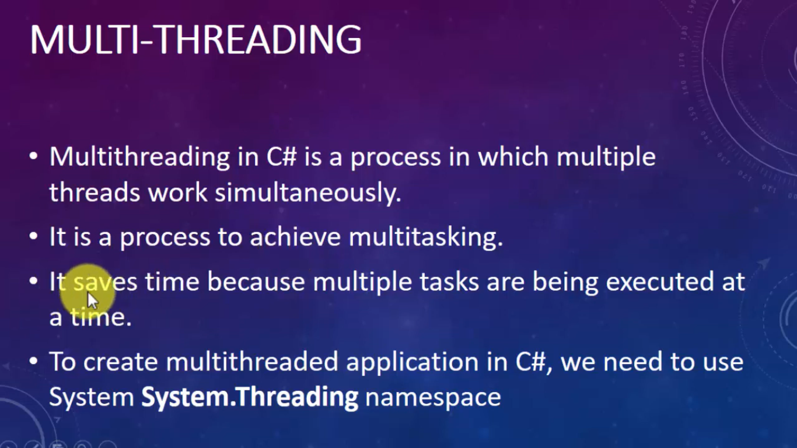

class Program

{

public static void func1()

{

for (int i = 0; i <= 50; i++)

{

Console.WriteLine("Func1="+i);

}

}

public static void func2()

{

for (int i = 0; i <=50; i++)

{

Console.WriteLine("Func2=" + i);

if (i == 25)

{

Console.WriteLine("Thread is going to sleep for 8 seconds ");

Thread.Sleep(8000);

}

}

}

public static void func3()

{

for (int i = 0; i <= 50; i++)

{

Console.WriteLine("Func3=" + i);

}

}

static void Main(string[] args)

{

Thread t1 = new Thread(func1);

Thread t2 = new Thread(func2);

Thread t3 = new Thread(func3);

t1.Start();

t2.Start();

t3.Start();

//Program.func1();

//Program.func2();

//Program.func3();

//Thread th = Thread.CurrentThread;

//th.Name = "Main Thread";

//Console.WriteLine("Current Executing Thread"+Thread.CurrentThread.Name);

}

}

**ExtensionMethod**

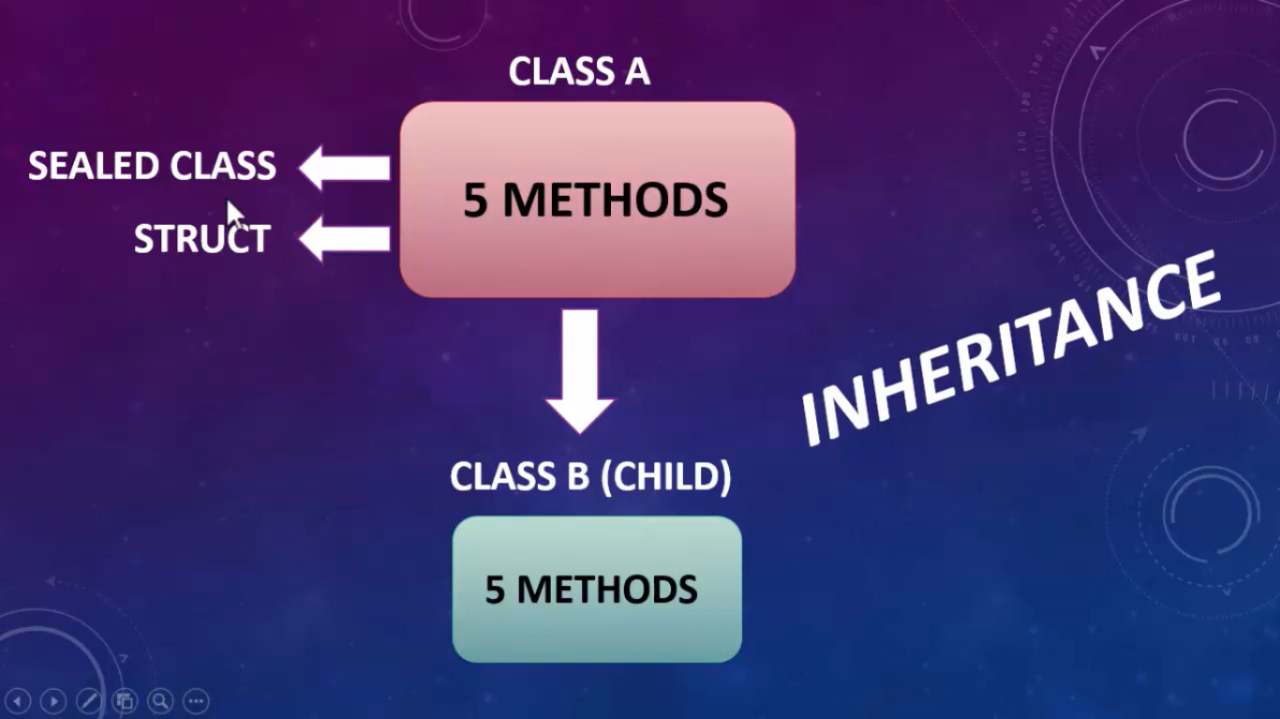

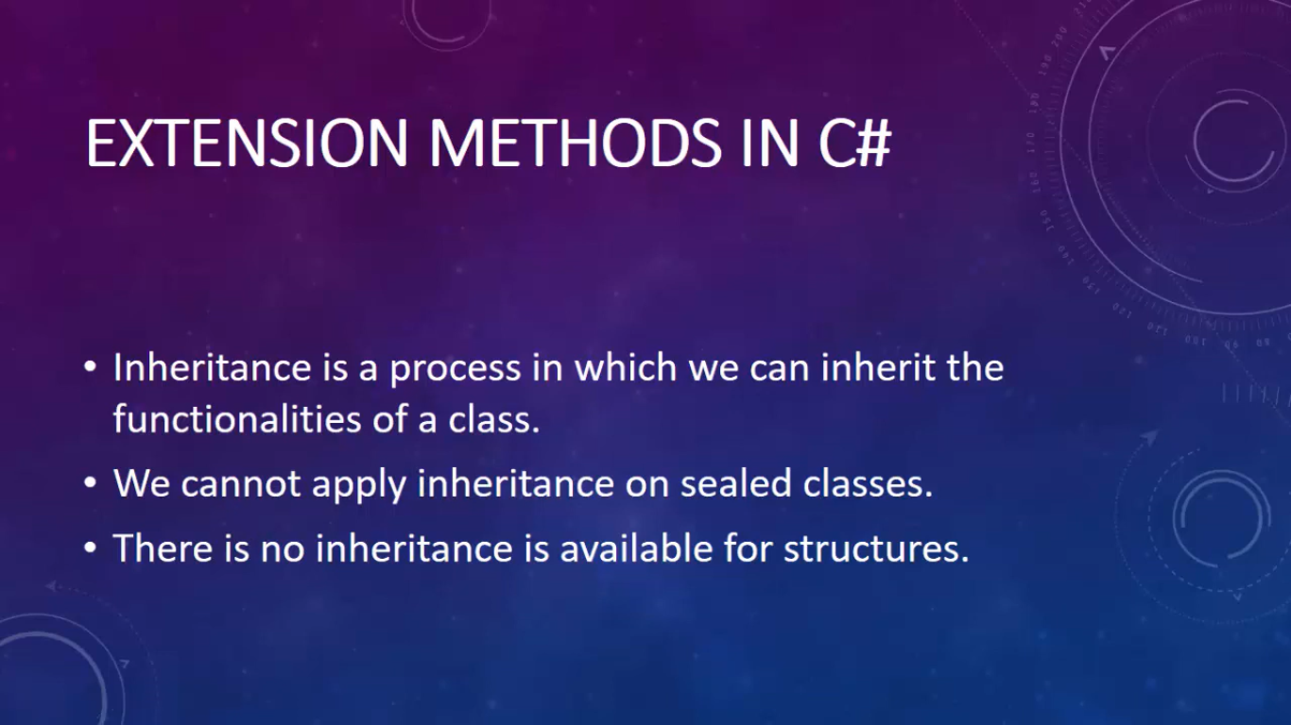

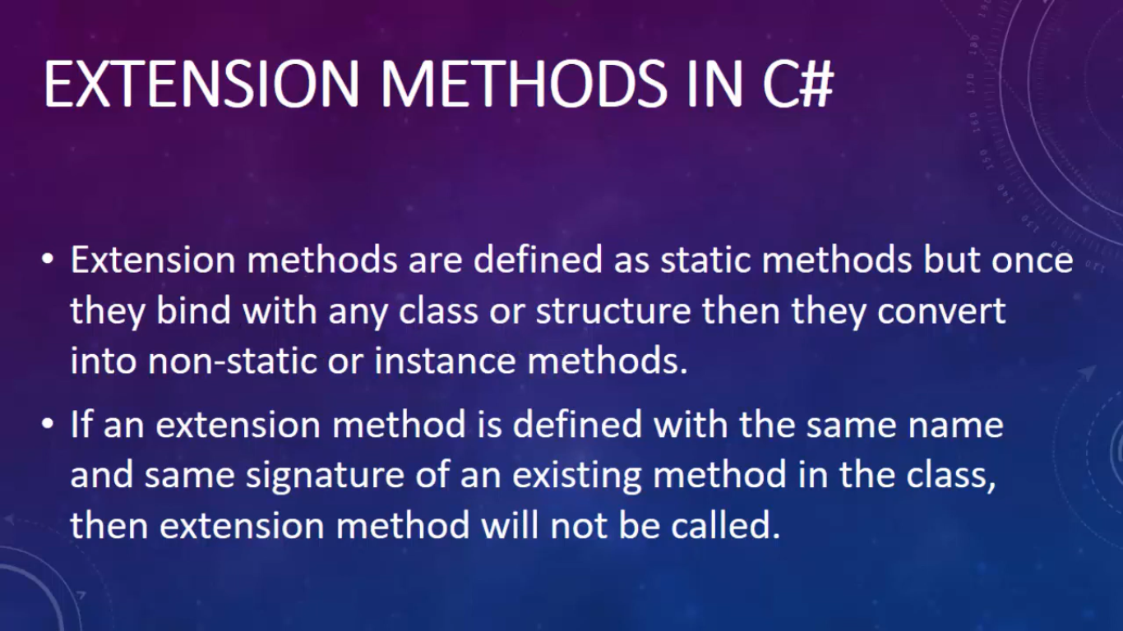

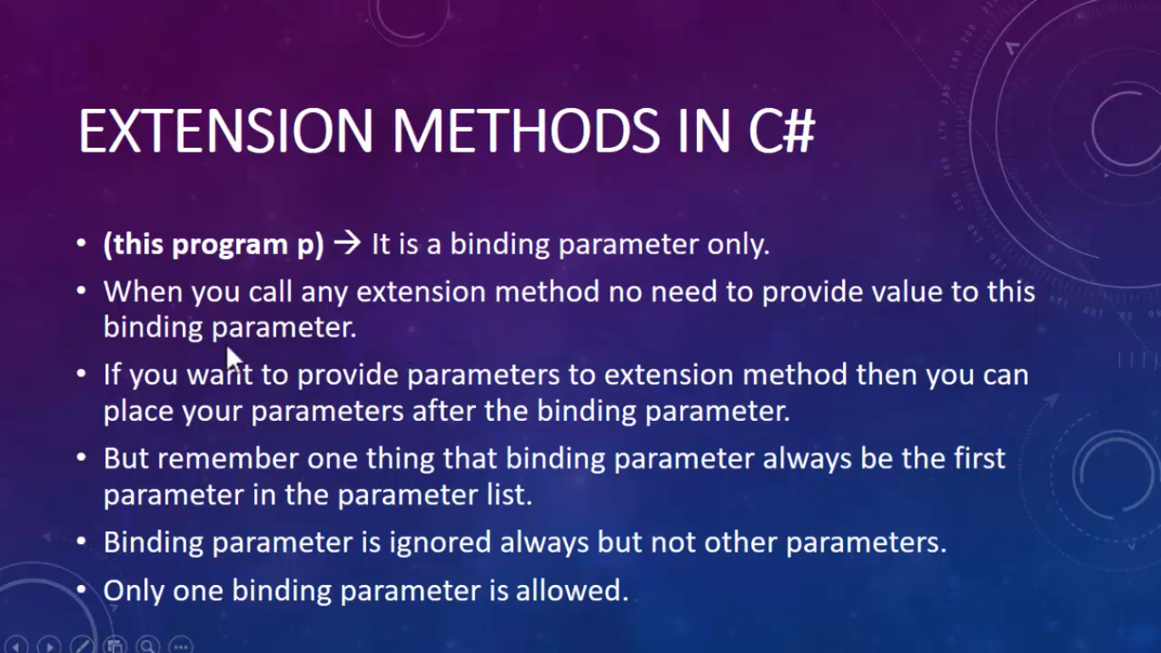

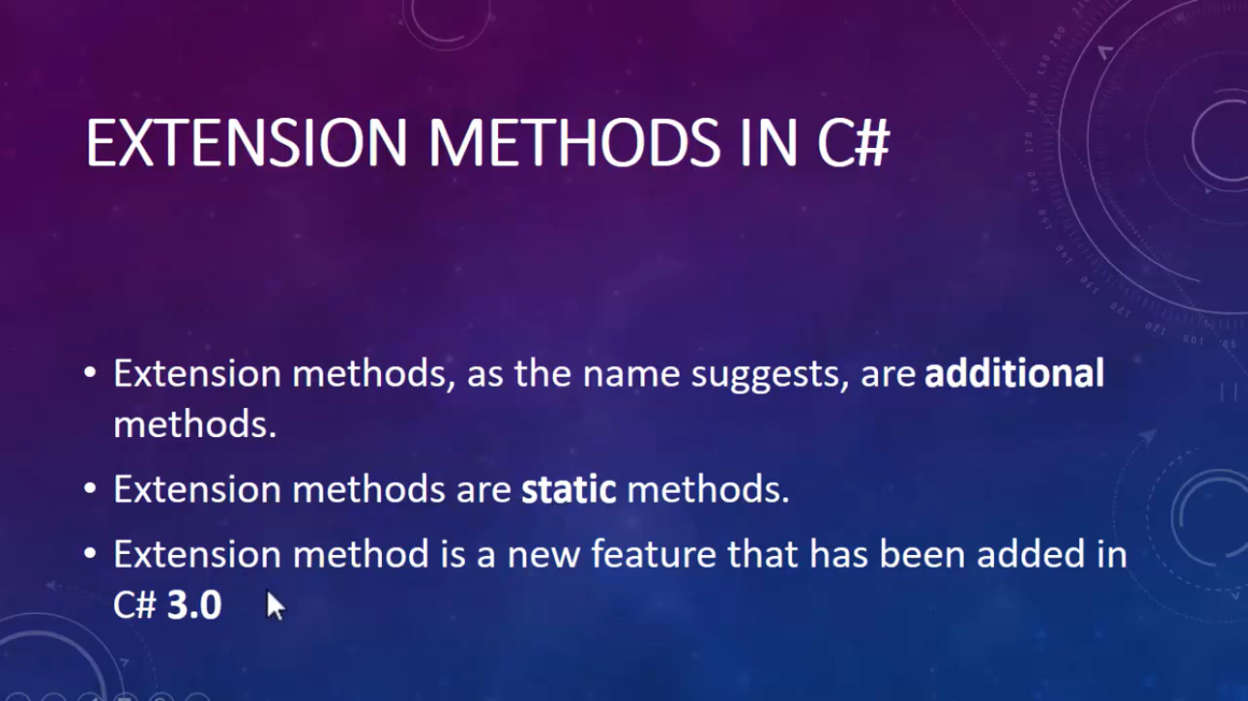

class Program

{

public void func1()

{

Console.WriteLine("This is Function1 ");

}

public void func2()

{

Console.WriteLine("This is Function2 ");

}

//static void Main(string[] args)

//{

// Program p1 = new Program();

// p1.func1();

// p1.func2();

//}

}

static class MyStaticClass

{

public static void Func3(this Program p)

{

Console.WriteLine("This is Function3");

}

public static void Func4(this Program p,int i)

{

Console.WriteLine("This is Function4:"+i);

}

public static Boolean isGreaterThan(this int i,int value)

{

return i > value;

}

}

class TestExtensionMethod

{

static void Main()

{

Program p2 = new Program();

p2.func1();

p2.func2();

p2.Func3();

p2.Func4(99);

int i = 20;

Boolean result = i.isGreaterThan(30);

Console.WriteLine(result);

}

}

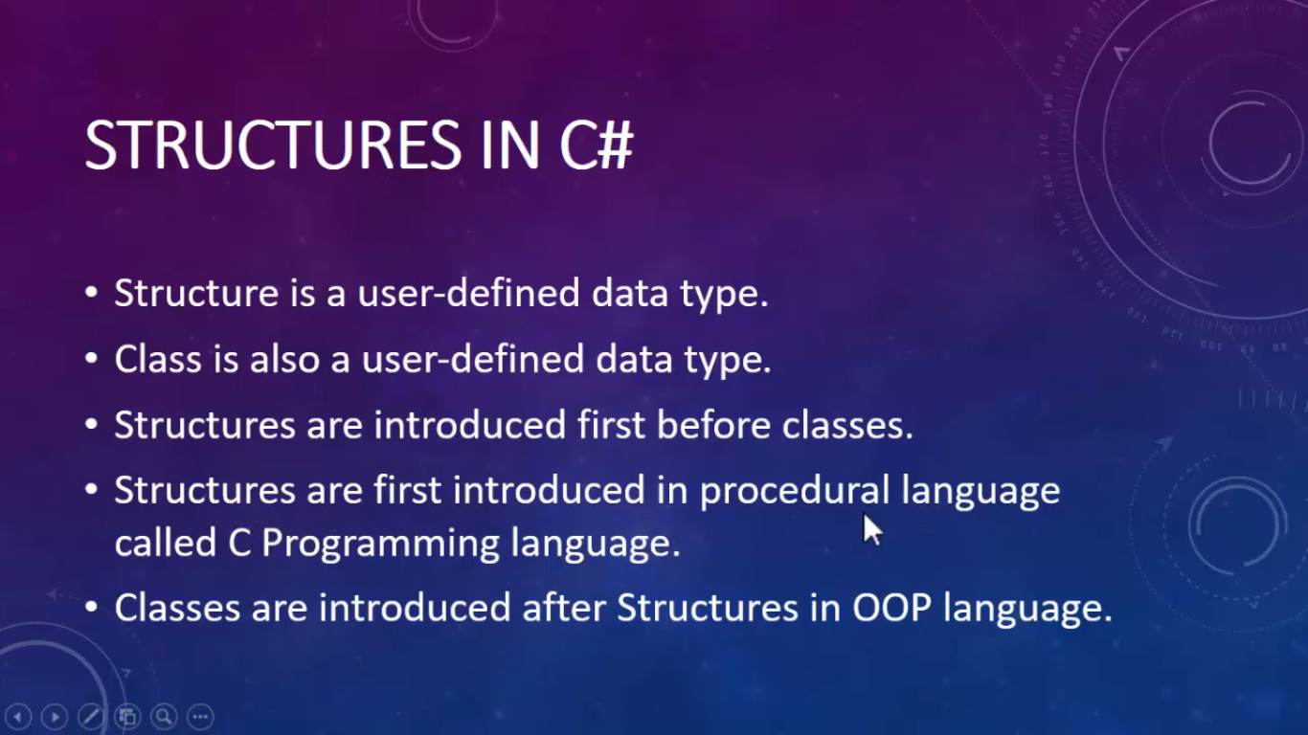

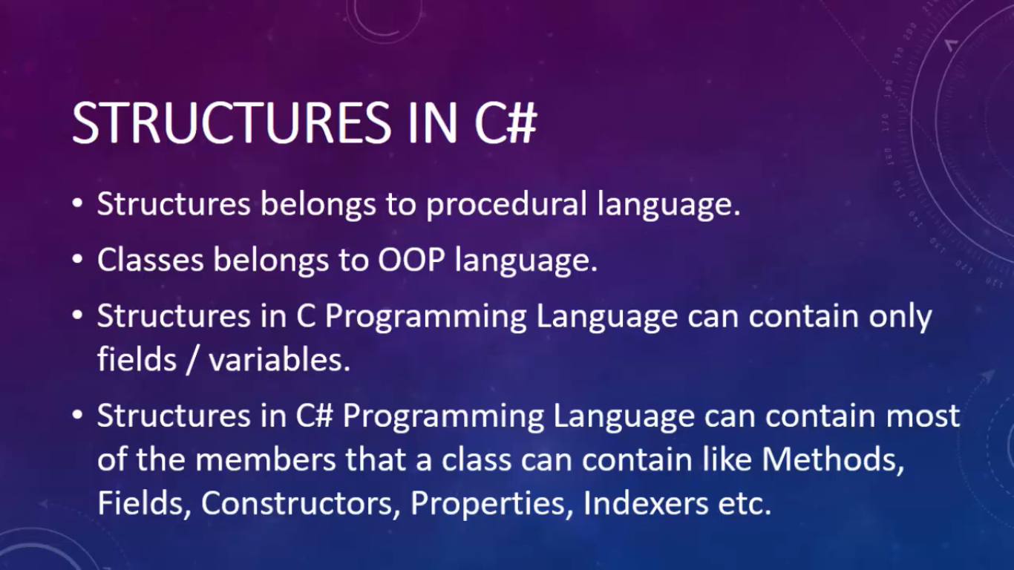

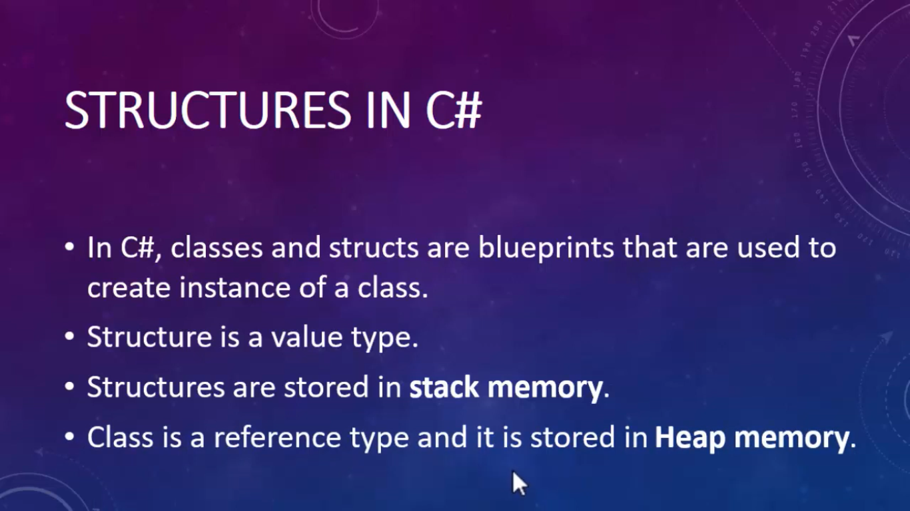

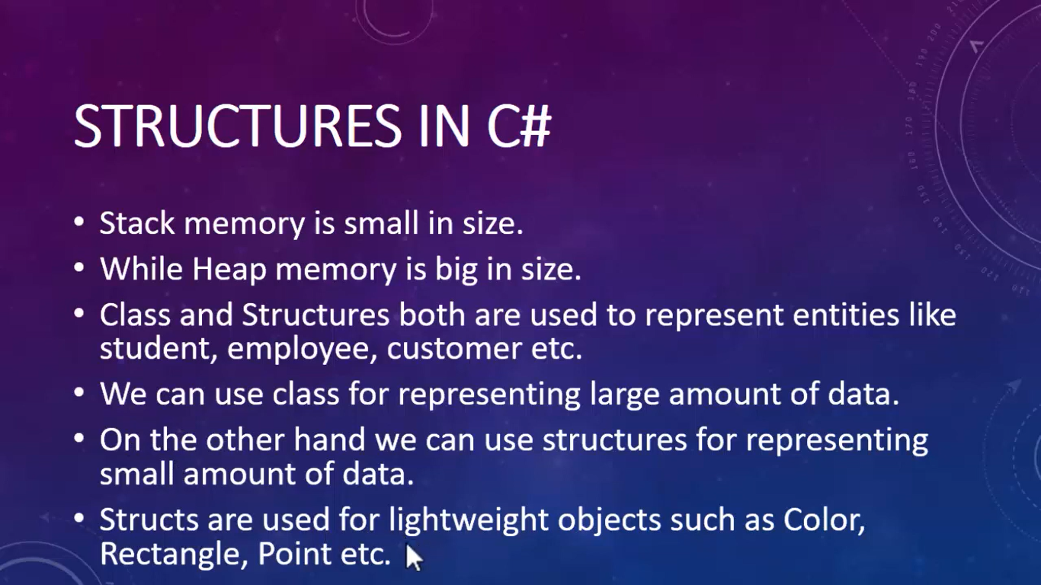

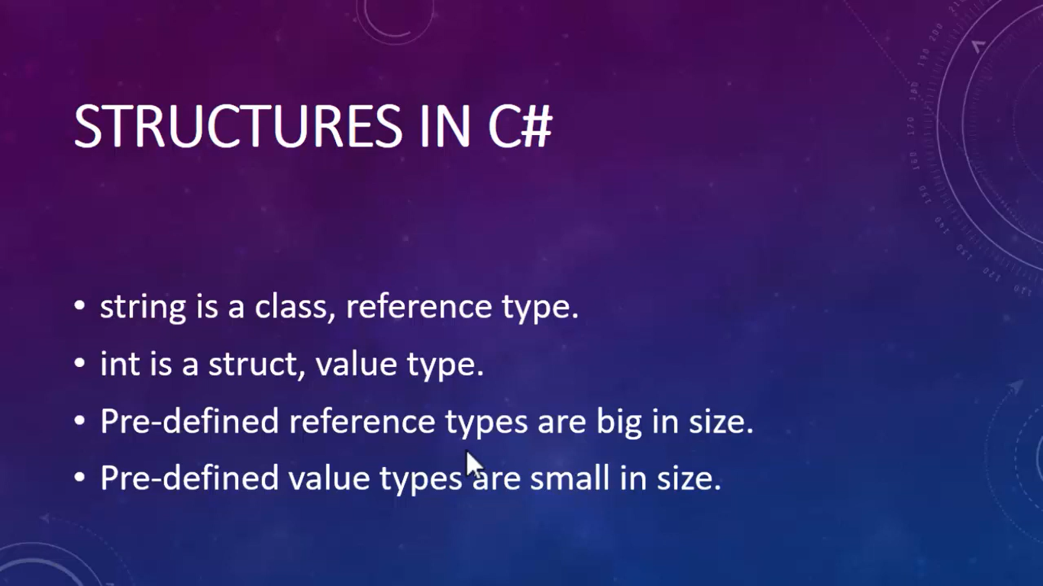

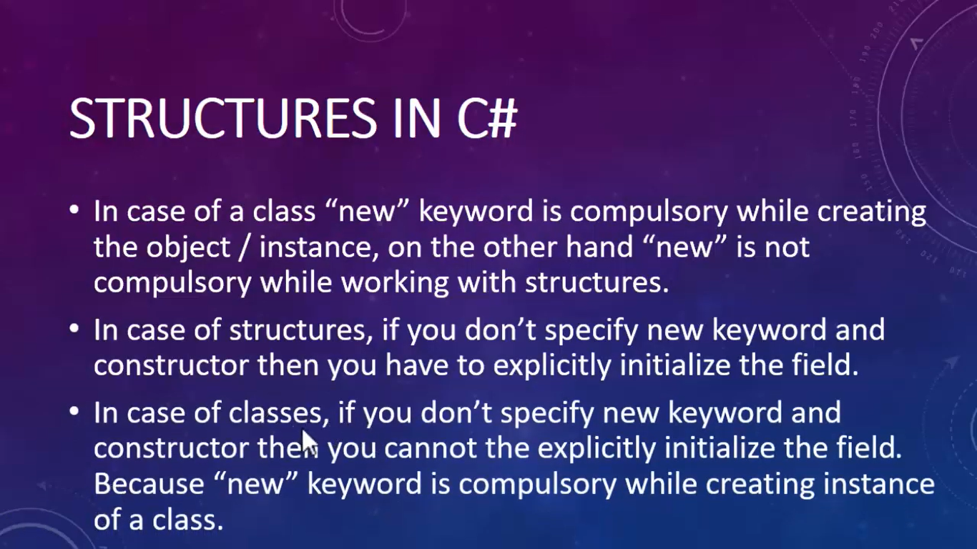

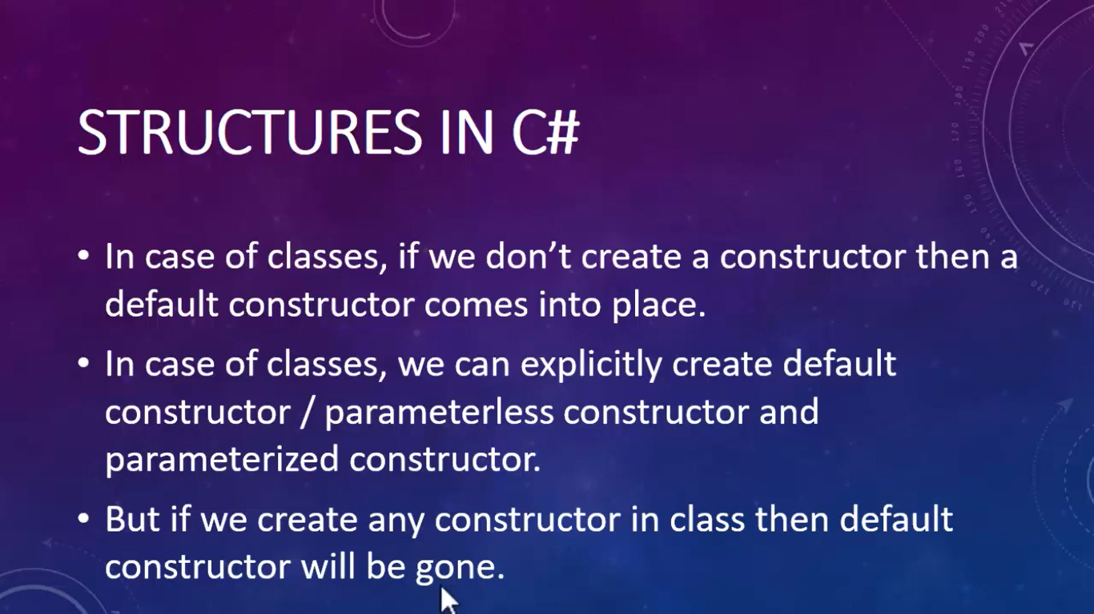

**New Keyword is necessary in class**

**New Keyword is not necessary in struct**

**Struct cannot contain explicit default constructor**

**In class default constructor will go if we create parameterized constructor**

**In struct default constructor will not go if we create parameterized constructor**

**We can create only parameterized constructor in sruct**

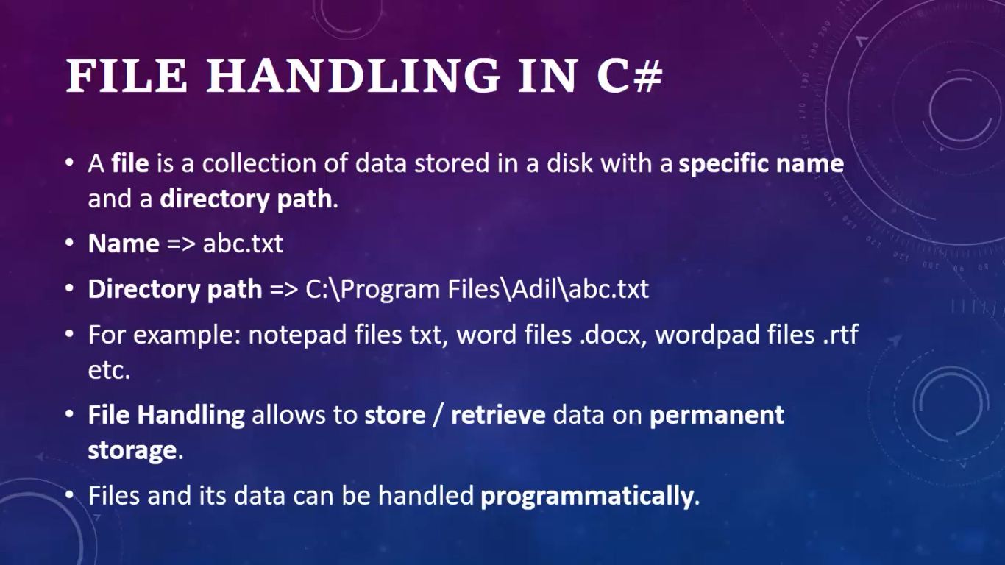

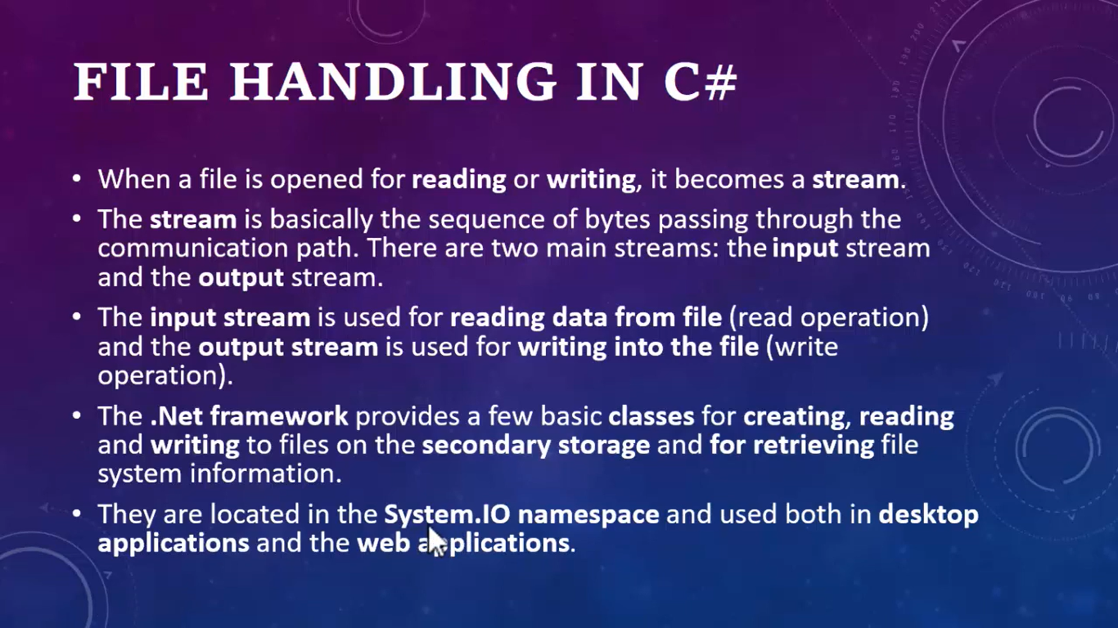

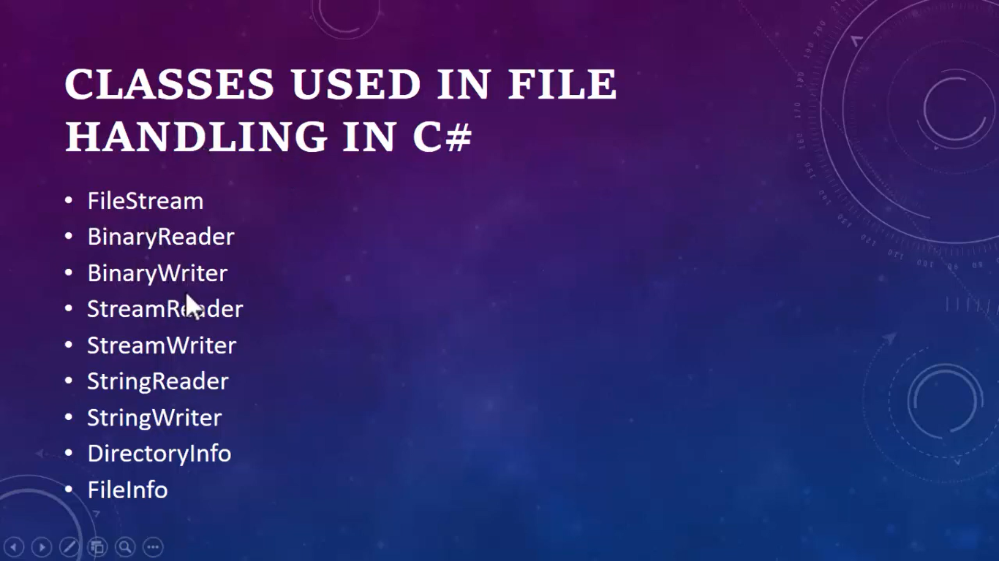

static void Main(string[] args)

{

string path = @"D:\Pradeep_WFX\testw.docx";

string path2= @"D:\Pradeep_WFX\testw2.docx";

if (File.Exists(path)==true)

{

Console.WriteLine("Yes , There is a File");

string data = File.ReadAllText(path);

Console.WriteLine(data);

File.Copy(path, path2,true);

}

else

{

Console.WriteLine("File Not Found");

}

}

}

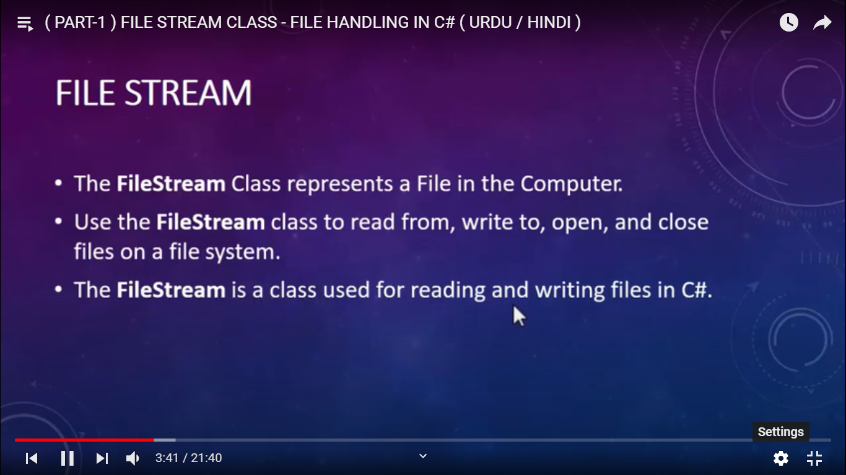



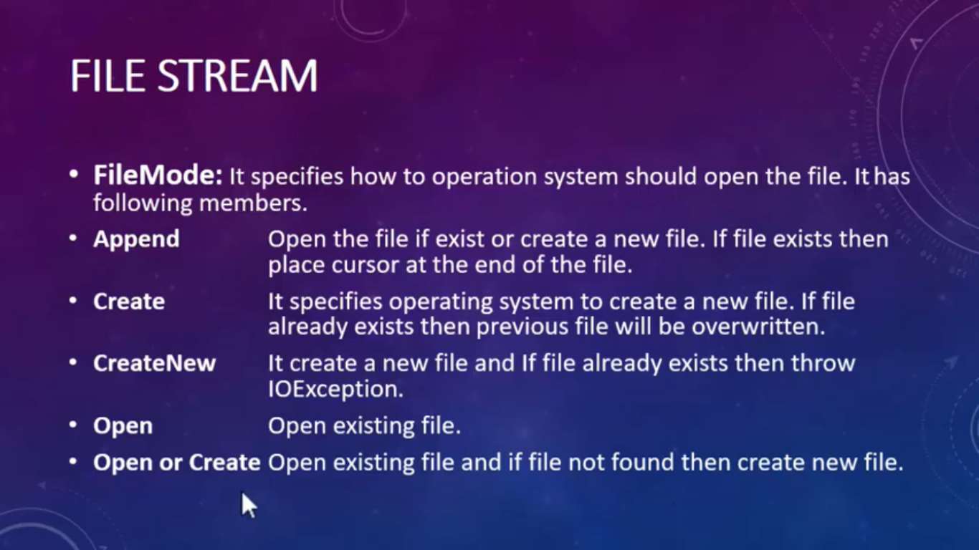

static void Main(string[] args)

{

string path = @"D:\Pradeep_WFX\myFileStream.txt";

using (FileStream file = new FileStream(path, FileMode.CreateNew, FileAccess.Write))

{

file.WriteByte(65); //A

file.WriteByte(66); //B

file.WriteByte(67); //C

file.WriteByte(68); //D

Console.WriteLine("File Created");

}

FileStream file = new FileStream(path, FileMode.Create);

Console.WriteLine("File Created");

file.Close();

using (FileStream file = new FileStream(path, FileMode.Create, FileAccess.Write))

{

file.WriteByte(65); //A

Console.WriteLine("File Created");

}

using (FileStream file = new FileStream(path, FileMode.Append, FileAccess.Write))

{

file.WriteByte(65); //A

file.WriteByte(66); //B

file.WriteByte(67); //C

file.WriteByte(68); //D

Console.WriteLine("File Created");

}

using (FileStream file = new FileStream(path, FileMode.Open, FileAccess.Write))

{

file.WriteByte(65); //A

file.WriteByte(66); //B

file.WriteByte(67); //C

file.WriteByte(68); //D

Console.WriteLine("File Created");

}

using (FileStream file = new FileStream(path, FileMode.OpenOrCreate, FileAccess.Write))

{

file.WriteByte(68); //D

Console.WriteLine("File Created");

}

using (FileStream file = new FileStream(path, FileMode.Truncate, FileAccess.Write))

{

Console.WriteLine("File Truncate Successfully");

}

using (FileStream file = new FileStream(path, FileMode.Append, FileAccess.Write))

{

string Data = "My Name is Pradeep";

byte[] write_data = Encoding.UTF8.GetBytes(Data);

file.Write(write_data, 0, Data.Length);

Console.WriteLine("Data written Successfully");

}

}

static void Main(string[] args)

{

string path = @"D:\Pradeep_WFX\myStreamWriter2.txt";

//using (FileStream file = new FileStream(path, FileMode.Append, FileAccess.Write))

//{

// using (StreamWriter writer = new StreamWriter(file,Encoding.UTF8))

// {

// writer.WriteLine("Statement No. 3");

// writer.WriteLine("Statement No. 4");

// writer.WriteLine("Statement No. 5");

// }

//}

using (FileStream file = new FileStream(path, FileMode.Append, FileAccess.Write))

{

using (StreamWriter writer = new StreamWriter(file, Encoding.UTF8))

{

int[] arr1 = { 11, 22, 33, 44, 55, 66, 77 };

foreach (var item in arr1)

{

writer.Write(item + " ");

}

char[] arr2 = { 'A', 'B', 'C', 'D', 'E', 'F' };

foreach (var item in arr2)

{

writer.Write(item + " ");

}

}

}

}

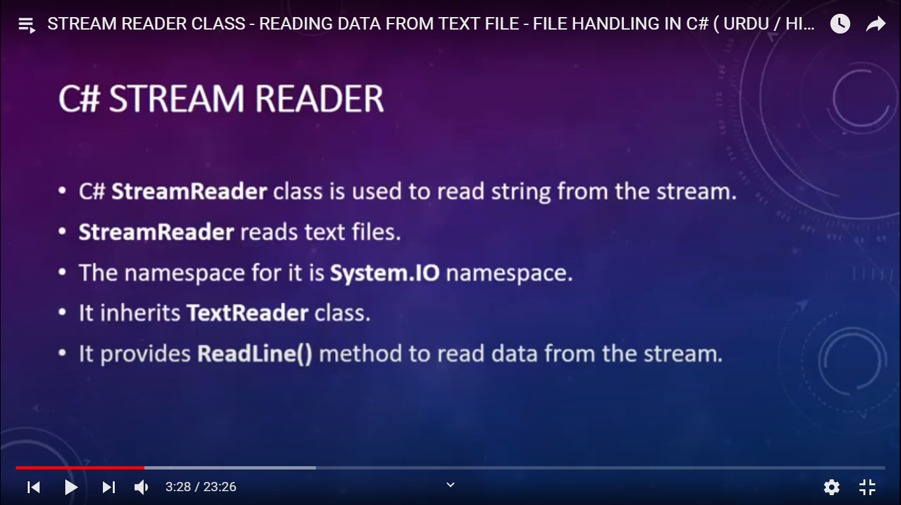

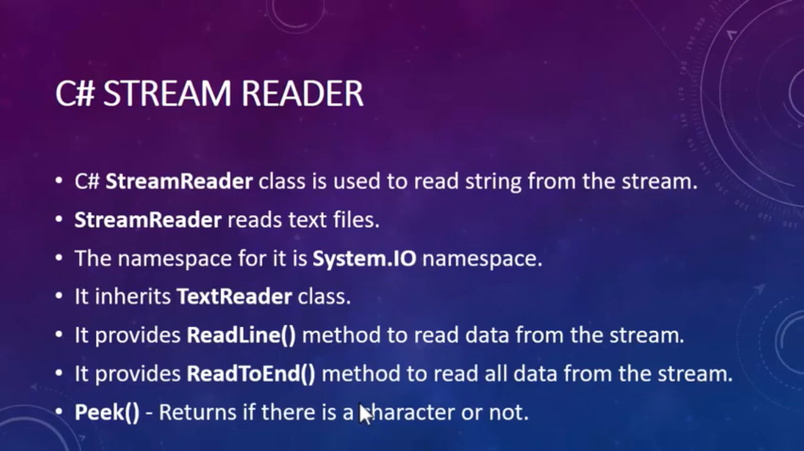

static void Main(string[] args)

{

string path = @"D:\Pradeep_WFX\myStreamWriter2.txt";

using (FileStream file = new FileStream(path, FileMode.Append, FileAccess.Write))

{

using (StreamWriter writer = new StreamWriter(file, Encoding.UTF8))

{

writer.WriteLine("Statement No. 3");

writer.WriteLine("Statement No. 4");

writer.WriteLine("Statement No. 5");

}

}

using (FileStream file = new FileStream(path, FileMode.Append, FileAccess.Write))

{

using (StreamWriter writer = new StreamWriter(file, Encoding.UTF8))

{

int[] arr1 = { 11, 22, 33, 44, 55, 66, 77 };

foreach (var item in arr1)

{

writer.Write(item + " ");

}

char[] arr2 = { 'A', 'B', 'C', 'D', 'E', 'F' };

foreach (var item in arr2)

{

writer.Write(item + " ");

}

}

}

string path = @"D:\Pradeep_WFX\myStreamReader3.txt";

using (FileStream fs = new FileStream(path, FileMode.Open, FileAccess.Read))

{

using (StreamReader reader = new StreamReader(fs))

{

string line = reader.ReadLine();

Console.WriteLine(line);

string line = "";

while ((line = reader.ReadLine()) != null)

{

Console.WriteLine(line);

}

foreach (var item in reader.ReadLine())

{

Console.WriteLine(item);

}

string[] names = new string[5];

for (int i = 0; i < names.Length; i++)

{

names[i] = reader.ReadLine();

}

foreach (var name in names)

{

Console.WriteLine(name);

}

string data = reader.ReadToEnd();

Console.WriteLine(data);

if (reader.Peek() > 0)

{

Console.WriteLine("true");

}

else

{

Console.WriteLine("false");

}

}

}

}

